|  |
| --- |
|  |
| **Newsletter – March/April 2022** |  |

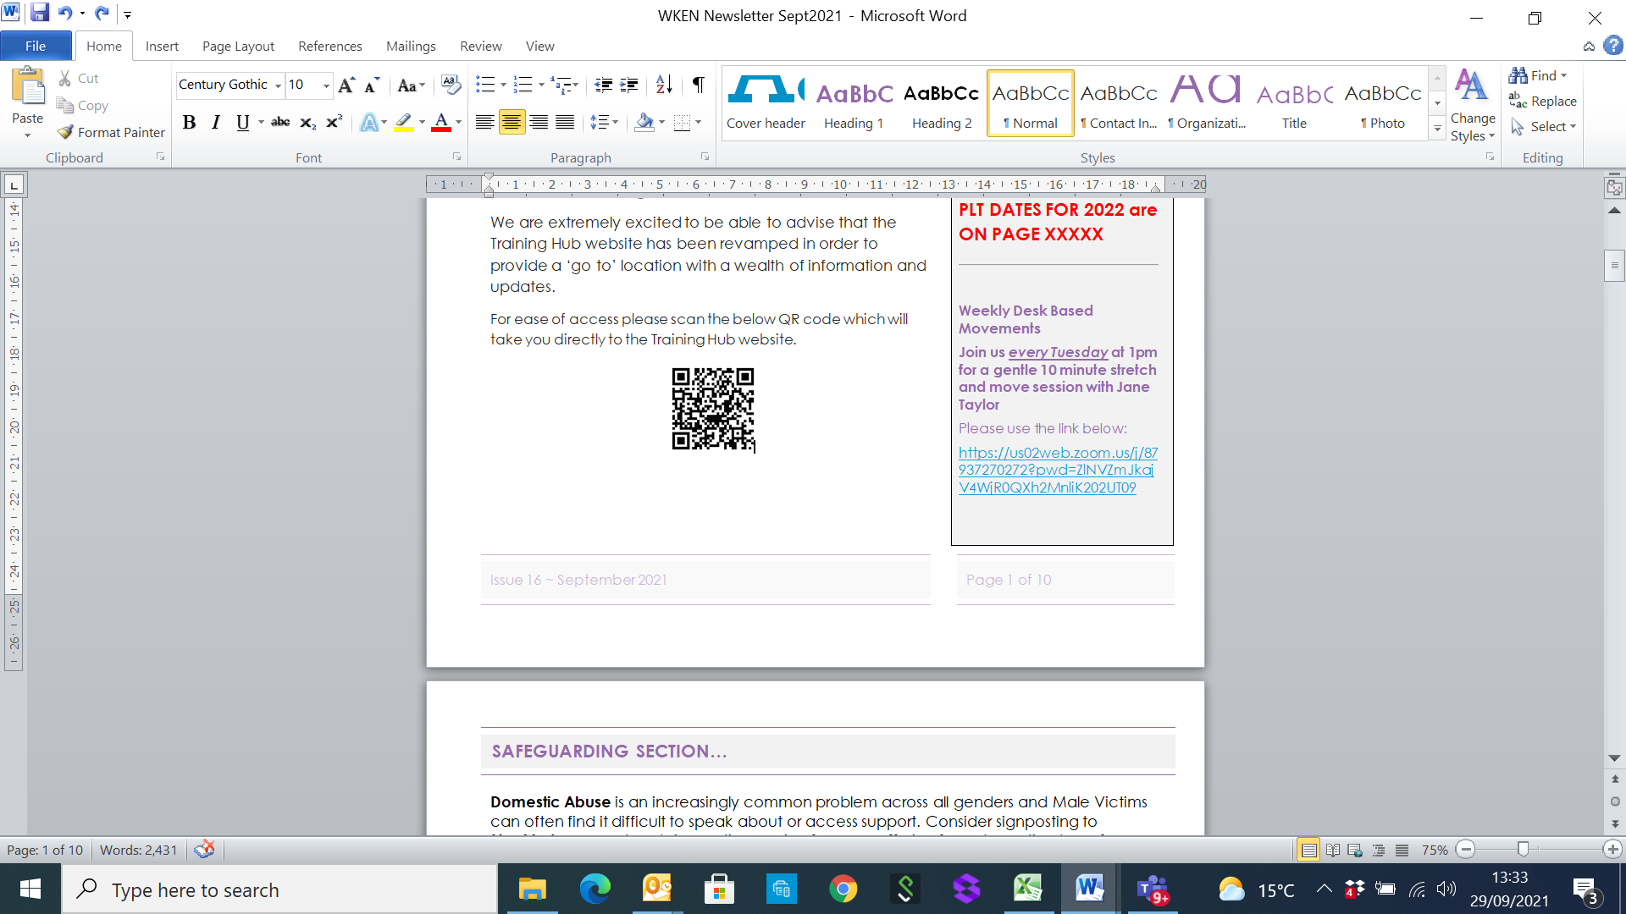**West Kent Training Hub**





**Deadline for Newsletter –** please send your items through by the **15th of the month** for inclusion in the next edition circulated at the end of the month.

**PLT DATES FOR 2022**





**FOR YOUR WELLBEING**

**Weekly Desk Based Movements**

**Join us *every Tuesday* at 1pm for a gentle 10 minute stretch and move session with Jane Taylor**

Please usethe link below:

<https://us02web.zoom.us/j/87937270272?pwd=ZlNVZmJkajV4WjR0QXh2MnliK202UT09>

[**www.westkenteducationnetwork.co.uk**](http://www.westkenteducationnetwork.co.uk)

**Email:** [**kmccg.wkentraininghub@nhs.net**](mailto:kmccg.wkentraininghub@nhs.net)

[Image result for twitter logo](https://www.bing.com/images/search?view=detailV2&ccid=CqXWN5l4&id=8B16F98F138AFC909C08261085B90A4D34866D39&thid=OIP.CqXWN5l4IM2LxlE-H0lHOAHaHa&mediaurl=https://img.talkandroid.com/uploads/2016/01/twitter-app-logo.png&exph=512&expw=512&q=twitter+logo&simid=607994475025467935&selectedIndex=0&qpvt=twitter+logo) **@westkentWKEN**

|  |
| --- |
|  |
| Dear Reader,  Welcome to the West Kent Training Hub (WKEN) Newsletter.  WKEN would like to thank all those who contribute to the content of this newsletter and ask that you please share this with your staff teams. There is an array of articles and opportunities open to all, so your help to share with your teams is very much appreciated.  ***We would love to hear from you and share your news***, so if you have suggestions for future items, including job vacancies, please send through to [**kmccg.wkentraininghub@nhs.net**](mailto:kmccg.wkentraininghub@nhs.net)  ***PLEASE NOTE: NEW JOBS SUPPLEMENT WILL BE SHARED SEPARATELY*** |
|  |

**Primary Care Training Hubs**

As you are almost certainly aware, across Kent and Medway are 3 locality training hubs supporting the Primary Care workforce in West, North and East Kent.

We have joined forces under the name of **Kent and Medway Primary Care Training Hub** and with a new logo, more communications will be sent out in due course, but in the interim and to ensure you receive relevant news, please click ‘**re-subscribe**’ in the below box to sign up to this combined newsletter:

[](https://forms.wix.com/46923212-ecea-4640-be80-941e6343ca7e:79c26855-8aa8-428c-9133-aa9749685b70)

***This******West Kent Newsletter and Job Supplement will continue to be produced and circulated in addition to the above***

|  |
| --- |
|  |
|  |
| **SAFEGUARDING SECTION…** |
|  |
|  |

**Safeguarding Children and Adults across Kent and Medway**

|  |  |  |
| --- | --- | --- |
| ***Compassion*** | ***Courage*** | ***Respect*** |

**Your local safeguarding contacts are below:**

**Kirsty Edgson, Designated Nurse for Safeguarding Children,** [k.edgson@nhs.net](mailto:k.edgson@nhs.net)

**Tracey Creaton. Designate Nurse for Adult Safeguarding.** [tracey.creaton@nhs.net](mailto:tracey.creaton@nhs.net)

**It is with pleasure we share with you the new digital Safeguarding Concern form for the Kent area along with guidance on how to access the form, guidance for professionals completing the form and a guidance document on when to make a referral. If you have any queries related to using the form please could you use the future ways of working link below, for queries about a safeguarding issue please continue to liaise with your HCPs Designate Nurse.**

“The digital Safeguarding Concern form can be accessed via the Kent County Council (KCC) website on our ‘report abuse’ and ‘information for professionals’ pages. Please follow [this link](https://eur01.safelinks.protection.outlook.com/?url=https%3A%2F%2Fwww.kent.gov.uk%2Fsocial-care-and-health%2Freport-abuse&data=04%7C01%7CNicola.Manington%40kent.gov.uk%7Ce26da5cba48a43e5a6b308da162b711c%7C3253a20dc7354bfea8b73e6ab37f5f90%7C0%7C0%7C637846673210054627%7CUnknown%7CTWFpbGZsb3d8eyJWIjoiMC4wLjAwMDAiLCJQIjoiV2luMzIiLCJBTiI6Ik1haWwiLCJXVCI6Mn0%3D%7C3000&sdata=AbeuAU99ynIy5mdDyVUdHU6803bJGPynWrUFa46DheY%3D&reserved=0) to access the ‘report abuse’ page, and [this link](https://eur01.safelinks.protection.outlook.com/?url=https%3A%2F%2Fwww.kent.gov.uk%2Fsocial-care-and-health%2Finformation-for-professionals%2Fadult-safeguarding%2Fadult-protection-forms&data=04%7C01%7CNicola.Manington%40kent.gov.uk%7Ce26da5cba48a43e5a6b308da162b711c%7C3253a20dc7354bfea8b73e6ab37f5f90%7C0%7C0%7C637846673210054627%7CUnknown%7CTWFpbGZsb3d8eyJWIjoiMC4wLjAwMDAiLCJQIjoiV2luMzIiLCJBTiI6Ik1haWwiLCJXVCI6Mn0%3D%7C3000&sdata=lC5Y1%2Ffd4gXOZHR%2F1mB7YNm3fzVu%2BZIoEiQDZs7BbBg%3D&reserved=0) to access the ‘information for professionals’ page.

Our digital form has replaced the word document version of the Safeguarding Concern form and whilst we promote partners to complete the digital form, we understand that some are unable to fulfil this request. Therefore, you will still be able to call our contact centre or use the current agreed process in your organisation if necessary.

Once a person submits their concern via the digital form, the screenshot below will come up. If you would like a copy of the form once you have submitted it, please click the ‘download PDF’ button.

We have also created a flow chart for partners which advises when to make a safeguarding referral to KCC Adult Social Care.

Please see flowchart attached. It has been adapted from the ADASS framework called: *‘Understanding what constitutes a safeguarding concern and how to support effective outcomes: Suggested multi-agency framework to support practice, recording and reporting’.*

We have previously shared this flow chart with partners, but please feel free to share wider if necessary.

If you have any questions, please email [futurewaysofworkingasch@kent.gov.uk](mailto:futurewaysofworkingasch@kent.gov.uk)



|  |
| --- |
|  |
|  |
| **SAFEGUARDING SECTION…** |
|  |
|  |

[Supporting Parents and Carers: A guide for those working with families affected by child sexual abuse (csacentre.org.uk)](https://www.csacentre.org.uk/documents/supporting-parents-and-carers-a-guide-for-those-working-with-families-affected-by-child-sexual-abuse/)

This guide is for anyone whose role brings them into contact with the parents and carers of children under 18 years old

The guide aims to help you provide a supportive response to parents when concerns about the sexual abuse of their child have been raised, or when such abuse has been identified. It does not cover safeguarding actions, local policies and procedures should be followed.

**Kent Escalation and Professional Challenge Policy**

This policy sets out the escalation pathway to be followed in the event of professional disagreements which cannot be resolved between individuals. For support contact the KMCCG Safeguarding Team – Generic email address here?

<https://www.kscmp.org.uk/search?mode=results&queries_keyword_query=escalation>

**IMPORTANT SAFEGUARDING INFORMATION:**

**Concerned about a child?**

**Call 03000 41 11 11 (text relay 18001 03000 41 11 11) or email** [**social.services@kent.gov.uk<mailto:social.services@kent.gov.uk**](mailto:social.services@kent.gov.uk%3cmailto:social.services@kent.gov.uk)

**Concerned about an adult?**

**·Call 03000 41 61 61 (text relay 18001 03000 41 61 61) or email** [**social.services@kent.gov.uk<mailto:social.services@kent.gov.uk**](mailto:social.services@kent.gov.uk%3cmailto:social.services@kent.gov.uk)**>**

**Out of hours and in an emergency**

**If you need to contact us outside of normal office hours, for example during the night, call 03000 41 91 91.**

**If you think someone is in immediate danger, the best thing to do is call 999 for the emergency services.**

|  |
| --- |
|  |
| **Wellbeing** |
|  |

**DESK BASED MOVEMENTS - weekly 10 minute sessions**

We have received some great feedback from the weekly movement sessions so keep sending in your comments. Jane Taylor has kindly set up a specific ‘member area’ on her website so all the recordings are available and can be easily accessed.

<https://vimeopro.com/taylormadefitness/wken-weekly-work-based-movement-sessions>

It is password protected and I have used the password:WKEN-move-more

**In addition, Jane has kindly provided the below links which offer some additional recordings:**

* [*Additional recording (15 minutes)*](https://vimeo.com/643940864/1a38830e62) - segmental movements of the spine plus a lovely shoulder exercise!

Also, here is the link for a previous session: <https://vimeo.com/669821863/531a70feaf>

**Join us every Tuesday at 1pm** - **we look forward to seeing you then:**

<https://us02web.zoom.us/j/87937270272?pwd=ZlNVZmJkajV4WjR0QXh2MnliK202UT09>

**Support available for our NHS people**

We know that our NHS people are often faced with significant stresses. The NHS can only achieve the extraordinary things for patients that it does if the safety, health and wellbeing of our people is recognised as a key priority.

**If you need someone to talk to**, we have introduced a **confidential staff support line**, operated by the [Samaritans](https://www.samaritans.org/) and free to access from 7:00am – 11:00pm, seven days a week.  Please **call 0800 069 6222**to speak to an advisor.

This support line is available to all our NHS colleagues who have had a tough day, who are feeling worried or overwhelmed, or who have a lot on their mind and need to talk it through.  Trained advisers will be available to help with signposting and confidential listening.

Alternatively, if you would prefer to speak to someone through text, you can access support by **texting FRONTLINE to 85258 for support 24/7**.

Alongside the above dedicated helpline, we also have a range of additional support offers in place for our NHS colleagues which suit a range of different health and wellbeing needs:

[**https://www.england.nhs.uk/supporting-our-nhs-people/support-now/**](https://www.england.nhs.uk/supporting-our-nhs-people/support-now/)

|  |
| --- |
|  |
| **Greener Practice** |
|  |

Welcome to our new Greener Practice regular feature in the newsletter.

We will use this space to share local initiatives, plans and ideas relating to greener practice. We are planning to start a 'Greener Practice' group locally and thank you to those who have contacted me to join.

Please feel free to email me [nicolaknight@nhs.net](mailto:nicolaknight@nhs.net) if you would like to be involved or if you have any ideas that you want to share or include in this feature.

Do take a look at the document below for this issue's article **'Reducing the environmental impact of Low Carbon Inhalers FAQ'**.

In addition, if you missed the Greener Practice PLT that was held in March, be sure to log into the Members Area of the WKEN website to access the recordings and resources:

[**https://www.westkenteducationnetwork.co.uk/event_resources/march-2022-plt-greener-practices/**](https://www.westkenteducationnetwork.co.uk/event_resources/march-2022-plt-greener-practices/)

Nicola Knight, Lead Practice Nurse The Mote Medical Practice

Multi Professional Lead, South Maidstone PCN



|  |
| --- |
|  |
|  |
| **Communities of Practice** |
|  |

**MAIDSTONE**

Facilitated by Dr Tony Jones, the following clinical communities of practice groups are available.

Email addresses are provided as the main contact for each group, but should you require further information or would like to discuss further, please contact [tony.jones@nhs.net](mailto:tony.jones@nhs.net)

Paramedics working in general practice - [ian.phillpott@nhs.net](mailto:ian.phillpott@nhs.net)

Clinical pharmacists in general practice - [elizabethwallis@nhs.net](mailto:elizabethwallis@nhs.net)

Advanced nurse practitioners in general practice - [vickiemehaffey@nhs.net](mailto:vickiemehaffey@nhs.net)

**TUNBRIDGE WELLS – and virtually to incorporate a wider area**

Facilitated by Dr Jane Roome,  both the New to West Kent (for GPs who are newly qualified, new to the area or new to role) and the West Kent Sessional GP group (for any GPs who are not a partner) have WhatsApp groups and are starting virtual meetings via Zoom. Traditionally these have been Tunbridge Wells based but given we're meeting virtually now please feel free to join and gain support and knowledge from other GPs in the area wherever your base may be. ​

Please contact [jane.roome@nhs.net](mailto:jane.roome@nhs.net) for more information and to join the groups.

|  |
| --- |
|  |
| **Items of interest** |
|  |

**Emergencies in primary care simulation training for internal and PCN PLTs**

The Kent and Medway Training Hub has generously agreed to fully fund the KSS Primary Care Simulation faculty to deliver in situ simulation training to practice and PCNs. These sessions are appropriate to all staff in primary care including non-clinical teams and work especially well where is opportunity to learn together as a whole primary care team. There is no cost to the practice or PCN.

Learning objectives and outcomes are learner centred and include clinical management of emergencies but are especially around non-technical skills including leadership, teamwork and communication skills which are difficult to learn through more traditional methods.

Please get in touch if you would like to learn more or to book a session for your practice or PCN PLT.

***There is no cost to the practice or PCN***

*"this was the best and most useful training I have ever been on."* attendee at Emergencies in Primary Care simulation day 19.3.22

*"Really engaging course organisers who encouraged open and honest discussion"* attendee 31.3.22

**Jane Roome, HEE KSS GP Fellow in Simulation**

[**jane.roome@nhs.net**](mailto:jane.roome@nhs.net)

|  |
| --- |
|  |
| **Partners pages** |
|  |
|  |

|  |
| --- |
| **A picture containing text, clipart  Description automatically generatedJoin us in   #CelebratingSocialCare** |
| This April, Skills for Care is #CelebratingSocialCare. While we work hard to recognise the achievements of the sector year-round, this dedicated month is a time to encourage everyone to shout out the importance of social care and the dedication and skills of the people who work within it. Throughout the month we’ll be sharing some of those achievements as articles on our website.  [**⇨ Find out more about #CelebratingSocialCare**](https://elinkeu.clickdimensions.) |

**The Research Champions programme is now open to applications.**

 Following three successful years we have secured funding for the next cohort of Research Champions starting September 2022. This programme is an exciting collaboration with the Centre for Health Services Studies at the University of Kent which is looking at supporting staff to have the confidence to make improvements to practice through the use of research and evidence based practice. This year we have also offered this opportunity to neighbouring organisations who have expressed interest and commitment in joining the programme. External applications will require funding from their employing organisations. For more information please take a look at the attached brochure and advert.

 The Research Champions Programme is aimed at novice researchers who want to grow their understanding of research before embarking on a clinical academic programme such as the NIHR Internship or Pre-Doctoral Clinical Academic Fellowship. The one year programme is aimed at Nurses, AHP’s, Dental and other patient facing staff mostly at a Band 5/6 who have service improvement/ development or evaluation ideas that are supported by their service lead. The programme will consist of workshops run by staff at CHSS. There are spaces available to start the programme in September and applications will need endorsement from your line manager in order to be considered.

**If you would like to apply please contact** [**Bethany.baldock@nhs.net**](mailto:Bethany.baldock@nhs.net) **for an application form. Deadline for applications is 5pm 6th June 2022.**

|  |
| --- |
|  |
| **Partners Pages** |
|  |
|  |



***Access the links to this training via the document below:***



|  |
| --- |
|  |
| **Dates for your diary…** |
|  |

[Click here to join the meeting](https://teams.microsoft.com/dl/launcher/launcher.html?url=%2F_%23%2Fl%2Fmeetup-join%2F19%3Ameeting_Zjc5YjQxZWMtMWYxNi00OGNhLWJmOTEtNjQ0OTFiNjQwMDRm%40thread.v2%2F0%3Fcontext%3D%257b%2522Tid%2522%253a%2522ffa7912b-b097-4131-9c0f-d0e80755b2ab%2522%252c%2522Oid%2522%253a%2522b4ef107b-2e25-402b-bb0c-141cce5e797b%2522%257d%26anon%3Dtrue&type=meetup-join&deeplinkId=efb9a409-8178-4510-89a6-a1559b1b36db&directDl=true&msLaunch=true&enableMobilePage=true&suppressPrompt=true)

|  |
| --- |
|  |
| **Dates for your diary…** |
|  |

***Educational Opportunities open for all Primary Care and interested staff***

​​​

*Thank you to everyone who has joined all the evening meetings over the last year and for all your comments and interaction which are all very much appreciated.*

*The feedback is always really useful so please continue to submit your evaluations of the sessions you attend.*

*In the meantime, we have a few meetings planned and details will be circulated in due course.*

*Do visit the WKEN website where you can access recordings and resources of past training events and PLTs* [*https://www.westkenteducationnetwork.co.uk/event_resources/*](https://www.westkenteducationnetwork.co.uk/event_resources/)

|  |
| --- |
|  |
| **Items of interest** |
|  |

**Kent and Medway Primary Care Training Hub**

Your Training Hubs across Kent & Medway (West Kent, North Kent and East Kent) are grouping their synergies and their training offers throughout the county under the name of **Kent & Medway Primary Care Training Hub.**

There are still local-specific training opportunities and support available via your locality training hub **(WKEN)**.

***In addition*** ***to your West Kent locality newsletter***, a new newsletter for the KMPC Training Hub will be shared from January, with a new logo, a different look but still monthly information for your practice.

In order to receive this new publication, for data protection purposes you will need to [**Subscribe to KMPC Training Hub Newsletter**](https://forms.wix.com/46923212-ecea-4640-be80-941e6343ca7e:79c26855-8aa8-428c-9133-aa9749685b70)

**Here at the Kent & Medway Primary Care Training Hub we are planning a brand new website. Bringing together North, East and West Training Hubs.**

As our Primary Care colleagues we would like to hear your thoughts. This will help us build the best website for you and your teams.

The survey is short and will take just a few minutes to complete.

**Access the survey here:** <https://www.surveymonkey.co.uk/r/RVGMXK5>

***This survey will close at the end of April***

**Wound dressings Appeal for Ukraine**

Does your Practice have sealed out of date wound dressings that you would like to donate to Ukraine?

The CCG have found a ‘Medical Aid’ provider in the Northeast that can use these dressings and the Training Hubs are happy to facilitate a coordinated approach to donations across Kent and Medway.

Should you wish to donate your out of date ‘sealed’ wound dressings, please contact [karen.hardy12@nhs.net](mailto:karen.hardy12@nhs.net)

|  |
| --- |
|  |
| **Exciting Opportunity…** |
|  |

**Workforce Planning Tool**

Most practices are feeling the pressure in Primary Care and challenges around recruitment and retention. Kent and Medway are encouraging Practices to use their workforce tool and are offering a payment of £500 per practice for completing the tool, which comes with many simple and practical steps to estimating current and future demand.

Benefits include:

* Planning your future workforce at practice / PCN level and having a costed plan
* Identify where there are learners in the system and increase placements
* Identify training needs for the future (For example if we need more ACPs/ Paramedic practitioners)
* Having a workforce plan will help with Estates Strategy when making applications to the CCG as additional workforce requirements and estates are critically linked

The embedded flyer will provide more detail, and should you require support from the Training Hub this can be obtained by contacting: [**kmccg.wkentraininghub@nhs.net**](mailto:kmccg.wkentraininghub@nhs.net)



**Thinking of becoming a Practice Assessor for Student Nurses or Trainee Nurse Associates?**

***In addition to paying course fees, West Kent Training Hub is offering salary support to undertake Practice Assessor and Practice Supervisor Training as follows:***

£300 education grant for 2 day course (Practice Assessor, previously known as Mentors)

£75 education grant for ½ day course (Clinical Supervisors)

To attend this Practice Assessor’s Study Day, delegates are encouraged in their favour to complete the online Pan London Practice Learning Group E-Learning Modules. Evidence of completion, such as a screenshot or printed E-Certificate, of the 7 EVOLVE Modules by PAN London Practice Learning Group should be sent to: [health.yourbooking@canterbury.ac.uk](mailto:health.yourbooking@canterbury.ac.uk).

* Understanding of the new NMC Standards for Nursing and Midwifery Education (May 2018)
* Understanding of the new roles and responsibilities (practice supervisor; practice assessor and academic assessor)
* Understand the student assessment process and associated documentation
* Giving appropriate feedback
* Effectively managing underperformance

Should you wish to take advantage of this offer please contact: [**Suganthy.Arumugam@nhs.net**](mailto:Suganthy.Arumugam@nhs.net)or for further information on course content please contact: [**philly.adams@nhs.net**](mailto:philly.adams@nhs.net)

|  |
| --- |
|  |
| **Don’t forget your CPD…** |
|  |

**WHAT IS CPD?**

* **Allocated funding from NHS England for all registered clinicians (except Pharmacists) working for a GP practice**
* **£333 per year (2020 – 2023)**
* **To spend on identified Continuing Professional Development**

**Who is eligible?**

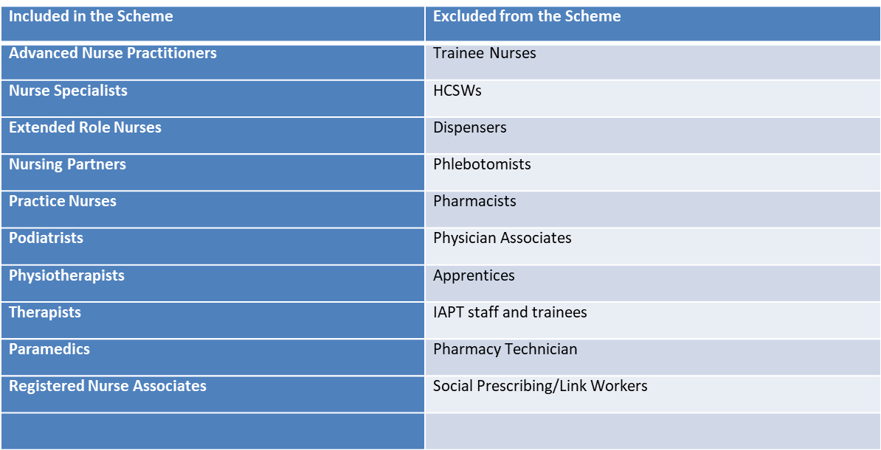

**Additional CPD allowance for HCA/Admin Staff**

**The Training Hub has made available £3000 per PCN specifically for the HCA and Admin teams.**

***This is separate to the main CPD allocation mentioned above so speak to your PCN CEF or MPL who can update you on how to claim.***

**This is now the 3rd and final year of this CPD allowance and funds are allocated to individuals, so if you have any questions regarding CPD, please contact** [**suganthy.arumugam@nhs.net**](mailto:suganthy.arumugam@nhs.net) **who will be able to assist you and offer any guidance on how to claim.**

**Tribute to the memory of Natalia Hearn**



Natalia sadly died on 21st February at Hospice in the Weald surrounded by her loving family.

Natalia worked at South Park Medical Practice for 20 years.  She was an incredibly fun person to work with and will be remembered for her professionalism, constant desire to help patients, laugh and enduring desire to vaccinate anyone who moved with the flu jab.  She was passionate about the job and supporting her peers and is a much-missed colleague and friend.

Natalia was also the Multi-Professional Lead for Sevenoaks PCN and worked with peers across West Kent to encourage and embed education and training. Natalia was dedicated to making a difference for both colleagues and patients, always showing kindness, empathy, and professionalism. Colleagues both within the PCN Multi-professional Team and West Kent Training Hub would also like to express the feeling of great loss of a friend and someone who made such a difference to peers, patients and families.

**Donations in memory of Natalia can be made to Hospice in the Weald.**

|  |
| --- |
|  |
| **Thank you and good luck…** |
|  |

**Karen Hardy** joined the operational group of the West Kent training hub in 2018, bringing a high-level programme and project view from a Kent & Medway Sustainability & Transformation Partnership (STP) perspective. Karen soon became the Programme Manager for the training hub, providing operational and managerial guidance on the projects and programmes of work undertaken by the training hub, ensuring they aligned with the funding workstreams provided by HEE and NHS England.

We are extremely grateful for the wealth of knowledge and experience Karen has brought to WKEN, not least around her expertise and extensive knowledge around Public Health and Workforce Planning, which we hope she will continue to support by way of the workforce tool, so watch this space as you may receive direct contact from Karen to support you in this important area within your practice.

Karen has been a key member of the WKEN family and is highly respected by us all. She has offered help, support and guidance to each of us whilst also offering funny anecdotes and stories that keep us all smiling. On behalf of WKEN, Karen has also been Line Manager to Caroline, plus to the Multi Professional Leads (MPLs) who have received an array of care and pastoral support for which we are also grateful.

Whilst this is not the last we will see of Karen, we felt it only right to say a fond farewell to her from the day to day training hub activity as she steps away to enjoy some well-earned time off, enabling plenty of time for her passion of following the cricket season.

On behalf of WKEN, we would like to thank Karen for her significant contribution to the Training Hub and look forward to hearing what is next for this kind, inspirational lady we are proud to call a friend.

***On behalf of the Multi Professional Leads (MPL) I would like to thank Kas for her hard work, enthusiasm and dedication to our group. She has been our advocate and rock through good times and bad. We will all miss her professional support but plan to maintain our friendships with her***.

**West Kent Nursing Associate Consortium**

Karen has been part of the West Kent Nursing Associate Consortium and contributed in the development of the trainees on the apprenticeship programme. As part of the work and contribution, Karen provided notable ideas and shared information with other colleagues during the consortium meetings. Karen provided regular updates about the trainees and placement planning for the apprentices employed within the training hub and was an advocate for the hub and voice of reasoning about some of the issues that were discussed. Karen and I worked very closely in the development of writing a brand new job description for a new role to support the registered nursing associates in the different organizations within the consortium within a short period of time. It was great working with Karen as she brought fresh ideas that was needed to ensure that community teams benefit from the role and the unique IT skills that helped me personally enabling the smooth running of putting the document together for the job panel interview which finally got approved after multiple attempts at submission.

Karen has truly inspired me in the way she lends her expertise and support to others within the consortium.

Toks Ojo, Lead Nurse for Education and Development, Professional Standards Team, Nursing and Quality Directorate

Maidstone and Tunbridge Wells NHS Trust