|  |
| --- |
|  |
| **Newsletter – February 2022** |  |

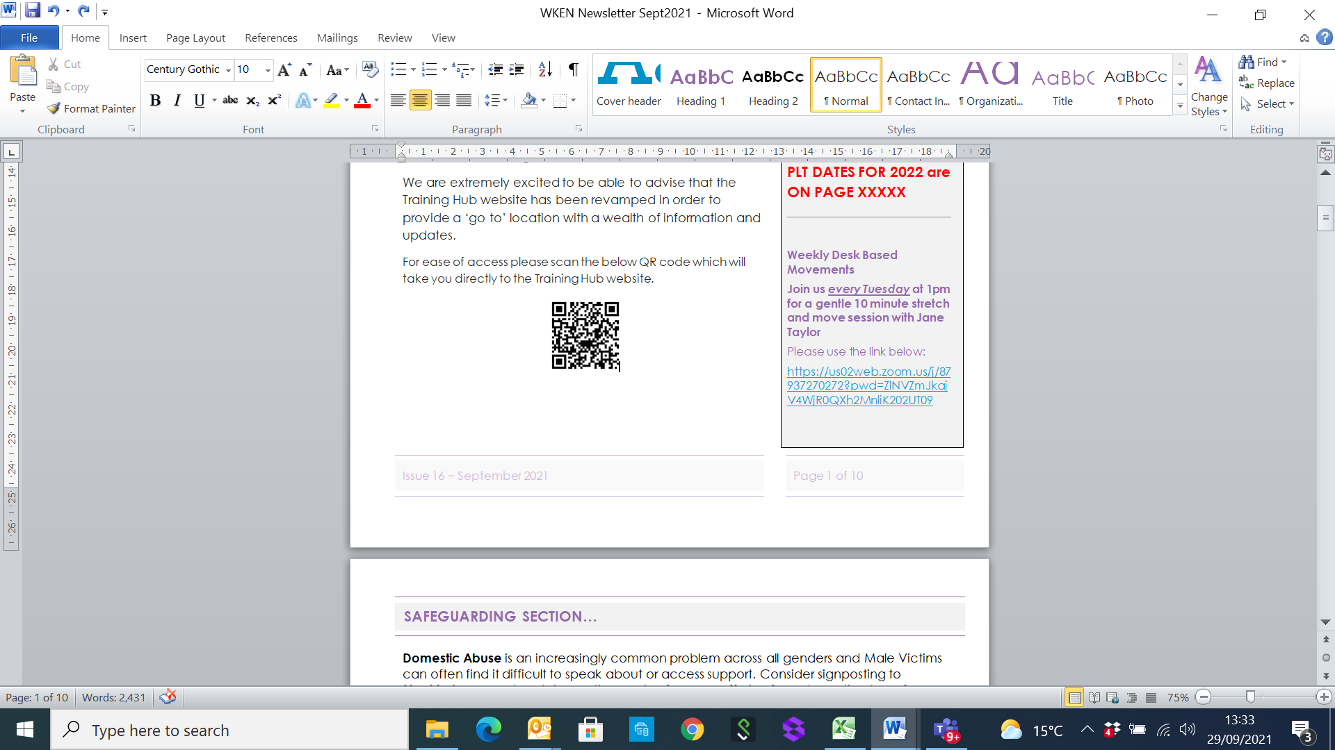**West Kent Training Hub**





**Deadline for Newsletter –** please send your items through by the **15th of the month** for inclusion in the next edition circulated at the end of the month.

**PLT DATES FOR 2022**





**FOR YOUR WELLBEING**

**Weekly Desk Based Movements**

**Join us *every Tuesday* at 1pm for a gentle 10 minute stretch and move session with Jane Taylor**

Please usethe link below:

<https://us02web.zoom.us/j/87937270272?pwd=ZlNVZmJkajV4WjR0QXh2MnliK202UT09>

[**www.westkenteducationnetwork.co.uk**](http://www.westkenteducationnetwork.co.uk)

**Email:** [**kmccg.wkentraininghub@nhs.net**](mailto:kmccg.wkentraininghub@nhs.net)

[Image result for twitter logo](https://www.bing.com/images/search?view=detailV2&ccid=CqXWN5l4&id=8B16F98F138AFC909C08261085B90A4D34866D39&thid=OIP.CqXWN5l4IM2LxlE-H0lHOAHaHa&mediaurl=https://img.talkandroid.com/uploads/2016/01/twitter-app-logo.png&exph=512&expw=512&q=twitter+logo&simid=607994475025467935&selectedIndex=0&qpvt=twitter+logo) **@westkentWKEN**

|  |
| --- |
|  |
| Dear Reader,  Welcome to the West Kent Training Hub (WKEN) Newsletter.  WKEN would like to thank all those who contribute to the content of this newsletter and ask that you please share this with your staff teams. There is an array of articles and opportunities open to all, so your help to share with your teams is very much appreciated.  ***We would love to hear from you and share your news***, so if you have suggestions for future items, including job vacancies, please send through to [**kmccg.wkentraininghub@nhs.net**](mailto:kmccg.wkentraininghub@nhs.net)  ***PLEASE NOTE: NEW JOBS SUPPLEMENT WILL BE SHARED SEPARATELY*** |
|  |

**Primary Care Training Hubs**

As you are almost certainly aware, across Kent and Medway are 3 locality training hubs supporting the Primary Care workforce in West, North and East Kent.

We are joining forces under the name of **Kent and Medway Primary Care Training Hub** and with a new logo, more communications will be sent out in due course, but in the interim and to ensure you receive relevant news, please click ‘**re-subscribe**’ in the below box to sign up to this combined newsletter:

[](https://forms.wix.com/46923212-ecea-4640-be80-941e6343ca7e:79c26855-8aa8-428c-9133-aa9749685b70)

***This******West Kent Newsletter and Job Supplement will continue to be produced and circulated in addition to the above***

|  |
| --- |
|  |
|  |
| **SAFEGUARDING SECTION…** |
|  |
|  |

|  |
| --- |
| **Supporting victims and survivors of sexual assault and abuse** |

|  |  |
| --- | --- |
| [Video providing more information about sexual assault referral centres](https://intouch.cmail19.com/t/d-l-auuukuy-jijjklljjr-yk/) | During Sexual Abuse and Sexual Violence Awareness week we [launched a campaign to raise awareness of our sexual assault referral centres (SARCs)](https://intouch.cmail19.com/t/d-l-auuukuy-jijjklljjr-yu/). These specialist services offer around the clock practical, medical and emotional support to anyone who has been raped, sexually assaulted or abused. Watch this [video](https://intouch.cmail19.com/t/d-l-auuukuy-jijjklljjr-jl/) or visit [nhs.uk/SARCs](https://intouch.cmail19.com/t/d-l-auuukuy-jijjklljjr-jr/) for more information and to find your nearest centre. We are here to help you.  <https://youtu.be/GuYtoVTioww> |

**Your local safeguarding contacts are below:**

**Kirsty Edgson, Designated Nurse for Safeguarding Children,** [k.edgson@nhs.net](mailto:k.edgson@nhs.net)

**Tracey Creaton. Designate Nurse for Adult Safeguarding.** [tracey.creaton@nhs.net](mailto:tracey.creaton@nhs.net)

**Safeguarding Children and Adults across Kent and Medway**

|  |  |  |
| --- | --- | --- |
| ***Compassion*** | ***Courage*** | ***Respect*** |

|  |
| --- |
|  |
| **Wellbeing** |
|  |

**DESK BASED MOVEMENTS - weekly 10 minute sessions**

We have received some great feedback from the weekly movement sessions so keep sending in your comments. Jane Taylor has kindly set up a specific ‘member area’ on her website so all the recordings are available and can be easily accessed.

<https://vimeopro.com/taylormadefitness/wken-weekly-work-based-movement-sessions>

It is password protected and I have used the password:WKEN-move-more

**In addition, Jane has kindly provided the below links which offer some additional recordings:**

* [*Additional recording (15 minutes)*](https://vimeo.com/643940864/1a38830e62) - segmental movements of the spine plus a lovely shoulder exercise!

Also, here is the link for the session last week (25/01/22) : <https://vimeo.com/669821863/531a70feaf>

**Join us every Tuesday at 1pm** - **we look forward to seeing you then:**

<https://us02web.zoom.us/j/87937270272?pwd=ZlNVZmJkajV4WjR0QXh2MnliK202UT09>

|  |
| --- |
|  |
| **Useful Resources…** |
|  |



**Paramedics supported with free e-learning modules**

Newly qualified and experienced paramedics can access bitesize e-learning sessions across a range of scenarios in the Paramedics e-learning programme. Developed by Health Education England e-learning for healthcare in partnership with the College of Paramedics, the programme is free to those with an NHS email address. There are 13 modules available, which aim to support those who are new to practice or those wishing to refresh their knowledge in certain areas.

These quick e-learning sessions can be accessed on a variety of devices and support continuing professional development. Read more and register for the e-learning programme by [visiting the Paramedics programme page](https://www.e-lfh.org.uk/programmes/paramedics/).



**Practice Assessor Course for Nursing**

* This is for practitioners who do not have a practice educator qualification, i.e. have not been a mentor. Please see <https://www.canterbury.ac.uk/medicine-health-and-social-care/continuing-professional-development/practice-assessor-courses.aspx>
* A 2 day course:

1 day of online e- modules

1 day virtual learning

Cost: £65 (CPD allowance can be used, please contact [suganthy.arumugam@nhs.net](mailto:suganthy.arumugam@nhs.net))

**Physiotherapy**

For Practice Educator course details, please see <https://www.canterbury.ac.uk/medicine-health-and-social-care/continuing-professional-development/practice-educators-physiotherapy.aspx>

**Continuous Professional Development: Multi professional**

Module Title & Code: Teaching in Practice Module (Facilitating Teaching, Learning and Assessment in Practice) (MSc Health Care Practice) Open to Multi professionals at level 7.

Module Title: Teaching in Practice (Facilitating teaching, learning and assessment in practice) Open to Multi professionals at level 7.

 

|  |
| --- |
|  |
|  |
| **Communities of Practice** |
|  |

**MAIDSTONE**

Facilitated by Dr Tony Jones, the following clinical communities of practice groups are available.

Email addresses are provided as the main contact for each group, but should you require further information or would like to discuss further, please contact [tony.jones@nhs.net](mailto:tony.jones@nhs.net)

Paramedics working in general practice - [ian.phillpott@nhs.net](mailto:ian.phillpott@nhs.net)

Clinical pharmacists in general practice - [elizabethwallis@nhs.net](mailto:elizabethwallis@nhs.net)

Advanced nurse practitioners in general practice - [vickiemehaffey@nhs.net](mailto:vickiemehaffey@nhs.net)

**TUNBRIDGE WELLS – and virtually to incorporate a wider area**

Facilitated by Dr Jane Roome,  both the New to West Kent (for GPs who are newly qualified, new to the area or new to role) and the West Kent Sessional GP group (for any GPs who are not a partner) have WhatsApp groups and are starting virtual meetings via Zoom. Traditionally these have been Tunbridge Wells based but given we're meeting virtually now please feel free to join and gain support and knowledge from other GPs in the area wherever your base may be. ​

Please contact [jane.roome@nhs.net](mailto:jane.roome@nhs.net) for more information and to join the groups.

|  |
| --- |
|  |
| **Dates for your diary…** |
|  |

***Educational Opportunities open for all Primary Care and interested staff***

​​​

*Thank you to everyone who has joined all the meetings over the last year and for all your comments and interaction which are all very much appreciated. The feedback is always really useful and I will be looking at acting on it for 2022.*

*In the meantime, we have a few meetings planned. Please see below for more information and to book a place on Eventbrite.*

*Dr Jane Roome*

*We look forward to seeing you at the PLT event on 3rd March.*

*Please see below for details of this and future events, including the links to register your place.*

|  |
| --- |
|  |
| **Dates for your diary…** |
|  |

**Greener Practices PLT, Thursday 3rd March 1.30-4.30pm on Zoom**

Please join us for this exciting opportunity to hear from national and local speakers on how we can work as individuals, practices, PCNs and within Kent and Medway CCG to build a Greener NHS together.

Greener healthcare aligns with better healthcare for everyone, by preventing ill health, empowering patients and reducing health inequalities and there is something that everyone can do whether you work in a clinical or non-clinical role.

Whilst this is the Protected Learning Time event for West Kent we welcome and encourage all colleagues to attend (clinical and non-clinical and whether working in primary, secondary, community care or any other healthcare remit) across the entire Kent and Medway CCG region so please share widely.

If you are interested in learning more about how we can work together to build a Greener NHS, please do join us.

**AGENDA**

**1.30-1.40pm:**Welcome and introduction Nicki Knight Lead Practice Nurse, The Mote Surgery, MPL for Maidstone South PCN and Jane Roome, GP tutor Tunbridge Wells, Deputy Chair, West Kent Education Network

**1.40-1.50pm**: Why do we need to do anything and what's it got to do with me? An overview. Stu Meades, Sustainability Lead KMCCG

**1.50-2.20pm**: Greener NHS in KMCCG: the case for Primary Care Leadership (includes 10 minutes Q and A) James Bates, Senior Project Manager and Simon Rollason, Senior Project Consultant, Greener NHS, NHS England and NHS Improvement, South East Region

**2.20- 2.50pm:** Planetary health and Primary care: why should I care and what can I do? Dr Aarti Bansal, GP and founder of Greener Practice, co-chair RCGP Climate emergency advisory group

**2.50-3.05pm:** Break

**3.05- 3.35pm:**The impact of inhalers on the carbon footprint and what practices and HCPs in primary care can do about it. Cath Cooksey, Lead Medicine Optimisation Pharmacist,KMCCG

**3.35-3.45pm:**Plant based diets for health and the environment Dr Ishani Rao, MTW GPST and Plant Based Health Professional

**3.45-4.00pm:** Local initiatives:

Gardening4health: Dr Richard Claxton, GP Warders Medical Centre, Tonbridge.

South East Nature Partnership: Dr Caroline Jessel, Chair South East Nature partnership

**4.00-4.20pm:**Q and A panel

**4.20-4.30pm**: Next steps and close Nicki Knight

**Registration needed and via the link below. Joining instructions will be sent out on the morning of the PLT**

<https://www.eventbrite.co.uk/x/greener-practice-plt-tickets-268549447627>

|  |
| --- |
|  |
| **Dates for your diary…** |
|  |

**Saturday 19th March 9am- 3pm. Paediatric emergencies in Primary Care simulation training, Education centre, level -2, Tunbridge Wells Hospital**

The Training Hubs are fully funding this simulation session around paediatric emergencies which can occur in primary care led by the West Kent Primary Care Simulation Team. We firmly believe that simulation gives a unique opportunity to learn compared to classroom style teaching so please do book a place to join us. Places are strictly limited and we will run a waiting list when the course is full.

Below are two of the comments on the feedback forms from attendees at our last session on the 27th November 2021:

*"Absolutely brilliant day that exceeded my expectations; usually, I hate role playing but at all times I felt supported and not judged"*

*"I was terrified of coming but this was the best course I have ever been on"*

<https://www.eventbrite.co.uk/e/paediatric-emergencies-in-primary-care-simulation-training-tickets-222561686997>

|  |  |
| --- | --- |
| [https://cdn.evbstatic.com/s3-build/280080-rc2021-12-01_16.04-ee3691e/django/images/logos/eb_orange_on_white_1200x630.png](https://www.eventbrite.co.uk/e/paediatric-emergencies-in-primary-care-simulation-training-tickets-222561686997) | [Paediatric emergencies in Primary Care simulation training](https://www.eventbrite.co.uk/e/paediatric-emergencies-in-primary-care-simulation-training-tickets-222561686997)  Paediatric emergencies in primary care simulation training  [www.eventbrite.co.uk](http://www.eventbrite.co.uk) |

**Managing frailty - making the best of frailty MDTs and updates to local services Thursday 17th March 7.30-9pm on Zoom**

Please join us for this opportunity to learn from the Frailty team about local services and pathways and how we can work together to enable the best possible care for patients with frailty.

Agenda and link to register on EventBrite below:

* West Kent Frailty service update - Proactive and reactive services and the plan for West Kent (15mins) Ginny Winstanley (GP and West Kent CCG Clinical lead for frailty), Owen Ingram (Consultant Geriatrician), Amy Heskett (Community Geriatrician and Clinical lead for West Kent Home Treatment Service)
* Frailty GPs - how can they help you? (10mins) - Deirdre McCauley (Frailty GP)
* Prescribing and frailty - what to stop and what to start (20mins) - Owen Ingram
* Treatment escalation planning - the role of RESPECT (20mins) - Amy Heskett
* KMCR- What is it and why should we use? Ginny Winstanley
* Q+A (10mins)

|  |
| --- |
|  |
| **Dates for your diary…** |
|  |

<https://www.eventbrite.co.uk/x/managing-frailty-making-the-best-of-frailty-mdts-and-updates-tickets-277354273097>

|  |  |
| --- | --- |
| [https://cdn.evbstatic.com/s3-build/280080-rc2021-12-01_16.04-ee3691e/django/images/logos/eb_orange_on_white_1200x630.png](https://www.eventbrite.co.uk/e/paediatric-emergencies-in-primary-care-simulation-training-tickets-222561686997) | Managing frailty - making the best of frailty MDTs and updates to local services  Paediatric emergencies in primary care simulation training  [www.eventbrite.co.uk](https://www.eventbrite.co.uk/x/managing-frailty-making-the-best-of-frailty-mdts-and-updates-tickets-277354273097) |

**Kent and Medway Virtual**

**Health Care Support Worker Conference**

**2 Half Days: 8th & 15th March 2022**

12.30pm-3pm

Please see below agendas for these events. Registration links for each are also included and we hope you can join us – do share with your HCA colleagues!



**Kent and Medway Primary Care Training Hub**

Your Training Hubs across Kent & Medway (West Kent, North Kent and East Kent) are grouping their synergies and their training offers throughout the county under the name of **Kent & Medway Primary Care Training Hub.**

There are still local-specific training opportunities and support available via your locality training hub **(WKEN)**.

***In addition*** ***to your West Kent locality newsletter***, a new newsletter for the KMPC Training Hub will be shared from January, with a new logo, a different look but still monthly information for your practice.

In order to receive this new publication, for data protection purposes you will need to [**Subscribe to KMPC Training Hub Newsletter**](https://forms.wix.com/46923212-ecea-4640-be80-941e6343ca7e:79c26855-8aa8-428c-9133-aa9749685b70)

|  |
| --- |
|  |
| **Items of Interest…** |
|  |

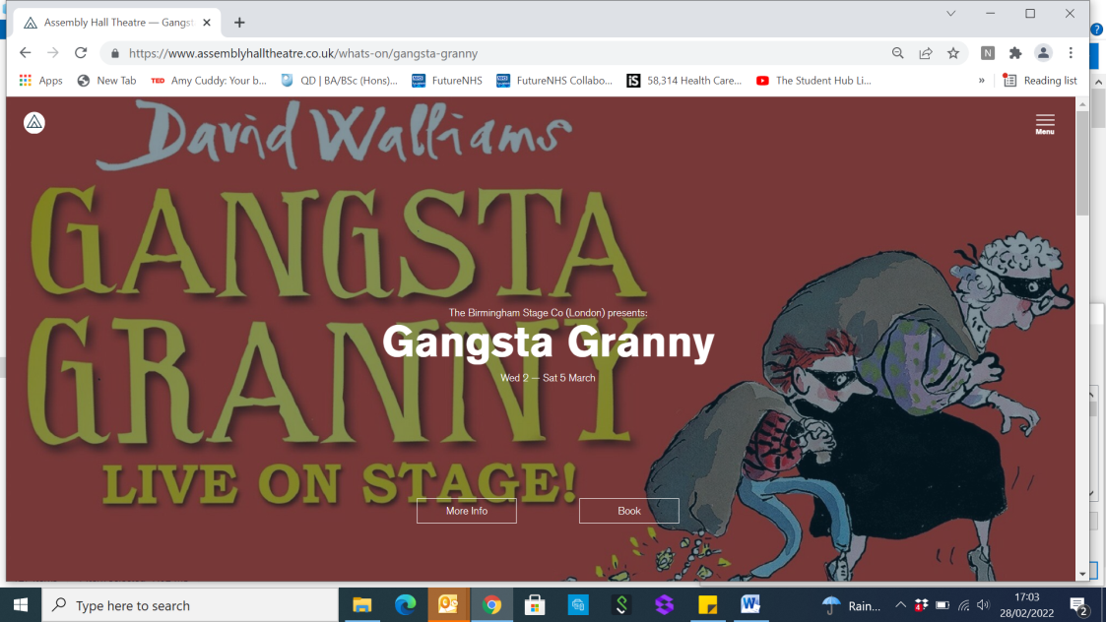**GANGSTA GRANNY- 40 complimentary tickets…**

Our friends at the Tunbridge Wells Assembly Hall have very kindly offered our WEST KENT colleagues 40 complimentary tickets for the 1.30pm performance of **Gangsta Granny on 3rd March**.

If you are interested in taking advantage of this generous offer, please use the following code when booking: **GANGSTA-NHS-FREE**

|  |
| --- |
|  |
| **Partners Pages** |
|  |



**Please see below for the latest list of courses available:**





|  |
| --- |
|  |
| **Exciting Opportunity…** |
|  |

**Workforce Planning Tool**

Most practices are feeling the pressure in Primary Care and challenges around recruitment and retention. Kent and Medway are encouraging Practices to use their workforce tool and are offering a payment of £500 per practice for completing the tool, which comes with many simple and practical steps to estimating current and future demand.

Benefits include:

* Planning your future workforce at practice / PCN level and having a costed plan
* Identify where there are learners in the system and increase placements
* Identify training needs for the future (For example if we need more ACPs/ Paramedic practitioners)
* Having a workforce plan will help with Estates Strategy when making applications to the CCG as additional workforce requirements and estates are critically linked

The embedded flyer will provide more detail and should you require support from the Training Hub this can be obtained by contacting: [kmccg.wkentraininghub@nhs.net](mailto:kmccg.wkentraininghub@nhs.net)



**Celebrating Advanced Clinical Practice across Kent & Medway**

**18th March 2022 from 10am to 4pm**

**Ashford International Hotel – TN24 8LU**

**Topics include:**

Multi-professional approach to Advance Clinical Practice in Secondary and Primary Care

Independent Prescribing

Manage Your Mind

Celebration Award Ceremony



|  |
| --- |
|  |
| **Exciting Opportunity…** |
|  |

**Thinking of becoming a Practice Assessor for Student Nurses or Trainee Nurse Associates?**

***In addition to paying course fees, West Kent Training Hub is offering salary support to undertake Practice Assessor and Clinical Supervisor Training as follows:***

£300 education grant for 2 day course (Practice Assessor, previously known as Mentors)

£75 education grant for ½ day course (Clinical Supervisors)

To attend this Practice Assessor’s Study Day, delegates are encouraged in their favour to complete the below online Pan London Practice Learning Group E-Learning Modules. Evidence of completion, such as a screenshot or printed E-Certificate, of the 7 EVOLVE Modules by PAN London Practice Learning Group should be sent to: [health.yourbooking@canterbury.ac.uk](mailto:health.yourbooking@canterbury.ac.uk).

* Understanding of the new NMC Standards for Nursing and Midwifery Education (May 2018)
* Understanding of the new roles and responsibilities (practice supervisor; practice assessor and academic assessor)
* Understand the student assessment process and associated documentation
* Giving appropriate feedback
* Effectively managing underperformance

Should you wish to take advantage of this offer please contact: [**Suganthy.Arumugam@nhs.net**](mailto:Suganthy.Arumugam@nhs.net)or for further information on course content please contact: [**philly.adams@nhs.net**](mailto:philly.adams@nhs.net)

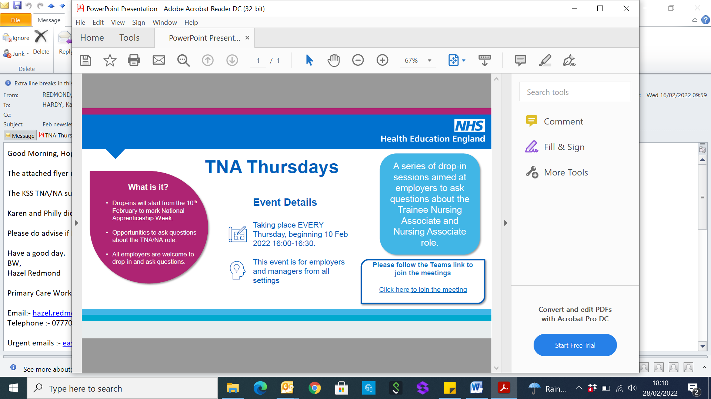

**TNA Thursdays…**

An exciting programme of drop-in sessions aimed at employers to ask questions about the Trainee Nursing Associate and Nursing Associate role.

Please see the attached flyer regarding the TNA drop in Thursdays with HEE. The KSS TNA/NA support sessions being held in March and April are also being promoted via our social media channels but please share with any colleagues you feel may be intereted.



|  |
| --- |
|  |
| **Exciting Opportunity…** |
|  |



**FCP roadmap supervisor training**

A new video that offers voluntary top up training to GPs who have already trained as educational supervisors is now available on Health Education England's e-learning for healthcare Hub. This e-learning offer has now replaced the previous virtual ES top-op training offered by KSS Primary Care School.  
  
The resource provides an overview of the differences between a first contact practitioner and an advanced practitioner and explains what masters level practice is and how this is evidenced in a portfolio.  
  
The video also provides additional information for GP trainers to understand how best to support allied health professionals moving into primary care at master's level of practice.  
After viewing the video, learners will:  
* be able to understand masters level practice  
* gain understanding of allied health professionals' offer to primary care and their specific roadmap  
* gain understanding of the background of the educational roadmaps and the advanced practice agenda  
  
For more information and to access the video, please visit the <https://www.e-lfh.org.uk/programmes/top-up-training-video-for-gp-educational-supervisors/>  
  
*Any accredited Educational Supervisor (GP Trainer) can access the resource to enable FCP supervision.*

Please contact your local training hub if you require any further information.

**CRN Primary Care learning event, Wednesday 9th & Thursday 10th March**Do you work in Primary Care and do you want to learn more about how to get involved in Primary Care Research? Do you work in Secondary Care and want to learn more about how you can get involved in research taking place in Primary Care settings?  
Across the two days there will be talks and interactive discussions on four topics:

* Primary Care Strategy Background and Overview
* Operational Considerations of Primary Care Research
* What the UPH Response has taught us for future Primary care research
* Building a community of primary care researchers

Each topic will be covered in short two-hour modules to maximise flexibility and you can join a single module, any mixture of modules, or up to all four if you prefer. Times will be confirmed shortly, but please hold the dates in your diary and watch out for more details over the coming weeks.  
  
Please note that this event is not targeted at colleagues who work day-to-day in primary care research, but they are welcome to attend to help to share their experiences.  
  
Please use this [form](https://nihr.us8.list-manage.com/track/click?u=8ca9df18d7c0930e4587b3d1d&id=1d2d058294&e=72aecd7ea6) to express your interest in attending the event.

|  |
| --- |
|  |
| **Don’t forget your CPD…** |
|  |

**WHAT IS CPD?**

* **Allocated funding from NHS England for all registered clinicians (except Pharmacists) working for a GP practice**
* **£333 per year (2020 – 2023)**
* **To spend on identified Continuing Professional Development**

**Who is eligible?**

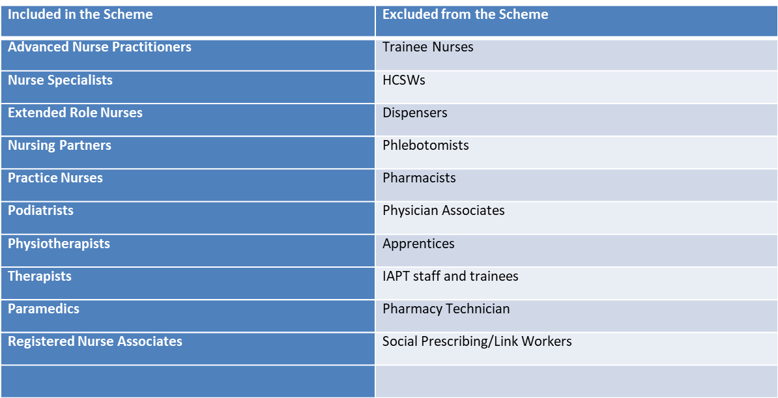

**Additional CPD allowance for HCA/Admin Staff**

**The Training Hub has made available £3000 per PCN specifically for the HCA and Admin teams.**

**This *is separate to the main CPD allocation mentioned above*.**

**We are approaching the 3rd and final year of this CPD allowance and unless funds are allocated they will be lost!**

**If you have any questions regarding CPD, please contact** [**suganthy.arumugam@nhs.net**](mailto:suganthy.arumugam@nhs.net) **who will be able to assist you and offer any guidance on how to claim.**