|  |
| --- |
|  |
| **Newsletter – September 2021** |  |

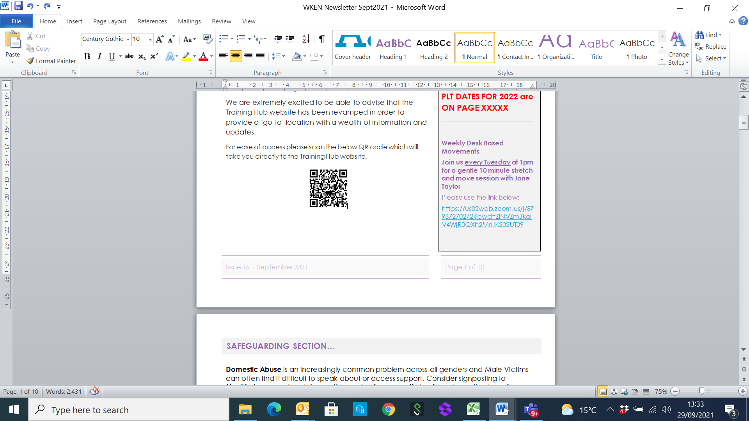**West Kent Training Hub**





**Dates for your Diary:**

**Deadline for Newsletter –** please send your items through by the **24th** of the month.

**PLT DATES FOR 2021**

**19th Oct TRAINING HUB**

**10th Nov PCN**

**PLT DATES FOR 2022**

These have been agreed and will be emailed out to practices and shared with all on the distribution list

**Weekly Desk Based Movements**

**Join us *every Tuesday* at 1pm for a gentle 10 minute stretch and move session with Jane Taylor**

Please usethe link below:

<https://us02web.zoom.us/j/87937270272?pwd=ZlNVZmJkajV4WjR0QXh2MnliK202UT09>

[**www.westkenteducationnetwork.co.uk**](http://www.westkenteducationnetwork.co.uk)

**Email:** [**kmccg.wkentraininghub@nhs.net**](mailto:kmccg.wkentraininghub@nhs.net)

[Image result for twitter logo](https://www.bing.com/images/search?view=detailV2&ccid=CqXWN5l4&id=8B16F98F138AFC909C08261085B90A4D34866D39&thid=OIP.CqXWN5l4IM2LxlE-H0lHOAHaHa&mediaurl=https://img.talkandroid.com/uploads/2016/01/twitter-app-logo.png&exph=512&expw=512&q=twitter+logo&simid=607994475025467935&selectedIndex=0&qpvt=twitter+logo) **@westkentWKEN**

|  |
| --- |
|  |
| Dear Reader,  Welcome to the West Kent Education Network Newsletter.  WKEN would like to thank all those who contribute to the content of this newsletter and ask that you please share this with your staff teams as there is an array of articles and opportunities open to all, so your help to share with your teams is very much appreciated.  We would love to hear from you and share your news, so if you have suggestions for future items, including job vacancies, please send through to [kmccg.wkentraininghub@nhs.net](mailto:kmccg.wkentraininghub@nhs.net) |
|  |

**PROTECTED LEARNING TIME (PLT)**

Discussions with CCG & IC24 are ongoing with a view to finding a solution for switching the phones through on PLT afternoons from January 2022.

I have spoken to GP education leads for each of the PCNs & the word coming back from those practices who did use their phone message to state that the practice was closed for education with a safety net for those whose problems were clinically urgent, was that **‘’it wasn’t too bad’’**

The average practice seems to have 6-10 patient contacts with maybe one who needed forwarding to IC24

IC24 report that the afternoon was quieter than normal for them which they thought was down to practice triage being less risk averse that the usual NHS111 service (I realize there could be alternative explanations).

I would encourage practices to attempt closure where they can for the network & PCN PLT events between now & the New Year.

***Tony Jones on behalf of WKEN***

|  |
| --- |
|  |
|  |
| **SAFEGUARDING SECTION…** |
|  |
|  |

**Domestic Abuse** is an increasingly common problem across all genders and Male Victims can often find it difficult to speak about or access support. Consider signposting to **Mankind** a support and signposting service for men suffering from domestic abuse from their current or former wife, partner (including same-sex partner) or husband. The helpline is a listening service which provides emotional support, practical information and signposting. 01823 334244 or <https://www.mankind.org.uk/>

A training programme is also on offer for victims.

**Suicide and Safeguarding Adult Reviews**

There are a number of reviews where tragically the individual died by suicide and therefore it is important that those who are experiencing these feelings are easily able to access the right support.

**Release the Pressure** provides free 24/7 expert advice from trained counsellors for mental health concerns. Signpost to <https://www.kent.gov.uk/social-care-and-health/health/release-the-pressure>

Or text the word ‘Kent’ to 85258; phone 0800 107 0160 - support can be provided to those who are struggling and need someone to talk to.

**Other Resources**[**https://www.kentyouthhealth.nhs.uk/topic/feeling-lonely/**](https://www.kentyouthhealth.nhs.uk/topic/feeling-lonely/)

[**https://www.porchlight.org.uk/information-support/connect-with-your-community-combating-loneliness-and-isolation**](https://www.porchlight.org.uk/information-support/connect-with-your-community-combating-loneliness-and-isolation)

[**https://www.medway.gov.uk/info/200231/mental_wellbeing/443/connect_with_your_community/2**](https://www.medway.gov.uk/info/200231/mental_wellbeing/443/connect_with_your_community/2)

**Training**

The autumn programme for the KMSAB multi-agency safeguarding adults training with five workshop topics is now available. For information on the courses and how you can book a place, please visit the [KMSAB website](https://kmsab.us6.list-manage.com/track/click?u=7502249434cba4e893d217bcf&id=3b9b3c2ae6&e=cb38249559)

**Dr Reshma Rajagopal**

**NHS CCG Kent and Medway Named GP for Safeguarding Children and Adults (West Kent)**



|  |
| --- |
|  |
| **Wellbeing** |
|  |

**DESK BASED MOVEMENTS - weekly 10 minute sessions**

We have received some great feedback from the weekly movement sessions so keep sending in your comments. Jane Taylor has kindly set up a specific ‘member area’ on her website so all the recordings are available and can be easily accessed.

* <https://vimeopro.com/taylormadefitness/wken-weekly-work-based-movement-sessions>

It is password protected and I have used the password:WKEN-move-more

**Join us every Tuesday at 1pm** - **we look forward to seeing you then:**

<https://us02web.zoom.us/j/87937270272?pwd=ZlNVZmJkajV4WjR0QXh2MnliK202UT09>

|  |
| --- |
|  |
|  |
| **Communities of Practice** |
|  |

**MAIDSTONE**

Facilitated by Dr Tony Jones, the following clinical communities of practice groups are available.

Email addresses are provided as the main contact for each group, but should you require further information or would like to discuss further, please contact [tony.jones@nhs.net](mailto:tony.jones@nhs.net)

Paramedics working in general practice - [ian.phillpott@nhs.net](mailto:ian.phillpott@nhs.net)

Clinical pharmacists in general practice - [elizabethwallis@nhs.net](mailto:elizabethwallis@nhs.net)

Advanced nurse practitioners in general practice - [vickiemehaffey@nhs.net](mailto:vickiemehaffey@nhs.net)

**TUNBRIDGE WELLS – and virtually to incorporate a wider area**

Facilitated by Dr Jane Roome,  both the New to West Kent (for GPs who are newly qualified, new to the area or new to role) and the West Kent Sessional GP group (for any GPs who are not a partner) have WhatsApp groups and are starting virtual meetings via Zoom. Traditionally these have been Tunbridge Wells based but given we're meeting virtually now please feel free to join and gain support and knowledge from other GPs in the area wherever your base may be. ​

Please contact [jane.roome@nhs.net](mailto:jane.roome@nhs.net) for more information and to join the groups.

|  |
| --- |
|  |
| **Dates for your diary…** |
|  |

***Educational Opportunities open for all Primary Care and interested staff***

​​​**Evening meetings for the rest of 2021 on Zoom, open to all in Primary Care. Please sign up using the links below.**

Here are the meetings planned for the rest of the year.

The links will be sent out the evening before the meeting so please sign up before 6pm on the day before to ensure you receive the information.

I am currently looking at plans for 2022 so if you have any topics or comments about areas you would like covered, then email me directly [jane.roome@nhs.net](mailto:jane.roome@nhs.net), thank you!

|  |
| --- |
|  |
| **Dates for your diary…** |
|  |

**Wednesday 6th October 7.30-9pm. Dr Reshma Rajagopal, Named GP for Safeguarding, Adults and Children (West Kent)**

***This event is now FULL and we are operating a waiting list. If you have signed up and can no longer attend then please either cancel your registration or email*** [***jane.roome@nhs.net***](mailto:jane.roome@nhs.net)***, thank you. Places will be released as they become available so, please do add your name to the waiting list if you'd like to attend and we will try and accommodate you.***

Learning from Safeguarding reviews: there will be opportunity to discuss anonymised cases in virtual break- out rooms and plenty of time for questions.

Certificates of attendance will be issued to those attending and will count as 1 hour Adult and 1 hour Child Safeguarding level 3 participatory hours.

<https://www.eventbrite.co.uk/e/167551690617>

|  |  |
| --- | --- |
| [https://cdn.evbstatic.com/s3-build/148050-rc2021-08-19_16.04-824fea2/django/images/logos/eb_orange_on_white_1200x630.png](https://www.eventbrite.co.uk/e/167551690617) | [Learning from Safeguarding reviews](https://www.eventbrite.co.uk/e/167551690617)  Learning from Safeguarding reviews  [www.eventbrite.co.uk](http://www.eventbrite.co.uk) |

**Resuscitation in Primary Care, to include Adult, Paediatric and Maternal BLS, choking, use of an AED and anaphylaxis. Thursday 14th October 7.30-9pm on Zoom with Steve Rochester**

Steve Rochester, Resuscitation Council ALS and EPALS instructor has kindly agreed to deliver another session after his very popular training events earlier in the year

A Certificate will be issued to all who register and attend the event. Please ensure your Zoom name corresponds with the name you would like on your certificate and that you register with.

Training will reflect the changes to the Resuscitation Council guidelines in light of the coronavirus pandemic.

A link to join the meeting will be sent out by 8pm on 13/10/21.

Please sign up using the link below.

<https://www.eventbrite.co.uk/e/resuscitation-in-primary-care-training-tickets-174047539877>

|  |  |
| --- | --- |
| [https://cdn.evbstatic.com/s3-build/180651-rc2021-09-16_16.04-6d72a2d/django/images/logos/eb_orange_on_white_1200x630.png](https://www.eventbrite.co.uk/e/resuscitation-in-primary-care-training-tickets-174047539877) | [Resuscitation in Primary Care training](https://www.eventbrite.co.uk/e/resuscitation-in-primary-care-training-tickets-174047539877)  Resuscitation in Primary Care, to include Adult, Paediatric and Maternal BLS, choking, use of an AED and anaphylaxis.  [www.eventbrite.co.uk](http://www.eventbrite.co.uk) |

|  |
| --- |
|  |
| **Dates for your diary…** |
|  |

**Thursday 11th November 7.30-9pm. Management of hyperlidaemia. Dr Supriya Joshi, Consultant Biochemist MTW NHS Hospital trust**

Dr Joshi has kindly agreed to talk about management of people with hyperlipidaemia.

|  |  |
| --- | --- |
| [https://cdn.evbstatic.com/s3-build/148050-rc2021-08-19_16.04-824fea2/django/images/logos/eb_orange_on_white_1200x630.png](https://www.eventbrite.co.uk/e/167744840333) | [Management of hyperlipidaemia](https://www.eventbrite.co.uk/e/167744840333)  Management of hyperlipidaemia  <https://www.eventbrite.co.uk/e/167744840333> |

**Wednesday 24th November 7.30-9pm. Obesity: the science, the myths and how we can make a difference in Primary Care. Dr Stephanie de Giorgio GP with expertise in Obesity management.**

Dr de Giorgio is a Kent GP with expertise in obesity management and has written the recent e-modules on management of patients with obesity for the RCGP. She will talk to us about how we can get better at managing patients who are overweight and obese, focusing on the areas below with plenty of time for your questions.

1. Dispelling the myths

2. The science of obesity and overweight

3. Weight stigma in medical care and what we need to learn.

4. What interventions actually make a difference?

5. What you can practically do in primary care and where to send patients to.

|  |  |
| --- | --- |
| [https://cdn.evbstatic.com/s3-build/148050-rc2021-08-19_16.04-824fea2/django/images/logos/eb_orange_on_white_1200x630.png](https://www.eventbrite.co.uk/e/167466953165) | [Obesity: the science, the myths and how we can make a difference](https://www.eventbrite.co.uk/e/167466953165)  The science, the myths and how we can make a difference in Primary Care  <https://www.eventbrite.co.uk/e/167466953165> |

**Thursday 2nd December 19.30-21.00. Diagnosis and management of polymyalgia rheumatica in Primary Care**

Dr Amit Saha, Consultant Rheumatologist, Maidstone and Tunbridge Wells NHS Trust

|  |  |
| --- | --- |
| [https://cdn.evbstatic.com/s3-build/201717-rc2021-09-28_16.04-bd32316/django/images/logos/eb_orange_on_white_1200x630.png](https://www.eventbrite.co.uk/e/diagnosis-and-management-of-polymyalgia-rheumatica-in-primary-care-tickets-181102060137) | [Diagnosis and management of Polymyalgia Rheumatica in Primary Care](https://www.eventbrite.co.uk/e/diagnosis-and-management-of-polymyalgia-rheumatica-in-primary-care-tickets-181102060137)  Diagnosis and management of Polymyalgia Rheumatica in Primary Care  <https://www.eventbrite.co.uk/e/diagnosis-and-management-of-polymyalgia-rheumatica-in-primary-care-tickets-181102060137> |

|  |
| --- |
|  |
| **Dates for your diary…** |
|  |

**Greener Practices meeting: What can we do in our own practices to make a difference? Dr Honey Smith, Chair Greener Practice Group. Thursday 21st October 7.30-9pm on Zoom**

*Please join us for this free event run by the SE Thames RCGP Faculty and open to all in Primary Care whatever your role. You do not need to be an RCGP member.*

Dr Honey Smith is a GP in Sheffield and chair of Greener Practice South Yorkshire. Greener Practice was founded in 2017 by Dr Aarti Bansal, as a hub for decarbonisation and sustainability in primary care. Honey was involved right from the start, and helped prepare the successful motion calling for the RCGP to declare a climate emergency. Greener Practice has now grown from a small group of South Yorkshire primary care professionals to an email network of 270 people, 12 local groups around the country (and more under consideration) and active, thriving national whatsapp groups to coordinate sustainability improvements in Primary Care. Honey currently chairs the national representatives' Greener Practice group. Honey also runs projects with Sheffield medical school to increase climate change awareness and sustainability teaching in the curriculum.

Webinar Chair: Dr Jane Roome - GP Tutor and Education Lead, South East Thames Faculty

To join please register on the link below

<https://rcgpportal.force.com/s/lt-event?id=a1U1i000005ooZNEAY&site=a0d0Y00000AeOP6QAN>

**Long Covid Education Event**

You may be aware that there is an obligation for practices to have accessed a ‘Long-Covid’ educational event as part of the DES arrangements in the current year. The below event is aimed at updating you with respect to the West Kent led Post Covid Assessment Service (PCAS), it’s experience to date together with specialist input as to their experience of managing long Covid patients in the West Kent locality.

The Training Hubs in East, North and West Kent with colleagues from Kent and Medway CCG have been working together to deliver two webinars on the management of patients with Long Covid. The two sessions are complimentary and with some intentional overlap to allow HCPs across the Kent and Medway area to choose the session most convenient to them and are open to anyone interested who would like to attend.

**For more information and to register please use the Event Brite links below:**

Tuesday 5th October; 7-8.45pm

<https://www.eventbrite.co.uk/e/best-practice-forum-long-covid-in-practice-tickets-169283783353>

Wednesday 13th October 7.30-9pm

<https://www.eventbrite.co.uk/e/managing-long-covid-in-primary-care-tickets-170170106369>

|  |
| --- |
|  |
| **Dates for your diary…** |
|  |

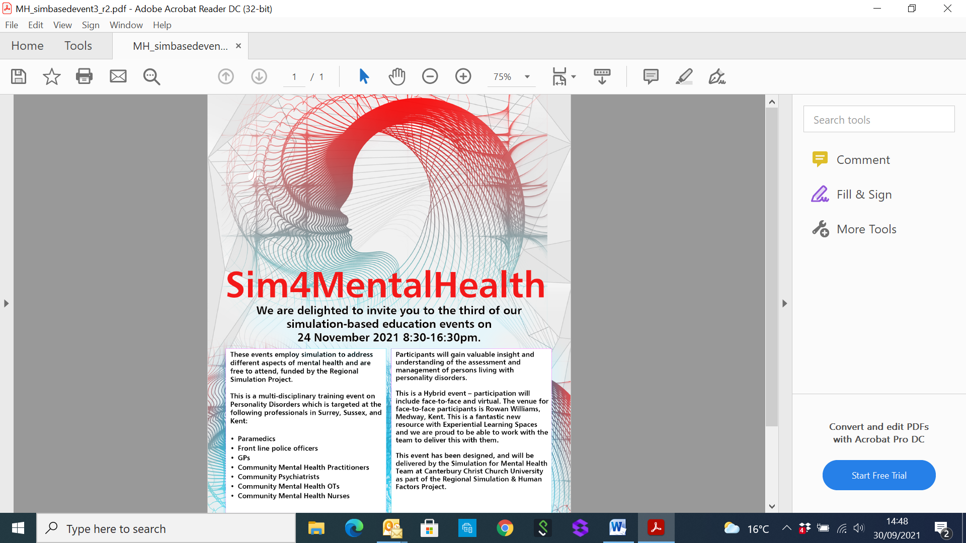

**To book your ticket please visit Eventbrite using the below link.**

[**https://www.eventbrite.com/e/personality-disorders-simulation-day-tickets-172789296437**](https://www.eventbrite.com/e/personality-disorders-simulation-day-tickets-172789296437)

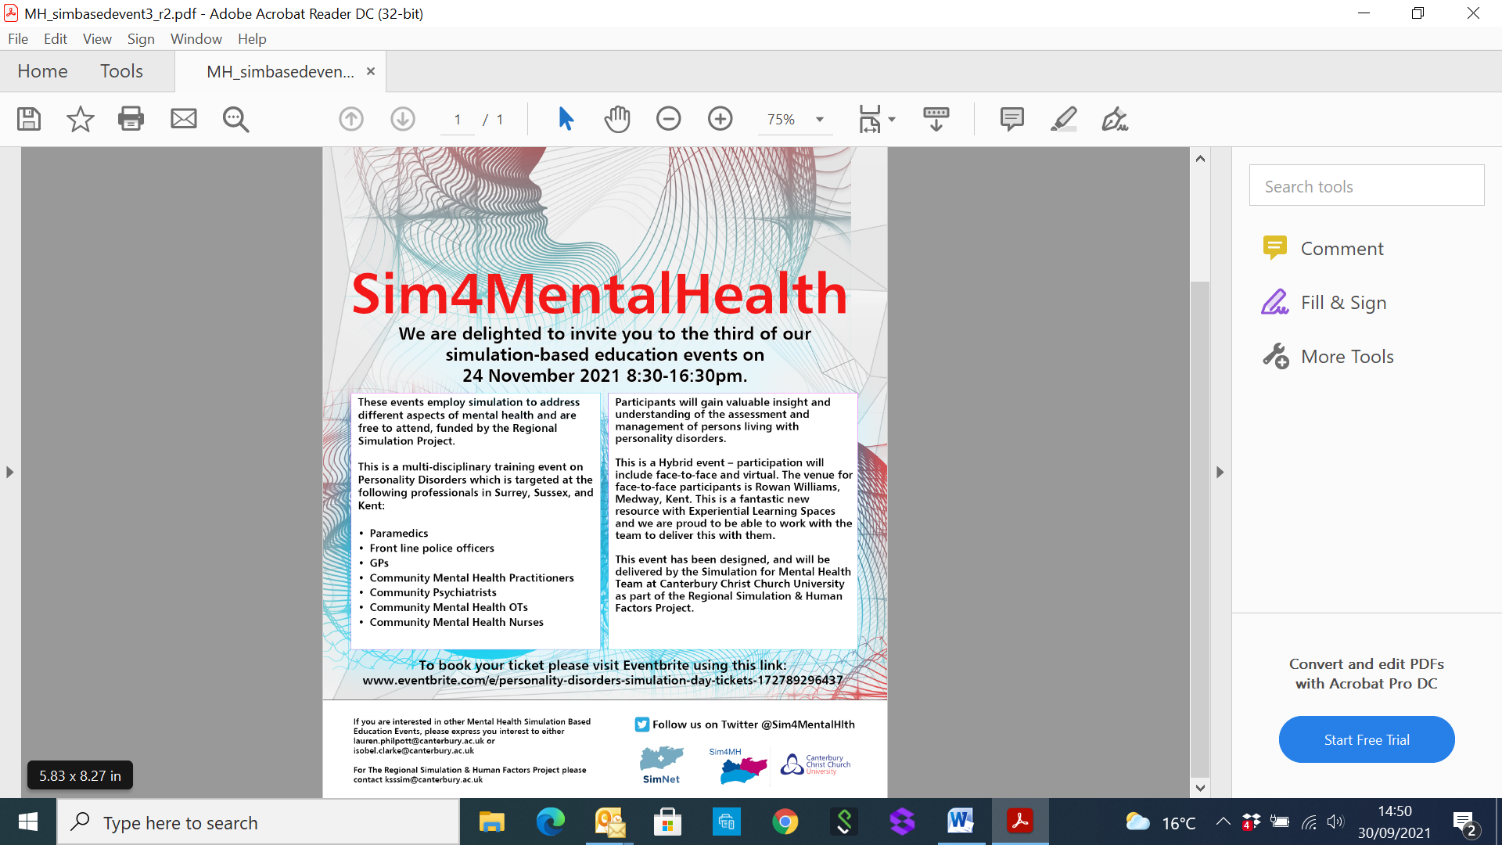

|  |
| --- |
|  |
| **Dates for your diary…** |
|  |

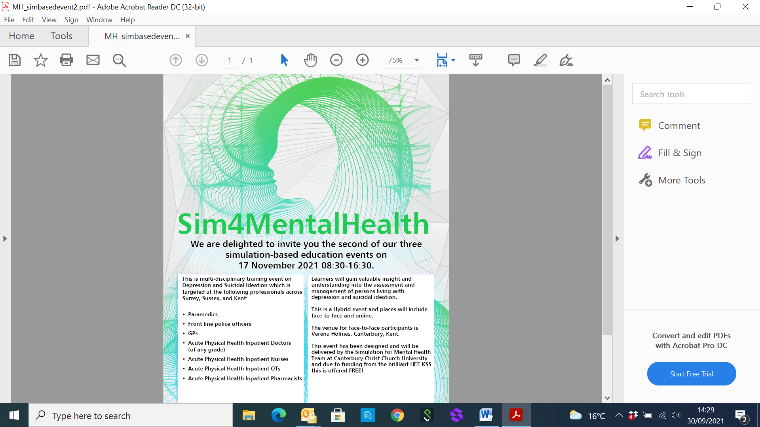

**TO REGISTER PLEASE CLICK ON LINK:**

[**https://www.eventbrite.com/e/depression-simulation-day-tickets-170130445743**](https://www.eventbrite.com/e/depression-simulation-day-tickets-170130445743)

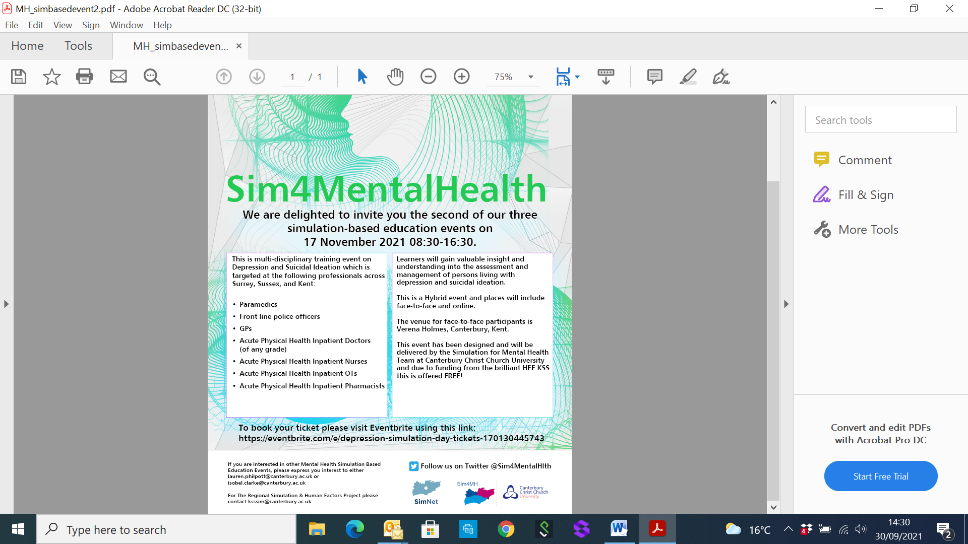

|  |
| --- |
|  |
| **Exciting Opportunities…** |
|  |
|  |

### Environmental Sustainability & Climate Action

**Gardening4Health – A Directory of Social and Therapeutic Horticulture**  
Dr Richard Claxton [**https://gardening4health.co.uk/**](https://gardening4health.co.uk/)

Dr Richard Claxton, a GP at Warders Medical Centre in Tonbridge has been shortlisted for a BMJ award in the above category. We would like to wish him luck with his nomination.

*‘As a GP, and keen gardener, I have long been aware of the benefits of gardening and horticulture for my own well-being, but more importantly for that of my patients.*

*Successive lockdowns have seen widespread recognition of how gardening can improve well-being. Moreover, there has been a proliferation in recent years of organisations providing Social and Therapeutic Horticulture (STH).*

*People living with mental health problems, physical health problems, sensory impairments, learning disabilities, and a range of other challenges, including loneliness and isolation, struggle to access the help, support and camaraderie that these organisations provide, organisations which also hugely benefit those who work for them - often sharing their time and expertise voluntarily.*

*Crucially, however, I didn’t know what was available in my area, neither did my patients, nor indeed my social prescribing colleagues. Although I'd encounter organisations by chance, perhaps visiting a garden, or through social media, there was no central, national resource, signposting them for prescribers, service users, or even potential volunteers.*

***Gardening4health*** *- an online directory is my response to this, connecting people with their local schemes. I’m delighted to see the register being discussed at conferences, and in the GP and Horticultural press. In just nine months it’s attracted 5000 visitors; now getting 50 hits daily and I’ve added 412 different therapeutic gardens/organisations. The list is growing all the time.*

*I’m thrilled with this shortlisting, partly as a recognition of my work, but also as an opportunity to highlight the benefits of STH, and, of course, to publicise the directory even further.’*



**Physician Associate Apprenticeship – Employer Engagement Webinar – 28th October 2021, 12pm – 2pm**

Health Education England are supporting a collaborative, national implementation of the Physician Associate Apprenticeship to ensure apprenticeship provision meets the needs of all employers and potential apprentices.  This webinar is suitable for employers who are considering implementing the Physician Associate Apprenticeship within their organisation and would like information around practical steps and actions needed to ensure effective implementation.   
**This webinar will cover:**

* Apprenticeships and Workforce Development
* The Physician Associate Role
* The Physician Associate Apprenticeship
* The National Physician Associate Apprenticeship procurement and implementation plan
* Action / commitment for future implementation of the apprenticeships and next steps  
  Please use [this link](https://forms.office.com/Pages/ResponsePage.aspx?id=K5Gn_5ewMUGcD9DoB1Wyq8XvZqI1auVFoYsadk171uZUQU5XQVNRRVdCNVEyREczOEdSTEgySTQyQS4u) to book your place. Please note, bookings will close at 12pm on Wednesday 27th October.

A link to the session will be emailed to you on **27th October** – please hold the date and time of the webinar in your diary.

Primary and Integrated CareProgramme - [physicianassociates@hee.nhs.uk](mailto:physicianassociates@hee.nhs.uk)

|  |
| --- |
|  |
| **Partners Pages** |
|  |





**How to book:** Please login to your Invicta Health Learning account [http://invictahealth.learningpool.com](https://invictahealth.learningpool.com/course/view.php?id=452) to book a place or email [learning@invictahealth.co.uk](mailto:learning@invictahealth.co.uk) for more information!

|  |
| --- |
|  |
| **Partners Pages** |
|  |

**Did you know from 11 November 2021 anyone entering a care home has to be provide evidence that they have been double vaccinated?**

Parliament has approved the new [Health and Social Care Act 2008 (Regulated Activities) (Amendment) (Coronavirus) Regulations 2021 (Regulations)](https://www.legislation.gov.uk/uksi/2021/891/introduction/made) which mean that care home provider must ensure that nobody enters care homes without being double vaccinated. This means ***any health professional that enters a care home must provide evidence to the registered manager of the home that they have been double vaccinated*** (unless they have an exemption or there is an emergency). The Care Quality Commission will be monitoring that the Registered Manager comply with the Regulations (more details of CQC’s role can be found [here.)](https://www.cqc.org.uk/news/stories/statement-covid-19-vaccination-people-workingdeployed-care-homes-role-care-quality) More details guidance for visiting professionals can be found [here](https://www.gov.uk/government/publications/vaccination-of-people-working-or-deployed-in-care-homes-operational-guidance/coronavirus-covid-19-vaccination-of-people-working-or-deployed-in-care-homes-operational-guidance#guidance-for-visiting-professionals)

***Pia Rathje-Burton, Locality Manager (London and South East)*** *Contact: 07815 429173*

|  |
| --- |
|  |
| **Exciting Multi Professional Opportunity…** |
|  |

**The Kent & Medway Primary Care ICS Transformation Programme**

Across Health and Social Care new pathways have been developed, new ways of working established, leaders have stepped up, some without formal titles, and others without formal training. How can we ensure we bring our people with us, and catch up those who we’ve left behind?

A hybrid part virtual / part in-person future beckons, but what are the rules of engagement and how can we impart that knowledge in a VUCA (Volatile, Uncertain Complex & Ambiguous) environment?

This programme attempts to model the hybrid future bringing together the 3 pillars of:

Leadership, Digital & Innovation and Quality Improvement.

We will have the conversations that no one is having; pull apart the things that people believe are too difficult to pull apart and we will inspire our delegates to make a real difference to person centred care, enabled by digital.

***Applicants must:***

• *work within primary care, either clinical or non-clinical, in Kent & Medway. Applicants* ***do not*** *have to have a formal leadership title.*

• *sign a learning agreement to commit to the full programme as places are limited and we wish to maximise our places for our people.*

**Full details can be found in the pdf document below, including contact email for expressions of interest:**



|  |
| --- |
|  |
| **Items of Interest…** |
|  |

**Marden Medical Centre - Bear Grylls Activity Day**

As promised, Marden Medical Centre have kindly shared the photographs from their recent activity day, provided from the wellbeing funds the practice received.

‘We threw axes, lit fires, learnt how to tie knots, built a stretcher to transport our casualty and even ate some rather gruesome wildlife! It was a great team building activity and great fun.’

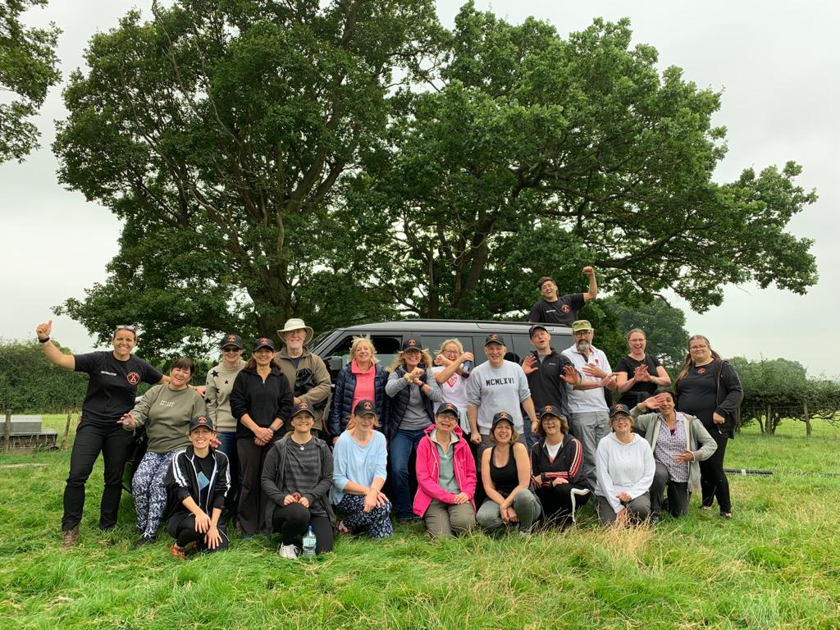

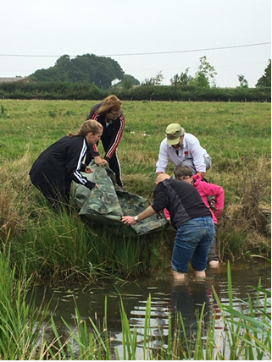 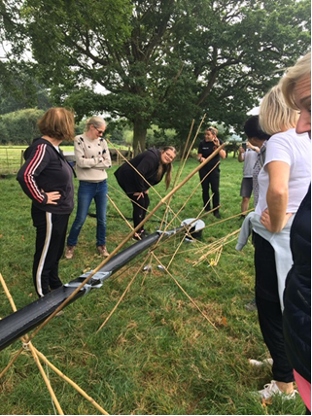

|  |
| --- |
|  |
| **Job Vacancies** |
|  |

**JOB TITLE: EXPERIENCED DISPENSER**

**Wateringbury Surgery** is a dispensing GP surgery in the semi-rural village of Wateringbury, Maidstone, Kent. A 3 GP partner practice with 3 salaried GPs, nursing team, dispensary and admin team. Our team has grown over the last two years with the introduction of Social prescriber, Clinical Pharmacist, First contact Physiotherapist, Learning Disability Care Coordinator and Child and Health Wellbeing Coordinator.

We are a friendly, hardworking, supportive and caring team with a recognised high standard of care and service to our patients.

We are looking for an experienced Dispenser with NVQ level 2 or equivalent Dispensing qualification to join our team for 29 hours per week. Experience within a GP dispensing practice would be preferred.

Pay: depending on experience

Working hours: Monday 08:00 – 13:00, Tuesday & Wednesday 08:00 – 18:00, Thursday Day off and Friday 12:00 – 18:00

**Closing date Wednesday 13th October 2021 - Interview date Tuesday 19th October 2021**

Please apply through NHS jobs - job reference number A1653-21-3723

**Fantastic opportunity to be the next member of our growing clinical team at Edenbridge Medical Practice**

*We are looking for an enthusiastic GP to join us for 4-6 sessions a week with the possibility of future partnership for the right candidate.*

This position is for a list holder with an extremely competitive salary of £11000 per session. The Practice is located in Sevenoaks district with two stations with excellent rail links to London, good schools and amenities.

We are passionate about delivering high quality healthcare to our 12,500 patients by combining traditional list- holding family medicine with more innovative primary care roles including Nurse Practitioners, First Contact Physiotherapists, Social Prescribers and GP Assistants.

Plans are currently well underway for a purpose-built, combined GP and community health facility in the near future, from which we will deliver more joined-up community care.

We are a Dispensing Practice, offering a very competitive income, using Emis Web and were recently rated as ‘good’ in all areas by the CQC. We are well represented within local networks, with GPs in the Practice having leadership roles at PCN and CCG level.

For more information or to apply for this role contact the Practice Manager, Karen Copping [karen.copping3@nhs.net](mailto:karen.copping3@nhs.net)

**JOB TITLE: ADMINISTRATIVE ASSISTANT**

**BREWER STREET**

Part Time Administrative Assistant / Receptionist required for busy central Maidstone GP Practice.

We are a happy team in a busy general practice. Administration duties to include scanning correspondence, email queries, reception cover, making appointments for follow up tests. Good communication skills are desirable.

24 hours per week over five days.

Please send CV to [brewer.street@nhs.net](mailto:brewer.street@nhs.net)

|  |
| --- |
|  |
| **Job Vacancies** |
|  |

**LOCUM PLT COVER REQUIRED – 19TH OCTOBER AND 10TH NOVEMBER – Cover needed from 13:30 -18:30**

Malling PCN require a GP locum to telephone triage urgent clinical problems whilst our surgeries are closed for PLT.

If after triaging the patient you decide that a face-to-face assessment is needed, you will be able to contact IC24 via a dedicated phone number to arrange an appointment with one of their clinicians.

***You will not be expected to see any patients face to face yourself.*** Rate of pay is £80/hr. Responses to [pam.lake1@nhs.net](mailto:pam.lake1@nhs.net)

**BREWER STREET SURGERY, MAIDSTONE. GP PARTNERSHIP VACANCY FEBRUARY 2022**

*Congratulations on choosing probably the best career available! We hope you enjoy general practice as much as we do.*

Brewer Street Surgery was established over 70 years ago and has been proudly serving patients in the heart of Maidstone and surrounding area since then. We are an exceptionally stable surgery, well-respected and currently with around 9,200 patients. Many of our elderly patients have been with us since birth, and we have a handful of families in which we are proud to look after all four generations. We achieve above the local and national average in the National Patient Survey.

We have a high reputation locally and engage with all local organisations and CCG-run schemes. We are an active member of our PCN. We achieve high QOF scores and earn well above the national average. We are fortunate to own our own building, so have no leasehold issues. We use the EMIS Web computer system.

We have a partner retiring around the end of January 2022 and are looking for a replacement partner, though we can be flexible on the dates. We are very happy to consider doctors straight off the VTS scheme who are looking to bring their skills to help develop a thriving successful partnership, or more experienced GPs, or a fulltime salaried post with a view to becoming a partner. We would be supportive if you are keen to develop interests either inside or outside the practice alongside your GP career. Most of all we are looking for someone who is passionate about being a GP- you would fit right in! If GP Partnership is for you, we would love to hear from you, even just for an informal chat.

There is so much more we would like to tell you than we can include in this short summary- we hope to hear from you if you are interested. [***edward.garrett@nhs.net***](mailto:edward.garrett@nhs.net)*and*[***chrismitchell@nhs.net***](mailto:chrismitchell@nhs.net)

**JOB TITLE: TWO SALARIED GP’S REQUIRED**

Due to our expanding practice we are looking for two committed Doctor’s with excellent communication and team working skills to integrate into our practice of around 9000 patients.

We use the EMIS Web as our clinical system, with integrated products such as Docman, DXS, Iplato, Lexicom, ECG and 24 hour BP.

We are part of the Tunbridge Wells PCN and work closely with our neighbouring surgeries.

**About the practice:** St Andrews Medical Centre is situated between Tunbridge Wells and Tonbridge, we are surrounded by beautiful rural country side.

Our Clinical team is made up of 3 partners, 4 salaried GP’s, Paramedic Practitioner, 2 Practice Nurses, HCA, Clinical Pharmacists, Pharmacy Technician. All are supported by a dedicated admin team.

We have recently moved into a purpose built new Medical centre. It is situated within the new Southborough Community Hub. The new centre will enable us to explore new concepts of care and further develop support networks for GP’s in caring for the community in conjunction with our local authority partners.

Our team is built on the principles of providing friendly, caring and compassionate healthcare to all.

If you are interested we would love to meet you and show you around. For an informal chat or to arrange a visit to the practice, please contact Sue Saunders, Practice Manager on 01892 320863 or email [pm.standrews@nhs.net](mailto:pm.standrews@nhs.net)

|  |
| --- |
|  |
| **Job Vacancies continued…** |
|  |

**Salaried GP with view to future Partnership if desired**

**Howell Surgery, Brenchley – Weald PCN**

Competitive salary to be discussed at interview 2-4 sessions per week; flexibility on days / sessions

Pro-rata 6 weeks annual leave

We are a small but busy rural practice, looking to recruit an enthusiastic and motivated GP to join our existing team of 2 partners and 2 salaried GPs. The surgery has excellent support from our Practice Nurses, HCA, Clinical Pharmacist, Social Prescriber, First Contact Physio and admin staff – all helping to look after our list of around 5100 lovely patients. We are an active member of our local Weald PCN.

You will be working 2 to 4 sessions per week as a salaried GP (days and sessions to be discussed), with a view to partnership in the future if desired. You will be keen to engage with all aspects of running our welcoming, village-based surgery including our busy in-house dispensary. We offer a competitive salary with pro rata 6 weeks annual leave.

Our friendly two site practice is based in the pretty and closely neighbouring villages of Brenchley and Horsmonden. Situated near the borders of Kent and Sussex and mid-way between London and the South Coast, the villages lie on the edge of the picturesque High Weald. The area offers excellent access to motorways and fast train connections to London, has a good choice of state and private schools, great walking and amenities and the convenience of being close to the larger towns of Tonbridge and Tunbridge Wells.

For an informal discussion, to learn more about the opportunity, or to visit the practice please contact our Practice Manager, Heather Hayden 01892 722007 or [h.hayden@nhs.net](mailto:h.hayden@nhs.net).

Applications via CV with covering letter to our Practice Manager on the above email.

**JOB TITLE: EXPERIENCED PRACTICE NURSE**

Lamberhurst Surgery is a small, friendly GP Practice; we are looking for an experienced Practice Nurse who can offer a full range of nursing services to our Practice population.  Ideally, we are looking for 20 hours per week; we are flexible on days to be worked.

Please contact Mrs Caroline Conlon, Practice Manager on 01892 890800 or [caroline.conlon@nhs.net](mailto:caroline.conlon@nhs.net) for more information.

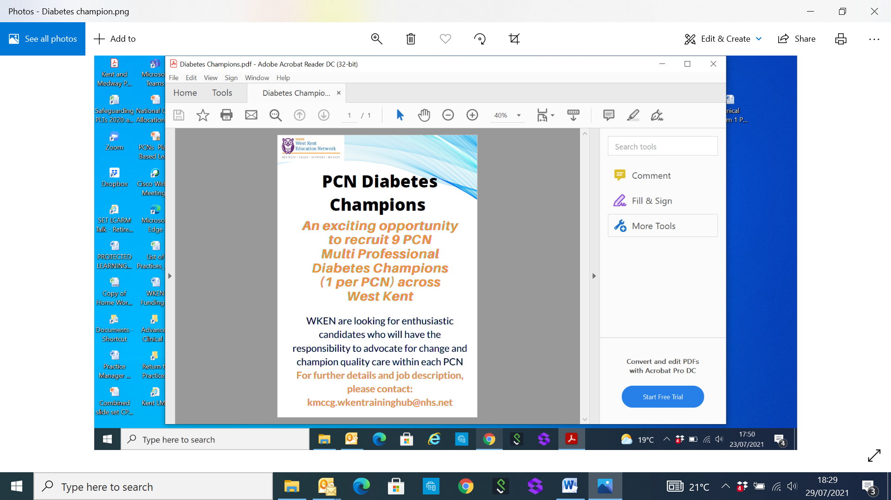

**IF YOU ARE CURRENTLY WORKING IN THE FOLLOWING PCNs:**

**The Weald, Malling, The Ridge or Maidstone Central**

**AND ARE INTERESTED IN THIS EXCITING OPPORTUNITY, WE WANT TO HEAR FROM YOU!**

[**kmccg.wkentraininghub@nhs.net**](mailto:kmccg.wkentraininghub@nhs.net)

*This role is being offered by the West Kent Training Hub as part of a training and education initiative*