|  |
| --- |
|  |
| **Newsletter – October 2021** |  |

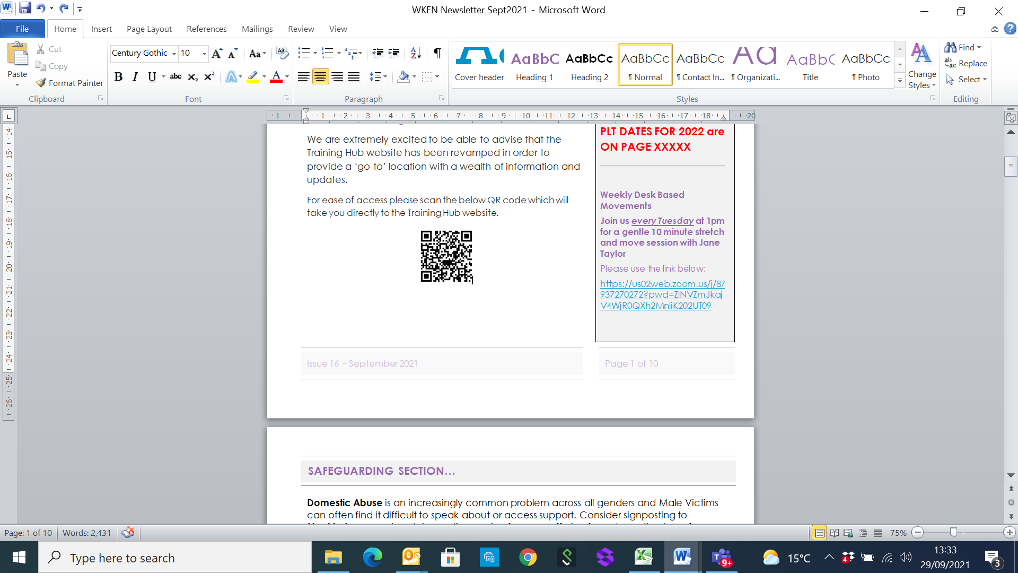**West Kent Training Hub**





**Dates for your Diary:**

**Deadline for Newsletter –** please send your items through by the **24th** of the month.

**PLT DATES FOR 2021**

**10th November PCN PLT**

**PLT DATES FOR 2022**



**Weekly Desk Based Movements**

**Join us *every Tuesday* at 1pm for a gentle 10 minute stretch and move session with Jane Taylor**

Please usethe link below:

<https://us02web.zoom.us/j/87937270272?pwd=ZlNVZmJkajV4WjR0QXh2MnliK202UT09>

[**www.westkenteducationnetwork.co.uk**](http://www.westkenteducationnetwork.co.uk)

**Email:** [**kmccg.wkentraininghub@nhs.net**](mailto:kmccg.wkentraininghub@nhs.net)

[Image result for twitter logo](https://www.bing.com/images/search?view=detailV2&ccid=CqXWN5l4&id=8B16F98F138AFC909C08261085B90A4D34866D39&thid=OIP.CqXWN5l4IM2LxlE-H0lHOAHaHa&mediaurl=https://img.talkandroid.com/uploads/2016/01/twitter-app-logo.png&exph=512&expw=512&q=twitter+logo&simid=607994475025467935&selectedIndex=0&qpvt=twitter+logo) **@westkentWKEN**

|  |
| --- |
|  |
| Dear Reader,  Welcome to the West Kent Education Network Newsletter.  WKEN would like to thank all those who contribute to the content of this newsletter and ask that you please share this with your staff teams. There is an array of articles and opportunities open to all, so your help to share with your teams is very much appreciated.  ***We would love to hear from you and share your news***, so if you have suggestions for future items, including job vacancies, please send through to [kmccg.wkentraininghub@nhs.net](mailto:kmccg.wkentraininghub@nhs.net) |
|  |

**SUPPORT FOR ALL IN PRIMARY CARE**

The Training Hub is pleased to be able to support the various wellbeing offers for all staff across Primary Care, particularly during these challenging times.

We would encourage anyone struggling with their personal resilience to please reach out for support.

Some of the offers available on Pages 3-5 and also via these websites:

<https://www.england.nhs.uk/supporting-our-nhs-people/>

<https://www.nhs.uk/mental-health/talking-therapies-medicine-treatments/talking-therapies-and-counselling/nhs-talking-therapies/>

<https://se.leadershipacademy.nhs.uk/development-opportunities-and-support/coaching-and-mentoring-2/coaching-in-a-crisis/>

Peer mentoring via the West Kent Training Hub is also available to all and accessible via [kmccg.wkentraininghub@nhs.net](mailto:kmccg.wkentraininghub@nhs.net), below is a personal review from a practicing GP who has recently used the mentoring service:

*'I have to admit, I wasn’t enthusiastic about mentoring having never been too into all that ‘fluffy stuff’. I’d rather just get on with it and learn on my own. I have to say that I was wrong about its utility. I was fortunate to have a great mentor who could associate with the issues I was facing and coax out of me ways to try and tackle these. It’s very different to the teaching you get with coaching, instead being more about exploring your experiences and being guided to develop your own solutions to any problems. I personally found it useful to spread the sessions out a little so that there’s time for things to evolve between them. I would encourage anyone to take up the opportunity for mentoring; it can only ever be beneficial to work with someone who facilitates self-reflection and improvement.’*

|  |
| --- |
|  |
|  |
| **SAFEGUARDING SECTION…** |
|  |
|  |

**Tackling County Lines Criminal Exploitation**

The ‘**Eyes Open’** website features content from Kent and Medway to help young people, parents and **professionals spot the signs of criminal exploitation, resources for professionals and useful contacts** to get help or report concerns. <https://eyes-open.co.uk/area/kent/>

**Fegans** is working with the Violence Reduction Unit to offer **counselling to young people in Kent who are involved in violence**, have the potential to become involved in violence or have suffered trauma from violence or violent home situations. For more information, call 01892 538288

**Child Sexual abuse**

<https://www.stopitnow.org.uk/> is a child protection charity, working to prevent child sexual abuse. There is a **confidential helpline**,**live chat and secure messaging**for anyone with concerns about child sexual abuse and its prevention – whether they’re worried about their own thoughts, feelings and behaviour, or about another adult or young person.

There are various resources to support professionals including a helpful guide on How to tell if a child’s sexual behaviour is age appropriate.

<https://www.stopitnow.org.uk/concerned-about-a-child-or-young-persons-sexual-behaviour/how-to-tell-if-a-childs-sexual-behaviour-is-age-appropriate/>

**Prohibition on charging for Medical Evidence of Domestic Abuse**

The Domestic Abuse bill (2020) places prohibiting charging for medical evidence of domestic abuse as from the 1st October 2021 on a statutory footing. This means it will **no longer be to the discretion of an individual GP for any charge for the preparation and provision of domestic abuse legal aid letters by health professionals in general practice.** This provision also ensures patients cannot be charged for these letters by a GP practice in its capacity as a company or partnership**.** Further information can be found in the DA Bill fact sheet in relation to this provision:

[**https://www.gov.uk/government/publications/domestic-abuse-bill-2020-factsheets/prohibition-on-charging-for-the-provision-of-medical-evidence-of-domestic-abuse**](https://www.gov.uk/government/publications/domestic-abuse-bill-2020-factsheets/prohibition-on-charging-for-the-provision-of-medical-evidence-of-domestic-abuse)

**Domestic Homicide Review**

for Connie (2018) has been published on the Kent County Council and Medway Council’s websites .A briefing outlining the learning from the review is **(below)**.

**PREVENT**

The Home office have produced a useful document **Family & Friends Factsheet**: Supporting people vulnerable to radicalisation. This is designed factsheet is designed to provide information

on how Prevent can help and support individuals and their families. It can be used to provide further information following a referral or if you are made aware of concerns about radicalisation **(below)**.

**National Safeguarding Adults Awareness Week 15th -21st November 2021**

The Kent and Medway Safeguarding Adults Board (KMSAB) will be using this time to raise awareness of adult safeguarding and there are daily themes for the week hosted by the Ann Craft Trust available here <https://www.anncrafttrust.org/events/national-safeguarding-adults-week-2021/>

You can share the key messages with the public on how to recognise abuse and report concerns using resources available at <https://kmsab.org.uk/p/professionals/awareness-raising-resources>

 

**Dr Reshma Rajagopal - NHS CCG Kent and Medway Named GP for Safeguarding Children and Adults (West Kent)**

|  |
| --- |
|  |
| **Wellbeing** |
|  |



|  |
| --- |
|  |
| **Wellbeing** |
|  |

**DESK BASED MOVEMENTS - weekly 10 minute sessions**

We have received some great feedback from the weekly movement sessions so keep sending in your comments. Jane Taylor has kindly set up a specific ‘member area’ on her website so all the recordings are available and can be easily accessed.

* <https://vimeopro.com/taylormadefitness/wken-weekly-work-based-movement-sessions>

It is password protected and I have used the password:WKEN-move-more

**Join us every Tuesday at 1pm** - **we look forward to seeing you then:**

<https://us02web.zoom.us/j/87937270272?pwd=ZlNVZmJkajV4WjR0QXh2MnliK202UT09>

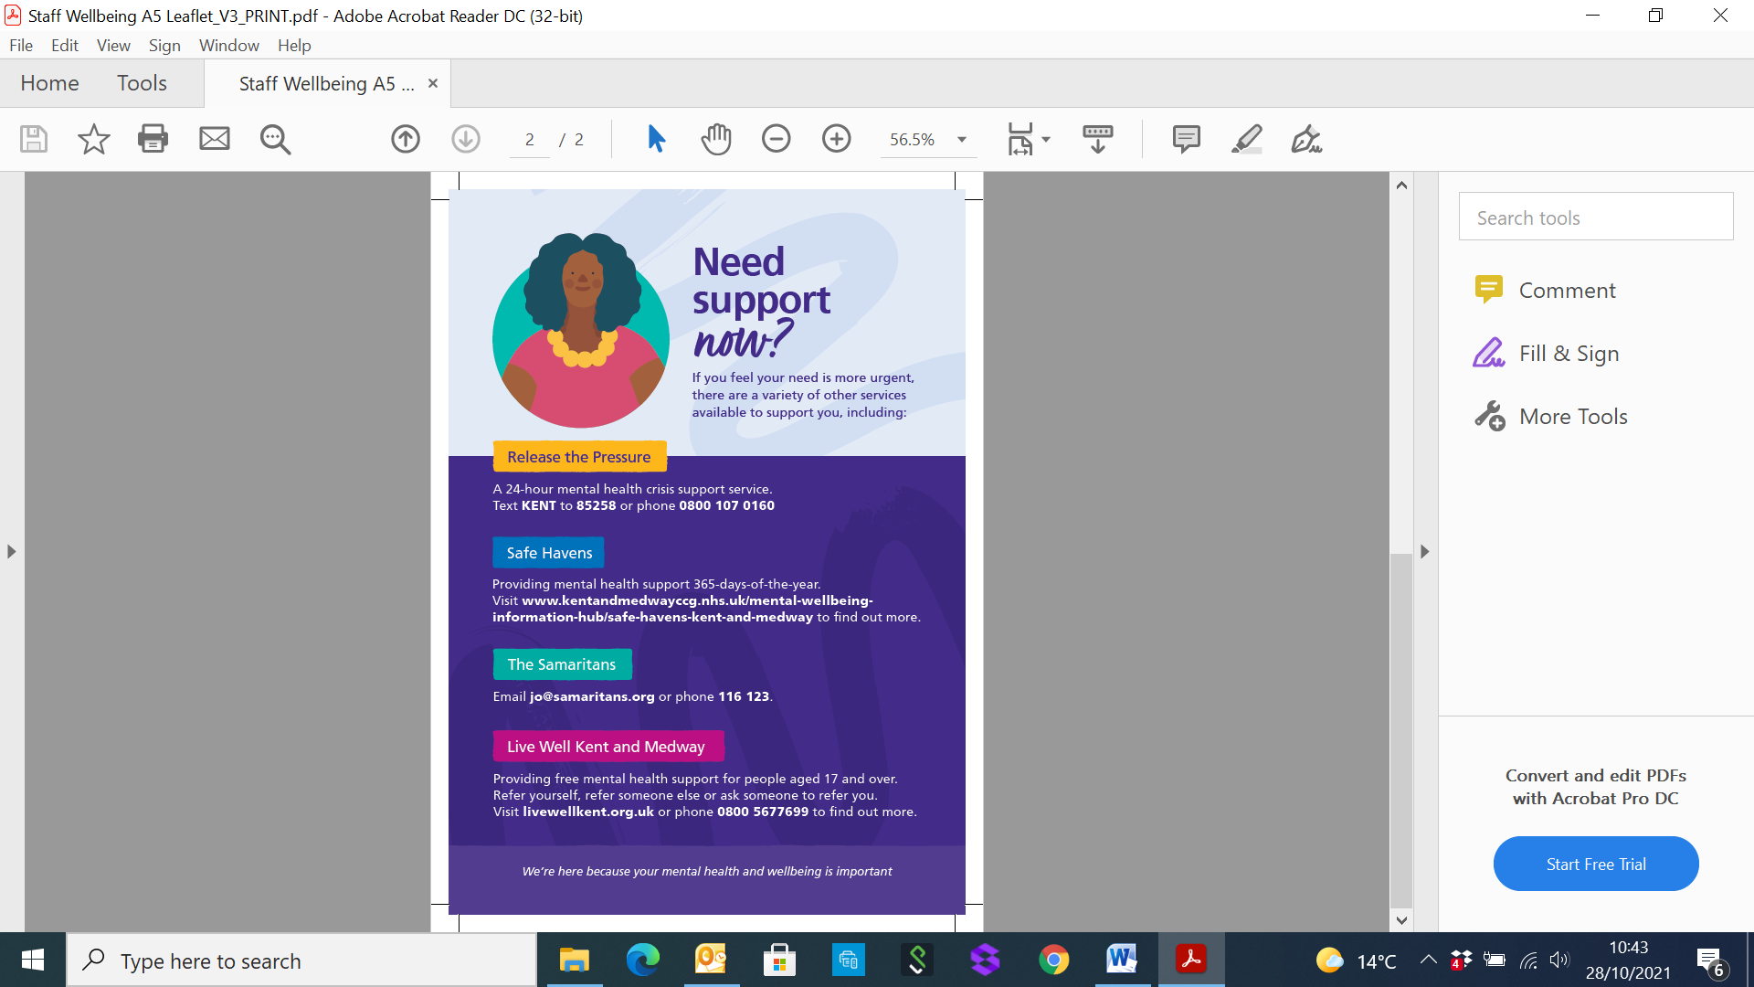

|  |
| --- |
|  |
| **Wellbeing** |
|  |



|  |
| --- |
|  |
|  |
| **Communities of Practice** |
|  |

**MAIDSTONE**

Facilitated by Dr Tony Jones, the following clinical communities of practice groups are available.

Email addresses are provided as the main contact for each group, but should you require further information or would like to discuss further, please contact [tony.jones@nhs.net](mailto:tony.jones@nhs.net)

Paramedics working in general practice - [ian.phillpott@nhs.net](mailto:ian.phillpott@nhs.net)

Clinical pharmacists in general practice - [elizabethwallis@nhs.net](mailto:elizabethwallis@nhs.net)

Advanced nurse practitioners in general practice - [vickiemehaffey@nhs.net](mailto:vickiemehaffey@nhs.net)

**TUNBRIDGE WELLS – and virtually to incorporate a wider area**

Facilitated by Dr Jane Roome,  both the New to West Kent (for GPs who are newly qualified, new to the area or new to role) and the West Kent Sessional GP group (for any GPs who are not a partner) have WhatsApp groups and are starting virtual meetings via Zoom. Traditionally these have been Tunbridge Wells based but given we're meeting virtually now please feel free to join and gain support and knowledge from other GPs in the area wherever your base may be. ​

Please contact [jane.roome@nhs.net](mailto:jane.roome@nhs.net) for more information and to join the groups.

|  |
| --- |
|  |
| **Dates for your diary…** |
|  |

***Educational Opportunities open for all Primary Care and interested staff***

​​​

Dear all

Please join us for the last of our meetings for 2021.

Open to all in Primary Care, delivered on Zoom and with plenty of time for questions we look forward to seeing you.

If you have any thoughts or ideas for meetings for 2022, please do get in touch [**jane.roome@nhs.net**](mailto:jane.roome@nhs.net)

**Thursday 11th November 7.30-9pm. Management of hyperlidaemia. Dr Supriya Joshi, Consultant Biochemist MTW NHS Hospital trust**

Dr Joshi has kindly agreed to talk about management of people with hyperlipidaemia.

|  |  |
| --- | --- |
| [https://cdn.evbstatic.com/s3-build/148050-rc2021-08-19_16.04-824fea2/django/images/logos/eb_orange_on_white_1200x630.png](https://www.eventbrite.co.uk/e/167744840333) | [Management of hyperlipidaemia](https://www.eventbrite.co.uk/e/167744840333)  Management of hyperlipidaemia  <https://www.eventbrite.co.uk/e/167744840333> |

**Wednesday 24th November 7.30-9pm. Management of people with obesity: the science, the myths and how we can make a difference in Primary Care. Dr Stephanie de Giorgio GP with expertise in Obesity management.**

Dr de Giorgio is a Kent GP with expertise in obesity management and has written the recent e-modules on management of patients with obesity for the RCGP. She will talk to us about how we can get better at managing patients who are overweight and obese, focusing on the areas below with plenty of time for your questions.

1. Dispelling the myths

2. The science of obesity and overweight

3. Weight stigma in medical care and what we need to learn.

4. What interventions actually make a difference?

5. What you can practically do in primary care and where to send patients to.

|  |  |
| --- | --- |
| [https://cdn.evbstatic.com/s3-build/148050-rc2021-08-19_16.04-824fea2/django/images/logos/eb_orange_on_white_1200x630.png](https://www.eventbrite.co.uk/e/167466953165) | [Obesity: the science, the myths and how we can make a difference](https://www.eventbrite.co.uk/e/167466953165)  The science, the myths and how we can make a difference in Primary Care  <https://www.eventbrite.co.uk/e/167466953165> |

|  |
| --- |
|  |
| **Dates for your diary…** |
|  |

**Thursday 2nd December 7.30-9pm. Diagnosis and management of polymyalgia rheumatica in Primary Care**

Dr Amit Saha, Consultant Rheumatologist, Maidstone and Tunbridge Wells NHS Trust

|  |  |
| --- | --- |
| [https://cdn.evbstatic.com/s3-build/201717-rc2021-09-28_16.04-bd32316/django/images/logos/eb_orange_on_white_1200x630.png](https://www.eventbrite.co.uk/e/diagnosis-and-management-of-polymyalgia-rheumatica-in-primary-care-tickets-181102060137) | [Diagnosis and management of Polymyalgia Rheumatica in Primary Care](https://www.eventbrite.co.uk/e/diagnosis-and-management-of-polymyalgia-rheumatica-in-primary-care-tickets-181102060137)  Diagnosis and management of Polymyalgia Rheumatica in Primary Care  <https://www.eventbrite.co.uk/e/diagnosis-and-management-of-polymyalgia-rheumatica-in-primary-care-tickets-181102060137> |

**Emergencies in Primary Care Simulation session. Saturday 27th November 9-2pm, Tunbridge Wells Hospital**

There are a very limited number of places available for this fully funded session around different emergencies that can occur in Primary Care.

Open to all but please sign-up ASAP using the Event Brite link below if you'd like to join us for this unique course.

*"This was the best course I have EVER been on"*

*Previous attendee's feedback.*

|  |  |
| --- | --- |
| [https://cdn.evbstatic.com/s3-build/232984-rc2021-10-21_16.04-8f0e424/django/images/logos/eb_orange_on_white_1200x630.png](https://www.eventbrite.co.uk/e/emergencies-in-primary-care-simulation-session-tickets-183873720247) | [Emergencies in Primary Care simulation session](https://www.eventbrite.co.uk/e/emergencies-in-primary-care-simulation-session-tickets-183873720247)  Emergencies in Primary Care simulation session  [www.eventbrite.co.uk](http://www.eventbrite.co.uk) |

|  |
| --- |
|  |
| **Items of Interest…** |
|  |

**Kent and Medway Training Hubs Survey**

Primary Care is going through unprecedented demand right now and coupled with the pandemic it has meant, more than ever, that staff working in General Practice are under increasing pressures to deliver care. We at the Training Hub are conscious of this and want to do what we can to help.

To help us understand the support needed on the ground, we have designed a survey to establish where the challenges are that we may be able to provide solutions for our non-medical, non-clinical colleagues. The survey will take approximately 5 minutes to complete, and whilst we know it is just one more thing to do in your day, it would really help us understand better what you need. This survey is for the multi-disciplinary workforce, and we ask that you share this with all of your practice team, both clinical and non-clinical, to complete.

<https://www.surveymonkey.co.uk/r/DBPLTMX> Thank you for taking the time to complete this and we will ensure that your input helps to develop the support going forward.

|  |
| --- |
|  |
| **Exciting Opportunities…** |
|  |
|  |

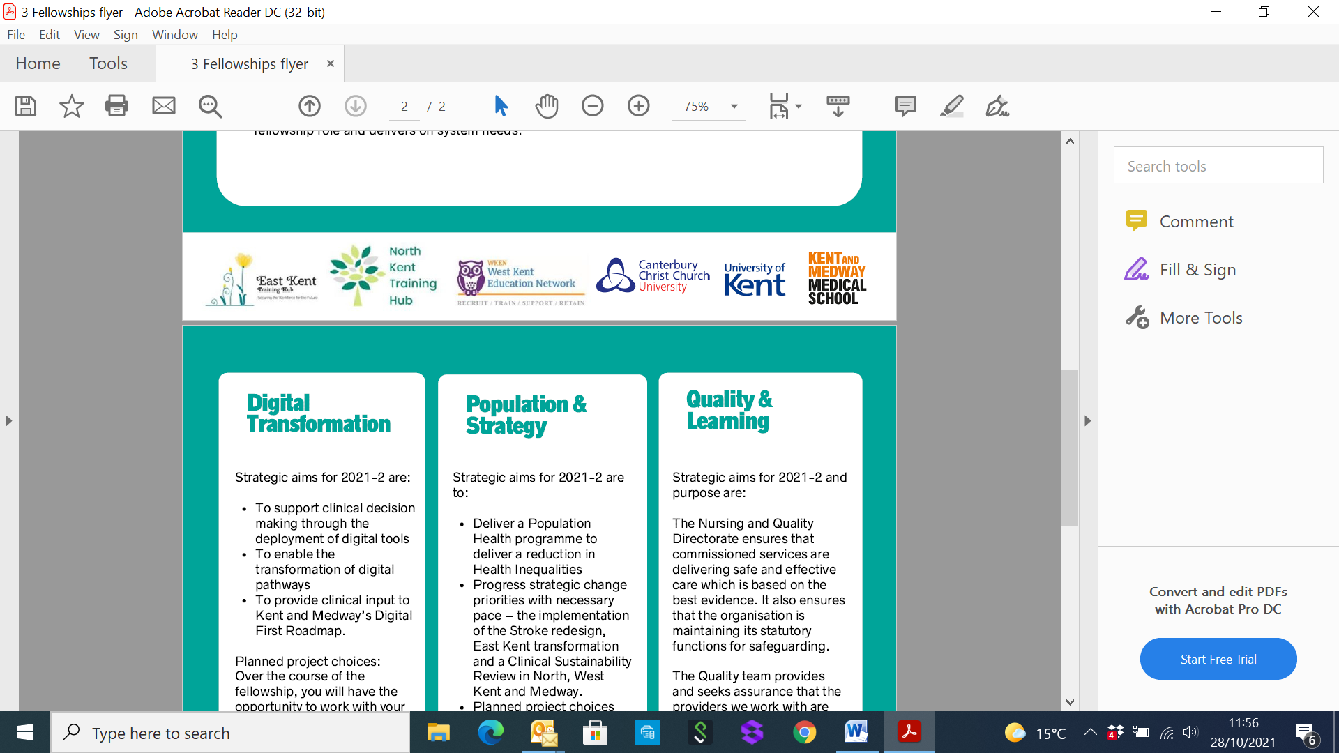

**Primary Care Fellowship Programme**

The Kent & Medway Training Hubs, in Partnership with local sponsors have secured funding for a Primary Care Fellowship programme (3 options available) to run over 12 months.

Fellowships are 1-year funded posts in Primary Care to gain experience in either:

Digital Transformation - Sponsor: Mark Needham, Programme Director - [m.needham@nhs.net](mailto:m.needham@nhs.net)

Population & Strategy - Sponsor: Nicola Smith, Deputy Director of Strategic Change - [nicola.smith76@nhs.net](mailto:nicola.smith76@nhs.net)

Quality & Learning - Sponsor: Rosie Baur, Deputy Chief Nurse - [rosie.baur@nhs.net](mailto:rosie.baur@nhs.net)

GPs and Clinicians in Kent & Medway are invited to apply with an expression of interest for these fantastic opportunities. More details can be found in the attached document.

**Closing date: midnight 5th November 2021**



**Calling all RCGP members.**

We would like to encourage you to apply for Fellowship of the RCGP.

As you probably know, all Members are eligible to apply for Fellowship who:

* have made a significant contribution to the health and welfare of their local community, the science or practice of medicine, the aims of the College, or to any organisation which directly or indirectly benefits general practice.
* and have been a member of the College in good standing for five continuous years at the date of registration for Fellowship.

There is a new simplified process for both application and nomination. You can find more information by following the link <https://www.rcgp.org.uk/fellowship>.

The RCGP would like to recognise all the hard work of members through the pandemic.

Applications and nominations for Fellowship should be e-mailed to sethames@rcgp.org.uk or [katie.biring@rcgp.org.uk](mailto:katie.biring@rcgp.org.uk)

If you would like further information or to speak to someone please contact Katie our administrator as above or myself Dr Debbie Taylor on [dtaylor2@nhs.net](mailto:dtaylor2@nhs.net) or Dr Kate Neden on [Catherine.neden@nhs.net](mailto:Catherine.neden@nhs.net)

*Message from Dr Debbie Taylor, Provost SET Faculty RCGP*  

|  |
| --- |
|  |
| **Exciting Opportunities…** |
|  |

** **

**KMPT Masterclass**

**Suicide, Self-Harm and Risk Assessment**

**Date: 19/11/2021 Venue: Virtual - Microsoft teams**

Free to join, this Masterclass is being run by Canterbury Christ Church University and open to everyone to join.  This is being held on Teams - ***just register for the link at*** [**medicalsciences@canterbury.ac.uk**](mailto:medicalsciences@canterbury.ac.uk)

**National Training Programme for Professional Nurse Advocates**

**Identifying Nurses across England to receive a PNA Training Programme funded by NHSEI**

12 spaces for the PNA cohorts starting end of November and  beginning of December 2021.

We would welcome applications from the providers across the South East  region , and I have attached an up to date application form and FAQs for the individuals to complete and must be return to [southeast.nursingpna@nhs.net](mailto:southeast.nursingpna@nhs.net) **on Wednesday  3rd of November 2021 5pm.**

Please don’t hesitate to contact us if you need more information. The programme is all paid for by NHS England & Improvement Further information on the PNA programme can also be found here  <https://www.england.nhs.uk/nursingmidwifery/delivering-the-nhs-ltp/professional-nurse-advocate/>

Here is the PNA animation below  that you can  share with your teams and networks

<https://vimeo.com/576496242/f2949fb8f7>.



 HEE recognise and value the essential role of the clinical educator with supporting, teaching and developing the nursing and midwifery workforce of both today, and the future.

 If you identify as a nursing associate, nurse or midwife that supports the education of either the pre-registration or post-registration nursing and midwifery workforce then we would like to invite you to participate in a survey, with the potential to also join interview/focus groups, to contribute to a better understanding of your training needs and experience as a clinical educator across health and social care.

Please access the survey here - <https://www.surveymonkey.co.uk/r/ClinicalPracticeEducators>

The survey takes around 15 minutes to complete and will be closing on November 8th 2021

|  |
| --- |
|  |
| **A DAY IN THE LIFE OF... A Paramedic Practitioner** |
|  |

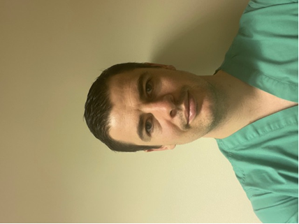My name is Matthew Cooper and I currently work at Marden Medical Centre. I have been working in general practice for approximately five years. I joined general practice as I wanted to continue my development, and felt that primary care offered new challenges and a new skillset. I used to find it frustrating being a paramedic practitioner in the ambulance service not being able to follow up with patients, which negatively impacted my ability to reflect and learn.

Entering general practice was daunting at first, due to the wider variety of clinical conditions, increase in number of daily patient contacts and having to learn about the treatment of conditions that I would not have come across in the emergency setting. However, with the right guidance, support and eagerness to learn I was quickly able to adapt to the requirements of my professional role.

Paramedics have been used in a variety of ways to support general practice. Some paramedics will work for a cluster of GP surgeries, undertaking home visits, or doing home visits and clinics. I myself work for a single surgery and work eight sessions a week. This also includes attending patients that are housebound in between my morning and afternoon clinics.

When I first joined general practice the majority of my consults were for patients who presented with acute medical problems, such as musculoskeletal injuries, infections and medical emergencies. However, with the experience I have gained I now manage patients with more complex medical conditions, and I now regularly review and follow up patients. I still seek support from the general practitioners, when necessary, which continues to aid my learning.

I am currently able to refer patients to secondary care (except one department who require a GP referral) and into private care settings. I can also refer for diagnostic imaging (mainly x-rays and ultrasounds). I have been able to extend my practice to be able to; withdraw blood, interpret bloods that I request, manage letters sent back from secondary care/a and e discharges, and have recently qualified as a non-medical prescriber.

As the paramedic practitioner role is very versatile, the scope of practice of each paramedic may differ. Currently patients who do not fit within my current remit are; pregnant patients with a pregnancy related presenting complaint, gynaecological issues requiring examination, contraception/HRT, and children under the age of one year and PR examinations. However, as a paramedic practitioner I have the ability to continue to broaden my scope of practice into these areas in the future.

General practice can be a challenging environment, especially in the past couple of years. It is still an enjoyable place to work and learn, and make a real contribution to the workforce and patient care.

|  |
| --- |
|  |
| **Partners Pages** |
|  |

 **Please see below for the latest list of courses available:**







**Encouraging Care Homes to sign up to NHSmail**

NHSmail is a secure emailing system which *any service commissioned to deliver publicly funded Health and Social Care can use*.  It is accredited for sharing patient identifiable and sensitive information. There are therefore huge benefits for care homes to have NHSmail to share sensitive information with other health care professionals (as well as allowing care homes to get rid of their fax machines!)

When a Care home has NHSmail they can:

* **Receiving test results from the hospital**
* **Contacting GP surgeries about their residents**
* **Simple process for ordering tests**
* **Enhanced prescription ordering service**

In order to apply for NHSmail the care home has to complete the Data Security and Protection Toolkit (DSPT ) This can be an obstacle and there is therefore lots of resources and support available for care home. In Kent the care homes can get local support via  <https://designandlearningcentre.com/data-security-protection-toolkit/> . The support includes webinar and 1:1 to complete the toolkit and how to use NHSmail. [Digital Social Care](mailto:https://www.digitalsocialcare.co.uk/data-security-protecting-my-information/) provide national support for anything digital including getting NHSmail and completing the DSPT. The website has lots of useful information, webinars and a helpline (contact 0208 133 3430 (Mon-Fri 9-5) or email [help@digitalsocialcare.co.uk](mailto:help@digitalsocialcare.co.uk) for free support)

On your next visit to a care home, please encourage them to consider signing up to NHSmail.

***Pia Rathje-Burton, Locality Manager (London and South East)*** *Contact: 07815 429173*

|  |
| --- |
|  |
| **Job Vacancies** |
|  |

**JOB TITLE: HEALTH CARE ASSISTANT FOR WEST MALLING GROUP PRACTICE**

We are looking for an enthusiastic, highly motivated Health Care Assistant to join our friendly practice team serving 21000 patients in the heart of Kent.

You will be part of our clinical team comprising of 7 GP Partners, 5 Salaried GPs, 2 Nurse Practitioners a Pharmacist and a team of Practice Nurses and HCA’s with strong support from an experienced administrative and management team. We are GP and Nurse training practice.

Your role will be varied to include phlebotomy, blood pressure checks, ECG, warfarin checks, smoking cessation, NHS health checks and ear syringing.

We are ideally looking for this to be a full time position and can be flexible. Pay will be subject to experience.

25 days holiday plus pro rata bank holidays

If you would like to be considered, please apply with full CV and a covering letter to the Practice Manager, Debbie Dean via [debbiedean@nhs.net](mailto:debbiedean@nhs.net)

We welcome informal inquiries or visits. **Application closes: 29.10.21**

**JOB TITLE: MEDICAL SECRETARY FOR TONBRIDGE MEDICAL GROUP**

Experience in EMIS clinical system preferred but not essential

Required to work 3 full days a week on Mondays, Wednesdays and Fridays

Salary to be discussed at interview – handsome NHS pension

To apply please email your CV to [pmanager21@nhs.net](mailto:PMANAGER21@NHS.NET)

**JOB TITLE: ADVANCED NURSE PRACTITIONER FOR WEST MALLING GROUP PRACTICE**

We are looking for an enthusiastic, highly motivated Advanced Nurse Practitioner to join our friendly practice team serving 21,000 patients in the heart of Kent.

We are a very supported team committed to providing high quality care patient care.

You will be part of a team of 7 GP Partners, 5 Salaried GPs, 2 Nurse Practitioners a Pharmacist and a team of Practice Nurses and HCA’s with strong support from an experienced administrative and management team. We are GP and Nurse training practice.

You will need to be a degree qualified Advanced Nurse Practitioner with relevant clinical skills and expertise to work autonomously. You must have relevant experience to be an independent nurse prescriber enabling you to independently assess, diagnose, treat and refer patients as appropriate. It will be expected that you will manage your own patient lists. We would also expect you to take on specific responsibilities in other areas of practice. A speciality are of interest would be an advantage. We are supportive of training and development.

We are ideally looking for this to be a full time position and can be flexible around the hours worked.

If you would like to be considered, please apply with full CV and a covering letter to the Practice Manager, Debbie Dean via [debbiedean@nhs.net](mailto:debbiedean@nhs.net)

We welcome informal inquiries or visits. **Application closes 29.10.2021**

|  |
| --- |
|  |
| **Job Vacancies** |
|  |

**LOCUM PLT COVER REQUIRED – 10TH NOVEMBER – Cover needed from 13:30 -18:30**

Malling PCN require a GP locum to telephone triage urgent clinical problems whilst our surgeries are closed for PLT.

If after triaging the patient you decide that a face-to-face assessment is needed, you will be able to contact IC24 via a dedicated phone number to arrange an appointment with one of their clinicians.

***You will not be expected to see any patients face to face yourself.*** Rate of pay is £80/hr. Responses to [pam.lake1@nhs.net](mailto:pam.lake1@nhs.net)

**BREWER STREET SURGERY, MAIDSTONE. GP PARTNERSHIP VACANCY FEBRUARY 2022**

*Congratulations on choosing probably the best career available! We hope you enjoy general practice as much as we do.*

Brewer Street Surgery was established over 70 years ago and has been proudly serving patients in the heart of Maidstone and surrounding area since then. We are an exceptionally stable surgery, well-respected and currently with around 9,200 patients. Many of our elderly patients have been with us since birth, and we have a handful of families in which we are proud to look after all four generations. We achieve above the local and national average in the National Patient Survey.

We have a high reputation locally and engage with all local organisations and CCG-run schemes. We are an active member of our PCN. We achieve high QOF scores and earn well above the national average. We are fortunate to own our own building, so have no leasehold issues. We use the EMIS Web computer system.

We have a partner retiring around the end of January 2022 and are looking for a replacement partner, though we can be flexible on the dates. We are very happy to consider doctors straight off the VTS scheme who are looking to bring their skills to help develop a thriving successful partnership, or more experienced GPs, or a fulltime salaried post with a view to becoming a partner. We would be supportive if you are keen to develop interests either inside or outside the practice alongside your GP career. Most of all we are looking for someone who is passionate about being a GP- you would fit right in! If GP Partnership is for you, we would love to hear from you, even just for an informal chat.

There is so much more we would like to tell you than we can include in this short summary- we hope to hear from you if you are interested. [***edward.garrett@nhs.net***](mailto:edward.garrett@nhs.net)*and*[***chrismitchell@nhs.net***](mailto:chrismitchell@nhs.net)

**JOB TITLE: SALARIED GP’S REQUIRED at THE VINE MEDICAL CENTRE**

An exciting opportunity has arisen to join our friendly and family-like team for a Salaried GP for 4-6 sessions per week.

We are looking for a passionate GP to join our team for 4-6 sessions per week with the possibility of future partnership. We thrive on delivering excellent healthcare to our 12,500 patients in a holistic way by utilising our forward-thinking and innovative approach to General Practice.

Our vast multidisciplinary team consists of GPs, ACPs, Paramedic Practitioners, Clinical Pharmacists, plus a large PCN team including Physiotherapists, Podiatrists, Mental Health Nurses and Social Prescribers. In addition to this, we have an enthusiastic Nursing and HCA team, and a fantastic and supportive Reception and Administrative team.

We are a high achieving practice with an exceptional reputation and a recent CQC rating of ‘Good’ in all areas, except ‘Outstanding’ for Well-Led. The partners have an active interest in medical education and with this we are a training practice for GP Registrars and Medical Students. Our ethos is to develop our teams’ strengths and interests, so will support your ambitions to develop special interests within your GP career.

If you wish to work in a happy and supportive team delivering high quality healthcare, please contact the Practice Manager, Lindsey Mulcahy [lindsey.mulcahy@nhs.net](mailto:lindsey.mulcahy@nhs.net) or Senior Partner, Dr Sugina Hesketh [suginahesketh@nhs.net](mailto:suginahesketh@nhs.net) to arrange an informal visit or for further information.

|  |
| --- |
|  |
| **Job Vacancies continued…** |
|  |

**JOB TITLE: SALARIED GP WITH A VIEW TO PARTNERSHIP at ST. ANDREW’S MEDICAL CENTRE**

We are looking to employ an enthusiastic & motivated salaried doctor, with a view to partnership potentially if requested. Number of sessions is negotiable according to candidates’ requirements.

Our team is built on the principles of providing friendly, caring and compassionate healthcare to all. We are an EMIS Web based practice, serving c9000 patients. We also use Docman 10, AccuRx, eConsult, iPlato, have in-house 24-hour BP monitoring and are always keen to explore new technologies as well.

*Key benefits at SAMC include:*

*• Impressive brand new, purpose-built, high-tech premises opening up a wealth of opportunities for the practice to develop and expand! The new centre will enable us to explore new concepts of care, offering a plethora of services to the local community and to create a working environment that will help all members of the team to flourish.*

*• Focus on staff communication – morning ‘huddles’ (covid secure of course!), daily updates, practice meetings in PLTs, practice socials etc*

*• Excellent in house supportive clinical pharmacist and pharmacy technician team, who are also supported by the PCN pharmacy / technicians as well*

*• Diabetic specialist practice supported by our Diabetic Specialist Nurse who runs National courses in diabetes.*

*• In house insulin specialist clinicians*

*• In house prescribing paramedic practitioner*

*• Minimal home visits due to our paramedic practitioner*

*• Visiting ophthalmology and ENT specialists running weekly clinics*

*• Open to career pathway development with creation of portfolio careers amongst GPs*

*• Pathway in place to become training practice, supporting medical students also (one partner is GP Fellow with Kent and Medway Medical School)*

*• We are actively involved within Tunbridge Wells PCN with daily access to First Contact Physios, Physician assistants, paramedic practitioner etc*

*• Improved access carried out by PCN clinical practitioners so reduced doctor input*

Whilst Covid has paused the project, we are now looking to move forward and embrace all recent thinking. Accordingly we are looking for forward thinking GP’s to be part of an enthusiastic and dedicated team to help design, influence, and implement a 5 year plan to create an exceptional business. Positions will be made with the view to invite to partnership also if desired.

We would love to meet you and show you around our surgery that we are really proud of! For an informal chat or to arrange a visit to the practice, please contact Sue Saunders, Practice Manager on 01892 320863 or email [pm.standrews@nhs.net](mailto:pm.standrews@nhs.net)

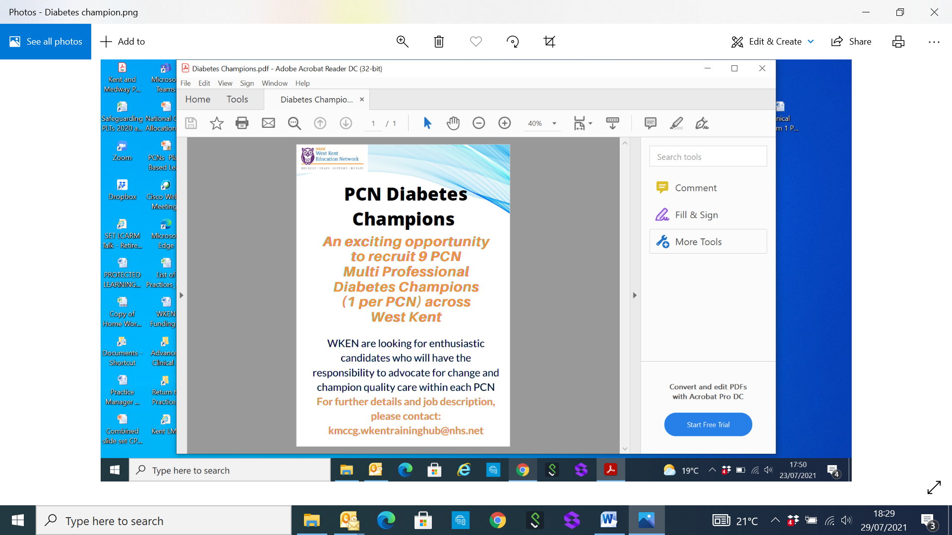**IF YOU ARE CURRENTLY WORKING IN THE FOLLOWING PCNs:**

**Malling, The Ridge or Maidstone Central**

**AND ARE INTERESTED IN THIS EXCITING OPPORTUNITY,**

**WE WANT TO HEAR FROM YOU!**

[**kmccg.wkentraininghub@nhs.net**](mailto:kmccg.wkentraininghub@nhs.net)

*This role is being offered by the West Kent Training Hub as part of a training and education initiative*

|  |
| --- |
|  |
| **Job Vacancies continued…** |
|  |

**JOB TITLE: GP PARTNER – SEVENOAKS, KENT - FROM APRIL 2022 – AMHERST MEDICAL PRACTICE**

A rare and exciting opportunity has arisen to join a 9 doctor Partnership (5FTE) in the market town of Sevenoaks, due to a senior partner retiring at the end of March 2022. The practice has been in existence for 90 years practicing traditional family medicine with personal lists and is an integral part of the local community. We are located within a 5 minute walk from Sevenoaks train station.

The Practice is a training practice (GPs, medical students, paramedic practitioners, PA’s and nurses) with 13 doctors, 5 registered nurses, 2 Healthcare Assistants, a Paramedic Practitioner and Clinical Pharmacist. We have a dispensing branch surgery in the nearby village of Brasted.

We offer:

• Full or part time work opportunities

• Excellent clinical, management and administrative support teams

• Established training practice

• Active research practice

• Active and leading member of Sevenoaks PCN with excellent relationships with local healthcare providers.

• Spacious car parks and recent refurbishment and extension have secured CQC - compliant premises fit for the Covid era

• Ownership of buildings under the Cost-Rent scheme.

• Clinically diverse team

• High QOF achievers and high income.

Informal enquires and visits would be welcomed; please email Ravi Iyer (Practice Manager) via email [ravi.iyer@nhs.net](mailto:ravi.iyer@nhs.net)

**WE NEED YOU!**

***We would love to hear from you and share your news***, so if you have recently completed a training course, joined a team or would simply like to acknowledge the hard work of a colleague or team, please send details through to [kmccg.wkentraininghub@nhs.net](mailto:kmccg.wkentraininghub@nhs.net)

***We would particularly like to hear from all roles for an article on ‘A Day in the Life Of…’***so if you would like to write a piece for the newsletter on what a typical day looks like for you, please do email to the above so we can gain an insight into each of the job roles within primary care.