|  |
| --- |
|  |
| **Newsletter – May 2021** |  |

**WKEN Training Hub**





**Dates for your Diary:**

**Deadline for Newsletter –** please send your items through by the **24th** of the month.

**PLT DATES FOR 2021**

**10th June PCN**

**13th July TRAINING HUB**

**9th Sept IN HOUSE**

**19th Oct TRAINING HUB**

**10th Nov PCN**

**Dates for your Diary:**

**See Pages 3, 4 & 5**

**Weekly Desk Based Movements**

**Join us Every Tuesday at 1pm for a gentle 10 minute stretch and move session with Jane Taylor**

Please usethe link below:

<https://us02web.zoom.us/j/87937270272?pwd=ZlNVZmJkajV4WjR0QXh2MnliK202UT09>

West Kent Education Network

[**www.westkenteducationnetwork.co.uk**](http://www.westkenteducationnetwork.co.uk)

**Email:** [**kmccg.wkentraininghub@nhs.net**](mailto:kmccg.wkentraininghub@nhs.net)

[Image result for twitter logo](https://www.bing.com/images/search?view=detailV2&ccid=CqXWN5l4&id=8B16F98F138AFC909C08261085B90A4D34866D39&thid=OIP.CqXWN5l4IM2LxlE-H0lHOAHaHa&mediaurl=https://img.talkandroid.com/uploads/2016/01/twitter-app-logo.png&exph=512&expw=512&q=twitter+logo&simid=607994475025467935&selectedIndex=0&qpvt=twitter+logo) **@westkentWKEN**

|  |
| --- |
|  |
| Dear Reader,  Welcome to the West Kent Education Network Newsletter.  WKEN would like to thank all those who contribute to the content of this newsletter and ask that you please share this with your staff teams as there is an array of articles and opportunities open to all, so your help to share with your teams is very much appreciated.  We are keen to hear from you with your stories of ‘A Day in the Life Of…’ plus news on your new staff members, perhaps someone in your team is retiring and you would like to acknowledge their contribution to your practice.  We would love to hear from you and share your news, so if you have suggestions for future items, including job vacancies, please send through to [kmccg.wkentraininghub@nhs.net](mailto:kmccg.wkentraininghub@nhs.net) |
|  |

## Your Wellbeing

The West Kent Training Hub continue to provide a weekly 10 minutes desk based movement session with Jane Taylor every Tuesday, so if you haven’t participated yet, please check out Page 6 for further details.

Additional support ‘Beyond Surviving to Thriving’ a modular program funded by the CCG is also detailed on Page 6 *‘to help you find your inner resources, such as your clarity, resilience and wellbeing to support you in these challenging times’.*

Peer Support is also available to all in West Kent via the Peer Mentoring Service, so if you would like confidential 1:1 sessions with a trained mentor, for support or simply a listening ear, please contact [kmccg.wkentraininghub@nhs.net](mailto:kmccg.wkentraininghub@nhs.net) in confidence.

|  |
| --- |
|  |
|  |
| **SAFEGUARDING SECTION…** |
|  |
|  |

The Royal College of Paediatricians and Child Health have recently published guidance in relation to Perplexing Presentations/ Fabricated or Induced Illness available here.

<https://childprotection.rcpch.ac.uk/wp-content/uploads/sites/6/2021/03/Perplexing-Presentations-FII-Guidance.pdf>

We will be producing summary and local pathway guidance for Kent and Medway primary care in due course.

A helpful video guide for professionals about the Kent Sexual Assault Referral centre is available to view at [https://vimeo.com/522707710/54ba277176](https://eur01.safelinks.protection.outlook.com/?url=https%3A%2F%2Fvimeo.com%2F522707710%2F54ba277176&data=04%7C01%7Cclare.hall2%40kent.gov.uk%7Cbc1912b90de447c62e5508d8ee987862%7C3253a20dc7354bfea8b73e6ab37f5f90%7C0%7C0%7C637521685912388125%7CUnknown%7CTWFpbGZsb3d8eyJWIjoiMC4wLjAwMDAiLCJQIjoiV2luMzIiLCJBTiI6Ik1haWwiLCJXVCI6Mn0%3D%7C1000&sdata=hJAHuldAnijaemgI0RGH4jbnqUWHugeEfzkN2CYz9Yk%3D&reserved=0)

Information about services available and contact details can be viewed at <https://www.beechhousesarc.org/>

Online training to raise awareness of stalking is now available. The links to register and further details including dates for training are in the **below** flyer.

Preventing and **tackling domestic abuse** is an integral part of providing a safe and effective work environment, helping employers to deliver their duty of care.

This toolkit, sponsored by The Insurance Charities and co-authored by Business in the Community and Public Health England, offers **employers guidance and support** and consolidates the best evidence and employer practice.

<https://static1.squarespace.com/static/5cd83ed84d871178f0307100/t/5cfe752a01f3c40001e7516d/1560180083314/bitc_phe_domestic_abuse_toolkit.pdf>

You may be aware the deadline for all EU and EEA citizens and their family members to apply to **the EU Settlement Scheme (EUSS)** and remain in the UK lawfully is the 30th June 2021. Although health do not have the responsibility for application we may be aware of those who are vulnerable in our community and can be a resource to inform and signpost to help prevent those most vulnerable becoming even more vulnerable (i.e.) lose access to public funds and therefore healthcare access beyond  emergency care

The process is entirely online and the evidence that you have applied and have status is also only available online. The **below** 7 minute briefing provides information and resources you can signpost for support.

 

***Dr Reshma Rajagopal***

***Named GP for safeguarding NHS CCG Kent and Medway Named GP for Safeguarding Children and Adults (West Kent)***

|  |
| --- |
|  |
|  |
| **Communities of Practice** |
|  |

**MAIDSTONE**

Facilitated by Dr Tony Jones, the following clinical communities of practice groups are available.

Email addresses are provided as the main contact for each group, but should you require further information or would like to discuss further, please contact [tony.jones@nhs.net](mailto:tony.jones@nhs.net)

Paramedics working in general practice - [ian.phillpott@nhs.net](mailto:ian.phillpott@nhs.net)

Clinical pharmacists in general practice - [elizabethwallis@nhs.net](mailto:elizabethwallis@nhs.net)

Advanced nurse practitioners in general practice - [vickiemehaffey@nhs.net](mailto:vickiemehaffey@nhs.net)

**TUNBRIDGE WELLS – and virtually to incorporate a wider area**

Facilitated by Dr Jane Roome,  both the New to West Kent (for GPs who are newly qualified, new to the area or new to role) and the West Kent Sessional GP group (for any GPs who are not a partner) have WhatsApp groups and are starting Virtual meetings via Zoom. Traditionally these have been Tunbridge Wells based but given we're meeting virtually now please feel free to join and gain support and knowledge from other GPs in the area wherever your base may be. ​

Please contact [jane.roome@nhs.net](mailto:jane.roome@nhs.net) for more information and to join the groups.

|  |
| --- |
|  |
| **Dates for your diary…** |
|  |

***Educational Opportunities open for all Primary Care and interested staff***

​​​**Virtual evening meetings via Zoom: Free and open to all staff**

We're in the process of finalising a few meetings based on what you've voted for in the polls and asked for on the evaluation forms, so please watch out for more details in the next few weeks. In the meantime, we'd love to see you at the next meeting in June.

Please email [jane.roome@nhs.net](mailto:jane.roome@nhs.net) with any ideas, comments or suggestions for topics or ideas for future meetings and look forward to seeing you at one of the upcoming meetings.

**Children with Challenging Behaviour, Thursday, 17th June, 19:00 – 20:00**

Children with challenging behavior can be a common presentation in General Practice. This 1 hour event hopes to up-skill GP’s in differentiating overt psychiatric or developmental pathology from ‘challenging behaviour’ as well as provide some guidance on supporting such children and their families. Dr Shakoor is an experienced consultant in community paediatrics and will present with Ann Walton, an advanced neurodevelopmental nurse specialist. As local clinicians, both hope to discuss this topic in the context of local service availability. This interactive Zoom event will comprise a presentation followed by ample opportunity for you to put questions to our speakers and attendance constitutes 1 hour of CPD.

**To book:** <https://www.eventbrite.co.uk/e/children-with-challenging-behaviour-primary-care-tickets-155834574407>

|  |
| --- |
|  |
| **Dates for your diary…** |
|  |

**Early Diagnosis of colorectal cancer, Tuesday, 6th July, 19:30-21:00**

Mr Chris Wright, Consultant Colorectal Surgeon, Maidstone and Tunbridge Wells NHS trust will address how the introduction of qFIT is changing management of patients with colorectal symptoms in Primary Care and who are referred under the 2 week wait suspected cancer pathway.

Brought to you by West Kent Education Network, there will be plenty of time for questions and discussion.

Open to all in Primary Care please book on Eventbrite using the link below.

The link to the meeting on Zoom will be sent by 10pm on 5th July.

We look forward to seeing you.

**To book:** <https://www.eventbrite.co.uk/e/early-diagnosis-of-colorectal-cancer-tickets-157109263035>

|  |  |
| --- | --- |
| [https://cdn.evbstatic.com/s3-build/perm_001/6ce389/django/images/logos/eb_orange_on_white_1200x630.png](https://www.eventbrite.co.uk/e/early-diagnosis-of-colorectal-cancer-tickets-157109263035) | [Early diagnosis of colorectal cancer](https://www.eventbrite.co.uk/e/early-diagnosis-of-colorectal-cancer-tickets-157109263035)  Early diagnosis of colorectal cancer  [www.eventbrite.co.uk](http://www.eventbrite.co.uk) |

**Save the date! Tuesday 13th July 2-5pm Diabetes PLT on Zoom**

***Please put the next external PLT date in your diary now of Tuesday 13th July***

Much work is going on behind the scenes and with our partner organisations to bring you an afternoon of interactive education about managing patients with diabetes in Primary Care in West Kent.

**A few highlights so far:**

• 3 different sessions to choose with one aimed at administration and reception staff

• Lessons about Diabetes management from Eclipse: queries, targeted case reviews and discussion

• Case based discussions around use of oral agents

Foot checks and important lessons to remember

• Psychological services for people with diabetes in West Kent

• Preconceptual care

• Patient's perspectives

plus much more planned - full agendas still being confirmed.

If there is an area of good practice that you would like to share, please contact us so we can include it.

All comments and suggestions welcomed to make this **YOUR PLT**.

We look forward to seeing you on the 13th.

|  |
| --- |
|  |
| **Dates for your diary…** |
|  |

**Management of sexual pain disorders in women, including managing sexual difficulties around the menopause.**

**Tuesday 29 June 2021 - 19:00 – 20:30**

Essentials Webinar Series is a programme of 1.5-hour webinars – broadcast live – providing expert specialist clinical training and essential information. These webinars are recorded live and are available for delegates to access freely for six months from the webinar date.

Sexual pain disorders affect 7.4% of women with treble the prevalence in under 25's and over 45's but their management is historically poorly taught and therefore, poorly managed.

***Dr Leila Frodsham, Consultant Gynaecologist and Psychosexual Lead at Guy's and St Thomas's, will guide you from consulting skills through to management of this highly distressing condition.***

**Learning objectives:**

1. Improved sexual consultation skills

2. Managing Vulvodynia and sexual pain disorders

3. Managing Anorgasmia

4. Managing sexual difficulties in menopause

5. Managing male sexual difficulties

**Pricing: AiT rate - £15 / RCGP Member rate - £20 / Non-Member rate - £30**

**To book:** <https://rcgpportal.force.com/s/lt-event?id=a1U1i000006DDNLEA4&site=a0d0Y00000AeOP6QAN>

|  |
| --- |
|  |
| **Exciting Opportunities…** |
|  |

**FCP roadmap supervisor training offer**

In support of the Additional Roles Reimbursement Scheme (ARRS), Allied Health Practitioners (AHP) who wish to follow the HEE roadmaps to practice and work within primary care will need a nationally approved supervisor. [HEE KSS will be enabling two routes](http://news.hee.nhs.uk/_act/link.php?mId=J923981692682506284043151zzzzz6463a56454a11ffebd48e9cbfa447a772f6196adc453d119a4efd2eb6637635568&tId=365212128) that will enable suitably experienced colleagues to become Roadmap Supervision and Verification (RMSV) supervisors.

**Route one - GP Trainer top up training**

Currently, GP educational supervisors (ES) are approved to become RMSV supervisors following a short top-up training to familiarise themselves with the assessments and portfolio requirements for ARRS practitioners sign off. GP Trainer top up training will all be delivered virtually on the following dates:

* Thursday 17 June, 14.00-17.30
* Wednesday 15 September, 14.00-17.30.

Please contact [northkent.traininghub@nhs.net](mailto:northkent.traininghub@nhs.net) to enrol on a course, including the date you wish to attend.

**Route two - multi-professional roadmap to practice training**

A full two day course will be required for those who are not currently GP ESs. We will soon be circulating a date to support those that meet the following supervisor entry requirements:

* an AHP Consultant Practitioner
* an Advanced Practitioner holding a full Advanced Clinical Practice master's degree.

|  |
| --- |
|  |
| **Exciting Opportunities (continued)** |
|  |

**Implementing the FCP roadmap for AHPs in primary care**

HEE and NHS England and Improvement have issued a joint position statement on the implementation of the FCP/Advanced Practice roadmap for AHPs in primary care. You can [read the statement here.](http://news.hee.nhs.uk/_act/link.php?mId=J923981692682506284043151zzzzz6463a56454a11ffebd48e9cbfa447a772f6196adc453d119a4efd2eb6637635568&tId=365212131)

Keep up to date with the latest information and regular updates via the [HEE website](http://news.hee.nhs.uk/_act/link.php?mId=J923981692682506284043151zzzzz6463a56454a11ffebd48e9cbfa447a772f6196adc453d119a4efd2eb6637635568&tId=365212134) for roadmaps (please note that this is currently offline for maintenance and will be back shortly).

|  |
| --- |
|  |
| **Wellbeing** |
|  |

**DESK BASED MOVEMENTS - weekly 10 minute sessions**

We have received some great feedback from the weekly movement sessions so keep sending in your comments. Jane Taylor has kindly set up a specific ‘member area’ on her website so all the recordings are available and can be easily accessed.

* <https://vimeopro.com/taylormadefitness/wken-weekly-work-based-movement-sessions>

It is password protected and I have used the password:WKEN-move-more

**Join us every Tuesday at 1pm** - **we look forward to seeing you then:**

<https://us02web.zoom.us/j/87937270272?pwd=ZlNVZmJkajV4WjR0QXh2MnliK202UT09>

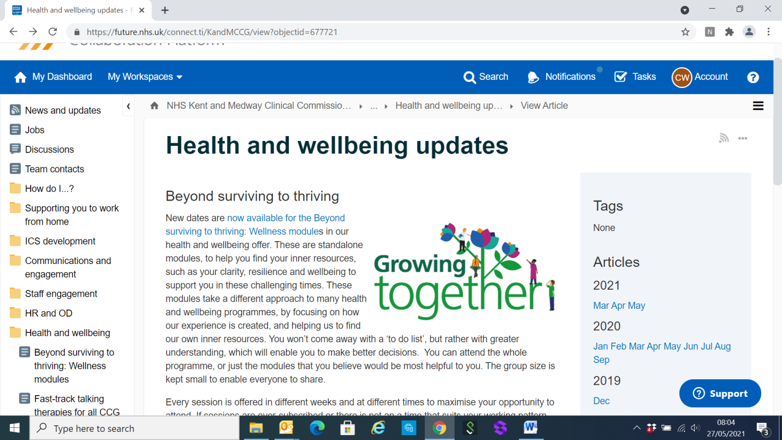**BEYOND SURVIVING TO THRIVING**

New dates are [now available for the Beyond surviving to thriving: Wellness module](https://future.nhs.uk/KandMCCG/view?objectId=827187#827187)s in our health and wellbeing offer. These are standalone modules, to help you find your inner resources, such as your clarity, resilience and wellbeing to support you in these challenging times. These modules take a different approach to many health and wellbeing programmes, by focusing on how our experience is created, and helping us to find our own inner resources. You won’t come away with a ‘to do list’, but rather with greater understanding, which will enable you to make better decisions.  You can attend the whole programme, or just the modules that you believe would be most helpful to you. The group size is kept small to enable everyone to share.

Every session is offered in different weeks and at different times to maximise your opportunity to attend. If sessions are over-subscribed or there is not an a time that suits your working pattern and other circumstances, please let the facilitator, [Alison Lally](mailto:alison@synergy-global.com) know and we will do our best to offer further options.

**These sessions are being funded by Kent and Medway CCG, and are open to all staff in the CCG and staff in primary care, where their practice is registered with the CCG.** They will be delivered via Zoom, and there will be no cost to attendees.

If you would like to discuss any of the modules before deciding, please email Alison who can answer questions and arrange to discuss options if that would be helpful.

*Shared from:* [*https://future.nhs.uk/connect.ti/KandMCCG/view?objectid=677721*](https://future.nhs.uk/connect.ti/KandMCCG/view?objectid=677721)

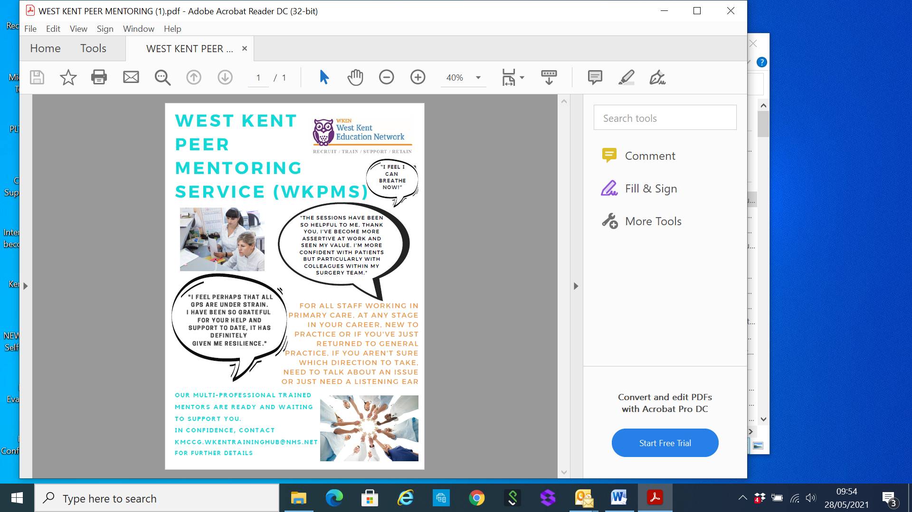

|  |
| --- |
|  |
| **Items of Interest** |
|  |

**Entries are now open for the annual General Practice Award as part of honours that celebrate excellence in primary care.**

The 13th annual [General Practice Awards](http://generalpracticeawards.com/), run by *Nursing in Practice* publisher Cogora, recognises the remarkable work carried out by Britain’s primary care professionals.

Categories include: GP of the year, Practice Nurse of the year, Pharmacist of the year, Practice Manager of the year, Receptionist of the year, GP Trainee/Rising Star or you could nominate the GP Team of the year.

Overall, the judges are looking for entries from those who go the extra mile, who have successfully implemented a project or initiative to improve patient care or deserve some overdue recognition.

The [deadline for entries is 1 June, with the ceremony taking place on 10 December](http://generalpracticeawards.com/hcp-awards-enter-now/).

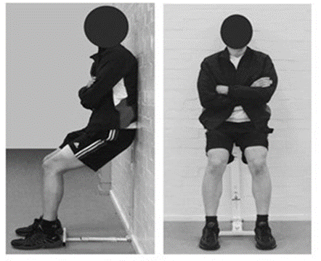**Feasibility study to assess the delivery of a novel isometric exercise intervention for people with Stage 1 hypertension in the NHS (IsoFIT-BP Study)**

The above study is being conducted at GP practices in the South East of England.  Evidence suggests that a particular type of exercise – an isometric exercise wall squat (see picture below) – can lower BP more efficiently and with significantly less time and effort than aerobic exercise. Isometric exercise involves holding a fixed body position for a very short period. This feasibility study aims to confirm if isometric exercise can be provided to patients in the NHS, is beneficial and acceptable to patients and easily adhered to.

The study will assess how feasible it is to provide an isometric wall squat exercise intervention to patients with Stage 1 hypertension in an NHS primary care setting.

For further information, please refer to this document. 

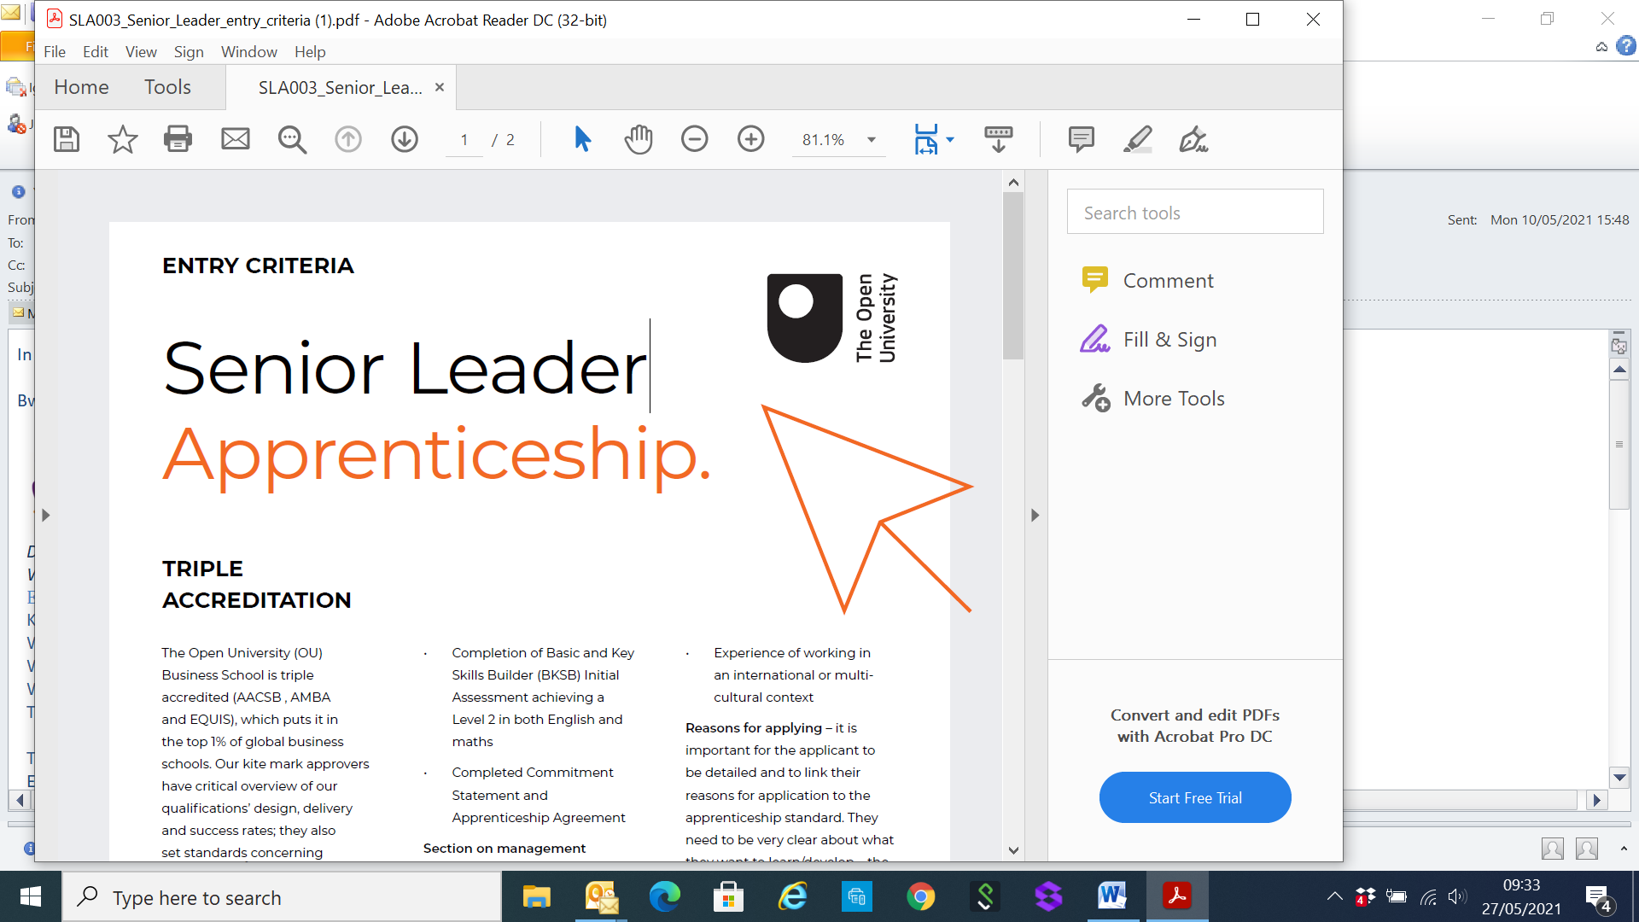**Senior Leader Apprenticeship**

The Open University Senior Leader Apprenticeship provides current and future leaders and senior managers with high-level leadership and management skills, core competencies and desired behaviours to become more effective leaders.

***QUALIFICATION: Apprentices who successfully complete the programme will gain the Postgraduate Diploma (Leadership Practice), awarded by The Open University.***

For further details please see below documents:

  

|  |
| --- |
|  |
| **Partners Page** |
|  |

|  |
| --- |
| [Support Worker Voice National Network event](https://learningpool.us14.list-manage.com/track/click?u=eb091041adad12fbba110166e&id=25f4aa3c31&e=51c14c77d7): **2nd June 2021 at 1:30 -3pm** ALL Support Workers in clinical roles in Health & Social Care are welcome! Together we will look at how to contribute to the Support Worker development agenda.  ECG Training – 8th June 2021 ~ CVD Management Update – 9th June 2021  Supervisory Skills – 8-9th June 2021 ~ Employment Law: Intro – 16th  June 2021  Reception Masterclass – 25th June 2021  There are a number of courses currently available, please click on the link for full details: <http://invictahealth.learningpool.com> |

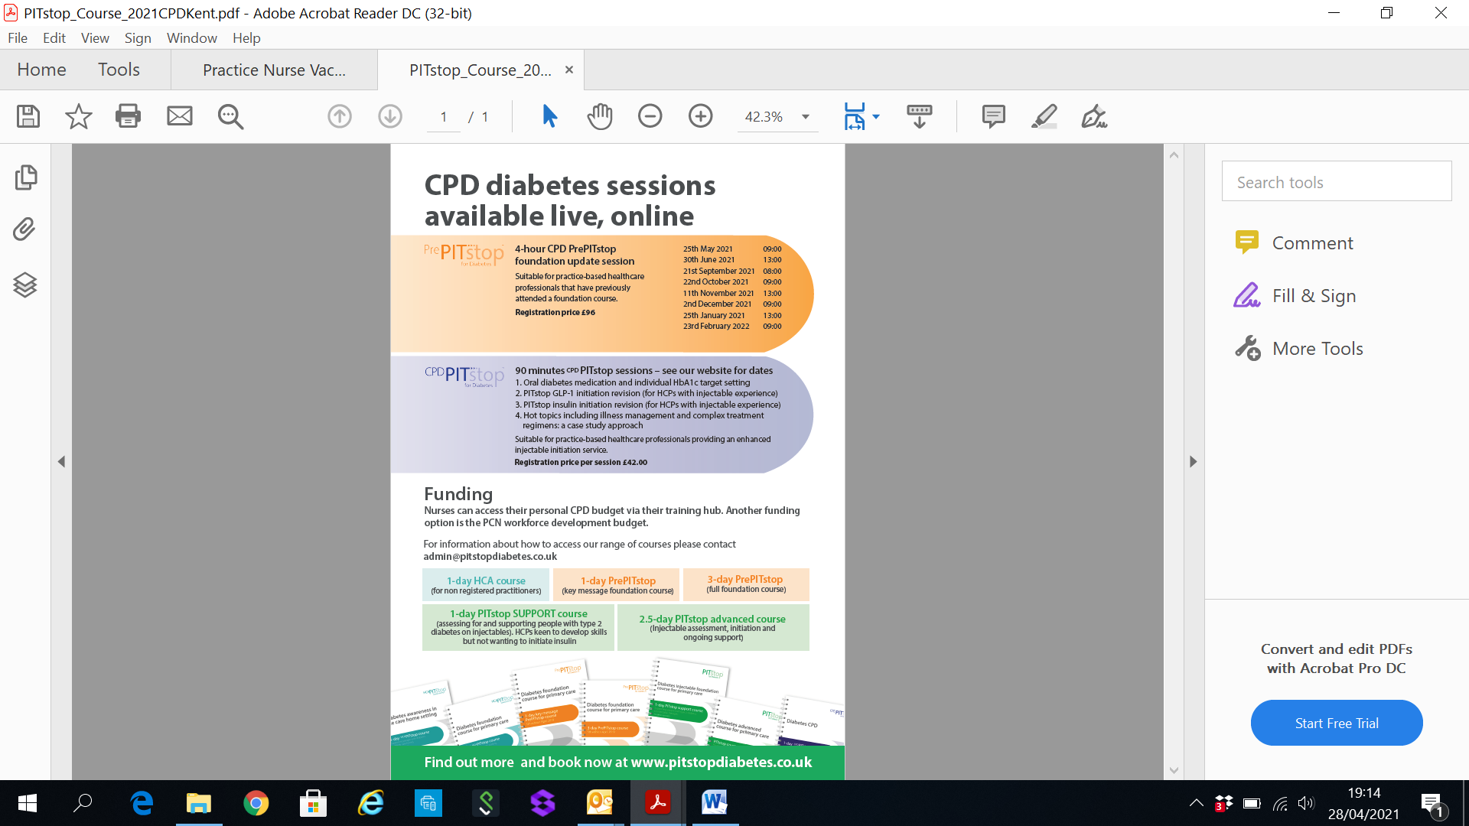 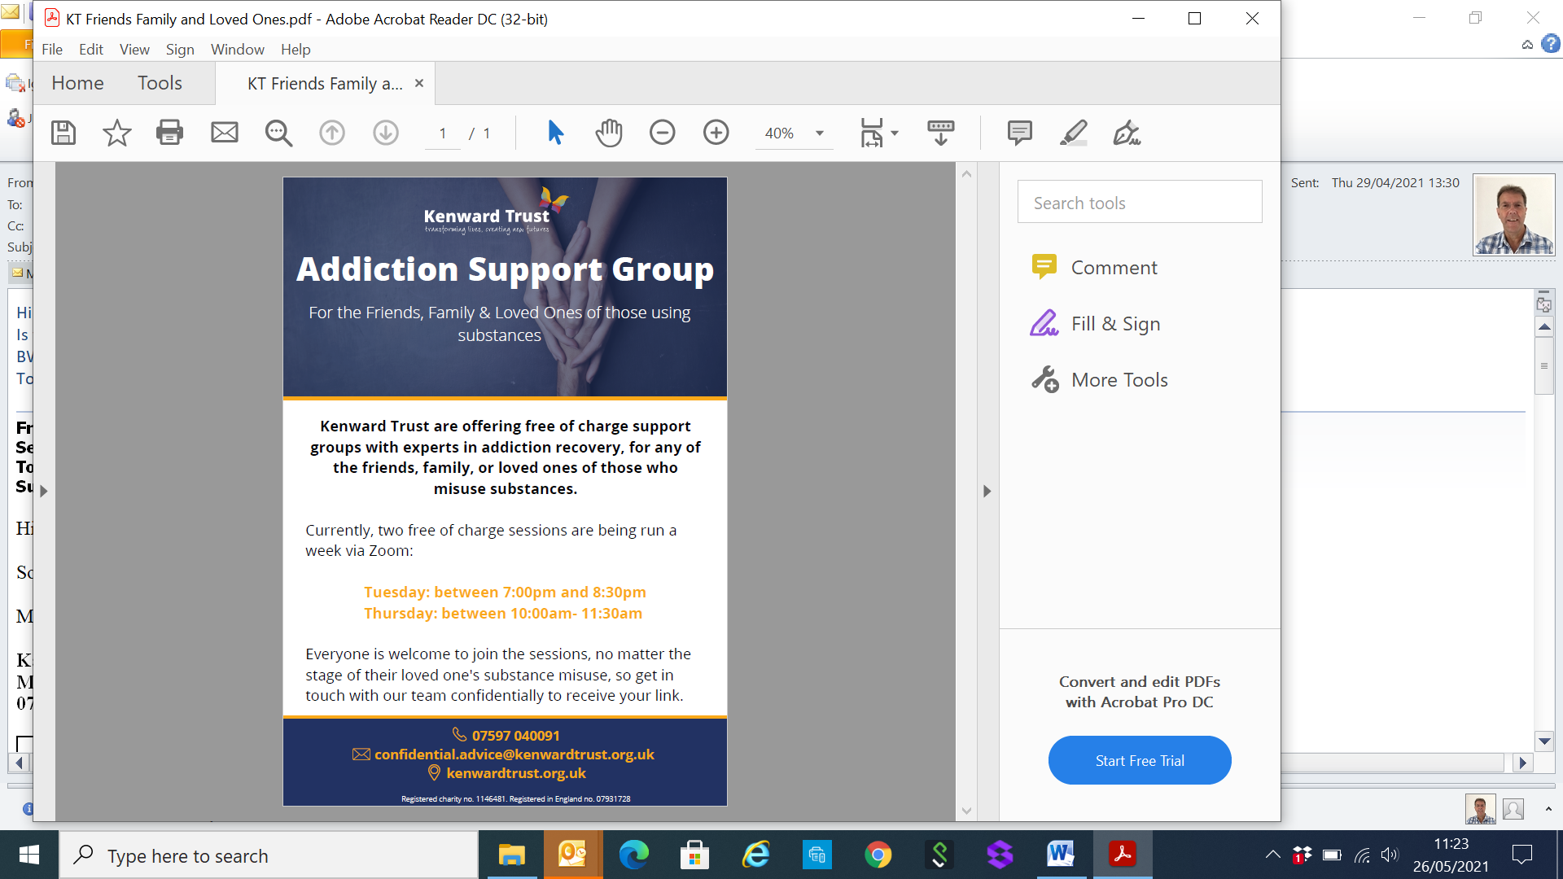

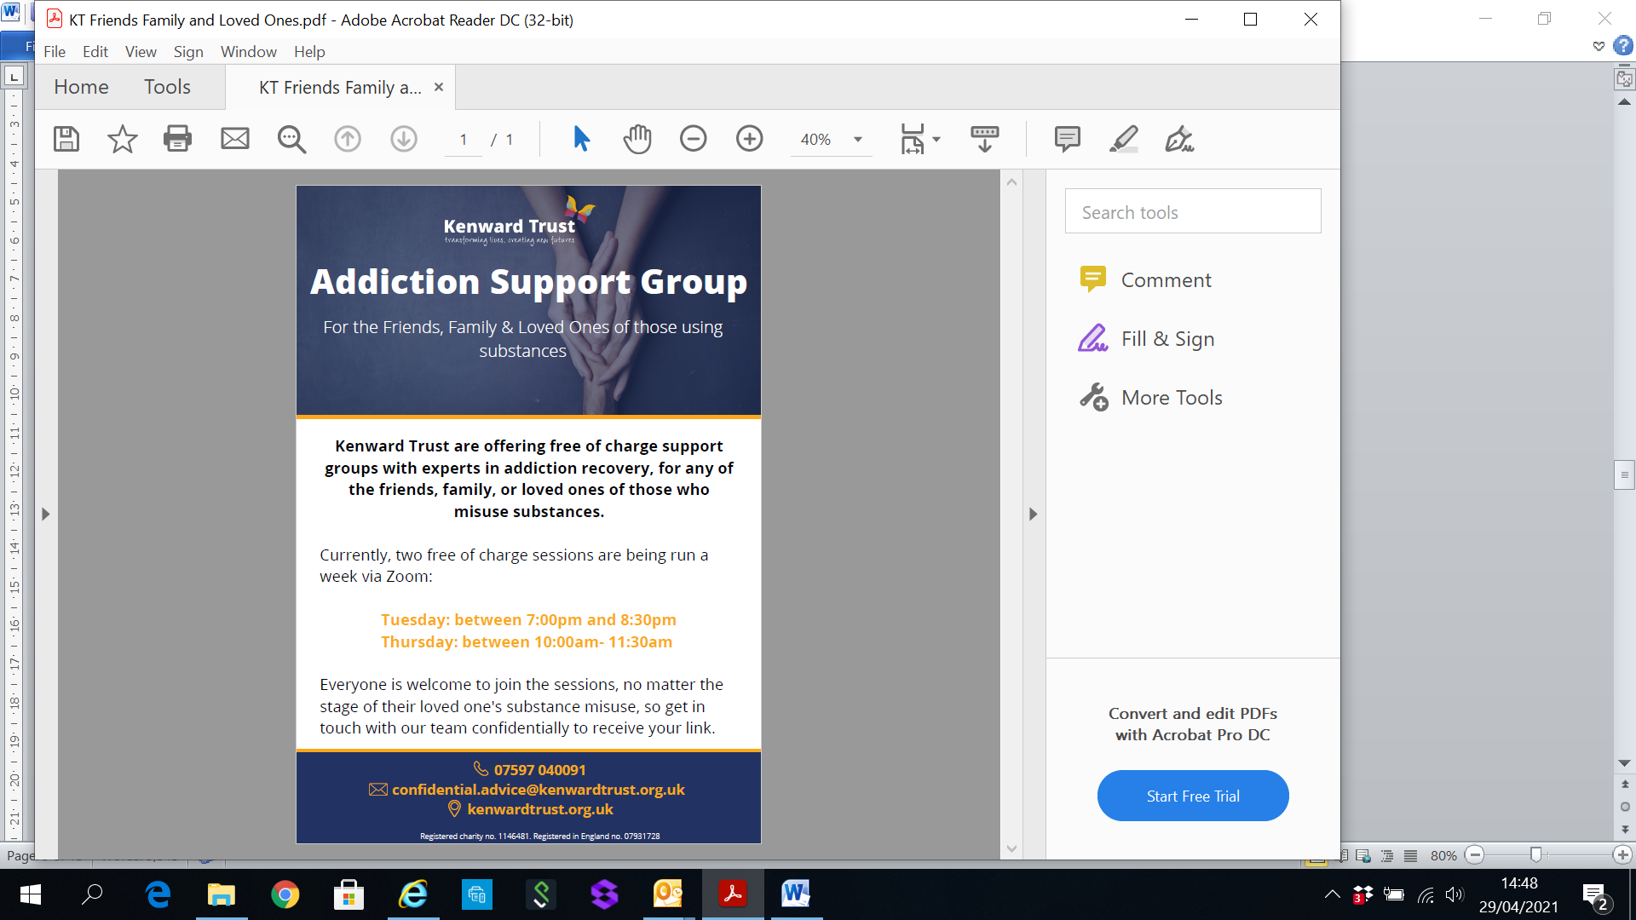

Find out more and book now at [www.pitstopdiabetes.co.uk](http://www.pitstopdiabetes.co.uk)

|  |
| --- |
|  |
| **Job Vacancies continued** |
|  |

**JOB TITLE: ADVANCED NURSE PRACTITIONER -** Closing Date: 11-JUNE-2021

**West Malling Group Practice** We are looking for an enthusiastic, highly motivated Advanced Nurse Practitioner to join our friendly practice team serving 21000 patients in the heart of Kent.

We are a very supported team committed to providing high quality patient care.

You will be part of a team of 7 GP Partners, 5 Salaried GPs, 2 Nurse Practitioners, a Pharmacist and a team of Practice Nurses and HCA’s with strong support from an experienced administrative and management team. We are GP and Nurse training practice.

You will need to be a degree qualified Advanced Nurse Practitioner with relevant clinical skills and expertise to work autonomously. You must have relevant experience to be an independent nurse prescriber enabling you to independently assess, diagnose, treat and refer patients as appropriate. IT will be expected that you will manage your own patient lists. We would also expect you to take on specific responsibilities in other areas of practice. A speciality area of interest would be an advantage. We are supportive of training and development.

We are ideally looking for this to be a full time position and can be flexible around the hours worked.

If you would like to be considered, please apply with full CV and a covering letter to the Practice Manager, Debbie Dean via [debbiedean@nhs.net](mailto:debbiedean@nhs.net) We welcome informal inquiries or visits

**JOB TITLE: FULL TIME OR 2 PART TIME TREATMENT ROOM NURSE(S) -** Closing Date: 23-JUNE-2021

**HEADCORN SURGERY** Due to expanding list size and the retirement of one of our nurses an exciting opportunity has occurred to join our friendly & innovative team at Headcorn Surgery. Our nursing team comprises 3 practice nurse, 2 ACPs, 3 health care assistants & 1 phlebotomist.

We are seeking 2 part or 1 full time treatment room nurse(s) with general practice experience. Duties will include general nursing services, cervical screening, child and adult immunisations, complex wound care, health and lifestyle, respiratory experience would be desirable.

We are offering a competitive salary depending on experience. Full NMC registration, relevant qualifications and enhanced DBS check are required. Headcorn Surgery is an equal opportunities employer.

For an informal discussion, please contact Alison O’Donoghue via alison.o’donoghue@nhs.net or telephone 01622 890608 (on Monday, Tuesday or Friday).

**Please visit our website for application form and job description** [www.headcornsurgery.co.uk](http://www.headcornsurgery.co.uk)

**JOB TITLE: 6 SESSION SALARIED GP**

Dynamic, well-established GMS practice in the town of Tonbridge, Kent. We are a forward-thinking, friendly and supportive surgery, with a list-size of 16,000 patients, working in brand new state of the arc building.

We have a team of 8 Partners, 7 Salaried Doctors, 4 Practice Nurses, 3 HCAs, and supportive admin team. We are a training practice and part of the Tonbridge PCN. We are looking for a Salaried GP to work 6 sessions a week.

Tonbridge has excellent road and rail links to Ashford, Canterbury, Folkestone and London. The practice is in a beautiful location by the river Medway, a short walk from the high street and shops.

Please contact Tonja Delafons – [tonja.delafons@nhs.net](mailto:tonja.delafons@nhs.net)   Tel: 01732 371599 for more information.

|  |
| --- |
|  |
| **Job Vacancies** |
|  |

**JOB TITLE: PRACTICE NURSE**

Dynamic, well-established GMS practice in the town of **Tonbridge, Kent**. We are a forward-thinking, friendly and supportive surgery, with a list-size of 16,000 patients, working in brand new state of the arc building.

We have a team of 8 Partners, 7 Salaried Doctors, 4 Practice Nurses, 3 HCAs, and supportive admin team. We are a training practice and part of the Tonbridge PCN.

We are looking for an experienced Practice Nurse to work approximately 26 hours a week which will include one late night on a Tuesday until 8pm.

The ideal candidate will be an experienced Practice Nurse who specialises in Diabetes and skills/experience includes childhood immunisations, travel vaccinations cytology, chronic disease management, along with the usual treatment room procedure.

Tonbridge has excellent road and rail links to Ashford, Canterbury, Folkestone and London. The practice is in a beautiful location by the river Medway, a short walk from the high street and shops.

Please contact Tonja Delafons – [tonja.delafons@nhs.net](mailto:tonja.delafons@nhs.net)

Tel: 01732 371599 for more information.

**JOB TITLE: SALARIED GP AT CLANRICARDE MEDICAL PRACTICE**

We are seeking two or more salaried GP’s to join our team and to cover a total of 10 sessions, starting from July 2021. We are recruiting due to an expansion in our practice list size. We would like the successful applicant(s) to be responsible for their own patient list.

We are a strong and supportive partnership of 8 GP’s with 4 part-time salaried GP’s. We have additional clinical care from one nurse prescriber, 4 practice nurses, 2 HCA’s along with a clinical pharmacist and social prescriber. We are a training practice and offer full contraceptive services and minor surgery.

We are located in central Tunbridge Wells with excellent schools and good transport links to London and the South East. We are a GMS practice caring for a patient population approaching 18000 and have excellent QOF achievements. We occupy a purpose built surgery with modern facilities. We are paper light and use EMIS and Docman 10.

Salary: £8800-£10000 per session per annum (depending on experience/qualifications) + 6 weeks holiday + 1 week study leave.

We are a warm, friendly practice and would welcome informal visits, or please submit your CV and covering letter to the Practice Manager: [denise.netherton@nhs.net](mailto:denise.netherton@nhs.net)