|  |
| --- |
|  |
| **Newsletter – July 2021** |  |

**WKEN Training Hub**





**Dates for your Diary:**

**Deadline for Newsletter –** please send your items through by the **24th** of the month.

**PLT DATES FOR 2021**

**9th Sept IN HOUSE**

**19th Oct TRAINING HUB**

**10th Nov PCN**

**Diabetes PLTs – An Update and how to access the recordings:**

**See Page 3 & 14**

**Weekly Desk Based Movements**

**Join us Every Tuesday at 1pm for a gentle 10 minute stretch and move session with Jane Taylor**

Please usethe link below:

<https://us02web.zoom.us/j/87937270272?pwd=ZlNVZmJkajV4WjR0QXh2MnliK202UT09>

West Kent Education Network

[**www.westkenteducationnetwork.co.uk**](http://www.westkenteducationnetwork.co.uk)

**Email:** [**kmccg.wkentraininghub@nhs.net**](mailto:kmccg.wkentraininghub@nhs.net)

[Image result for twitter logo](https://www.bing.com/images/search?view=detailV2&ccid=CqXWN5l4&id=8B16F98F138AFC909C08261085B90A4D34866D39&thid=OIP.CqXWN5l4IM2LxlE-H0lHOAHaHa&mediaurl=https://img.talkandroid.com/uploads/2016/01/twitter-app-logo.png&exph=512&expw=512&q=twitter+logo&simid=607994475025467935&selectedIndex=0&qpvt=twitter+logo) **@westkentWKEN**

|  |
| --- |
|  |
| Dear Reader,  Welcome to the West Kent Education Network Newsletter.  WKEN would like to thank all those who contribute to the content of this newsletter and ask that you please share this with your staff teams as there is an array of articles and opportunities open to all, so your help to share with your teams is very much appreciated.  We would love to hear from you and share your news, so if you have suggestions for future items, including job vacancies, please send through to [kmccg.wkentraininghub@nhs.net](mailto:kmccg.wkentraininghub@nhs.net) |
|  |

## West Kent Education Network (WKEN) has a new and improved website…

We are extremely excited to be able to advise that the Training Hub website has been revamped in order to provide a ‘go to’ location with a wealth of information and resources for those working in Primary Care in West Kent.

In addition to role specific information, latest updates and useful links, there is a new ‘Event Resources’ section found in the Members Area, where resources and recordings from WKEN training events, including from all 3 of the recent Diabetes PLTs can be located and viewed. So if you missed the PLT or would like to view 1 of the other recordings, log in to the Members Area (or register as a Member) on the websiteusing the link below[**www.westkenteducationnetwork.co.uk**](http://www.westkenteducationnetwork.co.uk) **(see Page 14).**

|  |
| --- |
|  |
|  |
| **SAFEGUARDING SECTION…** |
|  |
|  |

**Safeguarding adult Reviews** across Kent and Medway have highlighted the increased **vulnerabilities faced by carers** and they are often not aware that **carers assessment** is available for free to support their needs. Primary care are ideally placed to identify **carers** – **anyone over the age of 18** who is looking after someone regularly because they're ill, elderly or disabled – including family members.

If you identify a carer please signpost for self -referral or refer for a carers assessment via adult social care or to charities supporting young carers (under 18 ) <https://www.imago.community/Children-and-Young-People/Kent-Young-Carers>.

Further details including resources to support carers are available in the below 7 minute briefing.



**Domestic Violence and Abuse**

* one in four domestic homicides involve people over 60
* referrals into domestic abuse services drop off when clients reach 50 despite research identifying older women being just as likely to experience abuse
* older women stay in abusive relationships twice as long as younger women
* half of older female victims were killed by sons, grandsons and relatives

Myths and misconceptions about domestic abuse means that older victims aren’t asked about abuse. Remember to **Ask, Validate, Document & Refer.**If you want more information watch these videos below from the KIDAS 2020 Conference

* Warning Signs: [https://www.youtube.com/watch?v=wSRTsAmc1oY](https://eur01.safelinks.protection.outlook.com/?url=https%3A%2F%2Fwww.youtube.com%2Fwatch%3Fv%3DwSRTsAmc1oY&data=04%7C01%7CIona.Hunter-Whitehouse%40kent.gov.uk%7Cecdb2b5eb51741286d4408d92f13b464%7C3253a20dc7354bfea8b73e6ab37f5f90%7C0%7C0%7C637592585388949085%7CUnknown%7CTWFpbGZsb3d8eyJWIjoiMC4wLjAwMDAiLCJQIjoiV2luMzIiLCJBTiI6Ik1haWwiLCJXVCI6Mn0%3D%7C1000&sdata=6q8y4xSvBPa6ERQAwb24q3R6OHVoU9mq3jGNcmniFpA%3D&reserved=0)
* Managing Disclosure: [https://www.youtube.com/watch?v=BBENHoxzREM](https://eur01.safelinks.protection.outlook.com/?url=https%3A%2F%2Fwww.youtube.com%2Fwatch%3Fv%3DBBENHoxzREM&data=04%7C01%7CIona.Hunter-Whitehouse%40kent.gov.uk%7Cecdb2b5eb51741286d4408d92f13b464%7C3253a20dc7354bfea8b73e6ab37f5f90%7C0%7C0%7C637592585388959080%7CUnknown%7CTWFpbGZsb3d8eyJWIjoiMC4wLjAwMDAiLCJQIjoiV2luMzIiLCJBTiI6Ik1haWwiLCJXVCI6Mn0%3D%7C1000&sdata=kDP%2BYg%2Fmh6E%2BYNih8qXU6pqVTFsmb6bC00n1TLo12Gk%3D&reserved=0)
* How does DA Affect Older Victims - [https://www.youtube.com/watch?v=avQDFuZ70fY&list=PLphMV3M-GI_R8xpBrrS-OmwlszEyGNWcU&index=11](https://eur01.safelinks.protection.outlook.com/?url=https%3A%2F%2Fwww.youtube.com%2Fwatch%3Fv%3DavQDFuZ70fY%26list%3DPLphMV3M-GI_R8xpBrrS-OmwlszEyGNWcU%26index%3D11&data=04%7C01%7CIona.Hunter-Whitehouse%40kent.gov.uk%7Cecdb2b5eb51741286d4408d92f13b464%7C3253a20dc7354bfea8b73e6ab37f5f90%7C0%7C0%7C637592585388969076%7CUnknown%7CTWFpbGZsb3d8eyJWIjoiMC4wLjAwMDAiLCJQIjoiV2luMzIiLCJBTiI6Ik1haWwiLCJXVCI6Mn0%3D%7C1000&sdata=U1ODoL%2BaMHDpV7M%2FK49eDitkIe4NYIJQs544Yq3eLqE%3D&reserved=0)

Find out about how to refer to your local services across Kent and Medway here: [https://www.domesticabuseservices.org.uk/](https://eur01.safelinks.protection.outlook.com/?url=https%3A%2F%2Fwww.domesticabuseservices.org.uk%2F&data=04%7C01%7CIona.Hunter-Whitehouse%40kent.gov.uk%7Cecdb2b5eb51741286d4408d92f13b464%7C3253a20dc7354bfea8b73e6ab37f5f90%7C0%7C0%7C637592585388979069%7CUnknown%7CTWFpbGZsb3d8eyJWIjoiMC4wLjAwMDAiLCJQIjoiV2luMzIiLCJBTiI6Ik1haWwiLCJXVCI6Mn0%3D%7C1000&sdata=zFZRTUmhvo0XO9XovteoDqvtbRFs%2BKqGtoxiLiK2PpA%3D&reserved=0)

A list of specialist support services for Domestic Abuse is available here <https://www.gov.uk/government/publications/domestic-abuse-get-help-for-specific-needs-or-situations/domestic-abuse-specialist-sources-of-support>

**PREVENT Training**

**Basic Prevent Awareness Training should be included in all staff induction training.**

Competency at Level 1 and 2 can be acquired by completing targeted Prevent training, including:

* Basic Prevent Awareness (Level 1-2) e-learning (e-LfH)11; <https://portal.e-lfh.org.uk/Component/Details/459770>
* Prevent Awareness e-learning (gov.uk); <https://www.elearning.prevent.homeoffice.gov.uk/la2/screen1.html>
* Royal College of General Practitioners ‘Safeguarding People with a Vulnerability to Radicalisation e-learning: <https://elearning.rcgp.org.uk/course/search.php?search=radicalisation>

Training at Level 3 can be acquired through face-to-face and/or e-learning.

* Face-to-face training PLT events including PREVENT training
* Preventing Radicalisation Level 3 e-learning (e-LfH);21 <https://portal.e-lfh.org.uk/Component/Details/511790>
* Prevent Referrals e-learning (gov.uk). <https://www.elearning.prevent.homeoffice.gov.uk/prevent_referrals/01-welcome.html>

**Dr Reshma Rajagopal**

**Named GP for safeguarding NHS CCG Kent and Medway Named GP for Safeguarding Children and Adults (West Kent)**

|  |
| --- |
|  |
|  |
| **UPDATE ON THE DIABETES PLT EVENTS…** |
|  |
|  |

**WKEN were absolutely delighted to have over 840 people attending across the three PLTs, all learning together to improve the care of people with diabetes in West Kent.**

Thank you to all our speakers (22 in total for the 3 events!) for giving up their time to share their expertise. As always there is a massive team behind the events and thank you to everyone who helped with the organisation before and on the day itself. Special mention to Su Arumugam, David Kjellgren and Martin Steward for coordinating all the speakers who prerecorded their talks and to Rob Derrick and Caroline Wells for getting all of these up on the website, which the additional links will be a fabulous resource. Please do check these out and watch the talks for all the sessions.

It was great to work together with colleagues across KMCCG, West Kent Health, KCHFT and MTW NHS Trust to put on the event. This time we extended the invitation to join the PLT to anyone interested in joining and were delighted that staff from Social Care, Community trusts and Secondary Care took up the offer.  We look forward to being able to facilitate more joint learning in the future.

Big thank you to everyone for their interactions, questions and comments and those who have completed the evaluation forms. We really appreciate this and will be looking through the scores and comments so we can adapt and change and make the next PLT even better!

**Clinical Stream 1:** Chair – Dr Jane Roome, Co-Chair – Dr Rob Derrick with support from Sally Retallick, Carol Williams and Dr Sarah Crabbe with AV support from Dave Kjellgren

**Clinical Stream 2:** Chair – Dr Tony Jones, Co-Chair – Julia Speight with support from Su’ Arumugam, Nicki Knight and Philly Adams with AV support from Martin Stewart

**Non Clinical:** Chair – Clare Hairs, Co-Chair – Caroline Wells with support from Mel’ Prentice and Karen Hardy with AV support from Helen

*The results of the evaluations will be uploaded to the new WKEN website, along with the recordings from these and other WKEN training events, located in the ‘Members’ area (top right of the home page). If you haven’t already registered as a Member visit* [**www.westkenteducationnetwork.co.uk**](http://www.westkenteducationnetwork.co.uk)

|  |
| --- |
|  |
| **Wellbeing** |
|  |

**DESK BASED MOVEMENTS - weekly 10 minute sessions**

We have received some great feedback from the weekly movement sessions so keep sending in your comments. Jane Taylor has kindly set up a specific ‘member area’ on her website so all the recordings are available and can be easily accessed.

* <https://vimeopro.com/taylormadefitness/wken-weekly-work-based-movement-sessions>

It is password protected and I have used the password:WKEN-move-more

**Join us every Tuesday at 1pm** - **we look forward to seeing you then:**

<https://us02web.zoom.us/j/87937270272?pwd=ZlNVZmJkajV4WjR0QXh2MnliK202UT09>

|  |
| --- |
|  |
|  |
| **Communities of Practice** |
|  |

**MAIDSTONE**

Facilitated by Dr Tony Jones, the following clinical communities of practice groups are available.

Email addresses are provided as the main contact for each group, but should you require further information or would like to discuss further, please contact [tony.jones@nhs.net](mailto:tony.jones@nhs.net)

Paramedics working in general practice - [ian.phillpott@nhs.net](mailto:ian.phillpott@nhs.net)

Clinical pharmacists in general practice - [elizabethwallis@nhs.net](mailto:elizabethwallis@nhs.net)

Advanced nurse practitioners in general practice - [vickiemehaffey@nhs.net](mailto:vickiemehaffey@nhs.net)

**TUNBRIDGE WELLS – and virtually to incorporate a wider area**

Facilitated by Dr Jane Roome,  both the New to West Kent (for GPs who are newly qualified, new to the area or new to role) and the West Kent Sessional GP group (for any GPs who are not a partner) have WhatsApp groups and are starting Virtual meetings via Zoom. Traditionally these have been Tunbridge Wells based but given we're meeting virtually now please feel free to join and gain support and knowledge from other GPs in the area wherever your base may be. ​

Please contact [jane.roome@nhs.net](mailto:jane.roome@nhs.net) for more information and to join the groups.

|  |
| --- |
|  |
| **Dates for your diary…** |
|  |

***Educational Opportunities open for all Primary Care and interested staff***

​​​**Virtual evening meetings via Zoom: Free and open to all staff**

We're in the process of finalising a few meetings based on what you've voted for in the polls and asked for on the evaluation forms, so please watch out for more details in the next few weeks.

Please email [jane.roome@nhs.net](mailto:jane.roome@nhs.net) with any ideas, comments or suggestions for topics or ideas for future meetings and look forward to seeing you at one of the upcoming meetings.

|  |
| --- |
| Promoting the GP Retention scheme locally​​​​​​​ HEE logo |
| If you would like to promote the GP Retention scheme in your local area, there is a [guidance document](http://news.hee.nhs.uk/_act/link.php?mId=J923982614282652953143151zzzzz643ee15a23c62ee31fe78f65aadc68449845fc16a72a4fb8d18af422519c6dfcdd&tId=392991585) available with some helpful links and guidelines.  As always, the most up to date scheme information can be found on the [national Retention scheme webpages](http://news.hee.nhs.uk/_act/link.php?mId=J923982614282652953143151zzzzz643ee15a23c62ee31fe78f65aadc68449845fc16a72a4fb8d18af422519c6dfcdd&tId=392991588).  *Shared from KSS - South East Training Hub bulletin, Issue 104 - Friday 23 July 2021* |

|  |
| --- |
|  |
| **Exciting Opportunities…** |
|  |

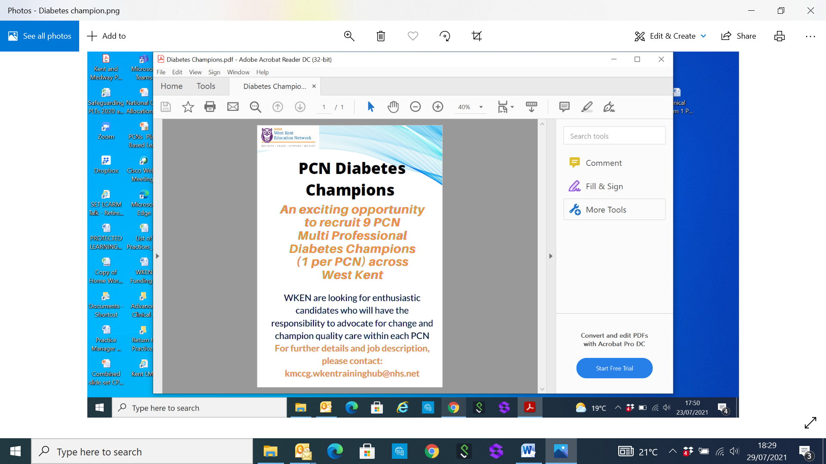

[**kmccg.wkentraininghub@nhs.net**](mailto:kmccg.wkentraininghub@nhs.net)

**CLOSING DATE 31st AUGUST 2021**



**GatewayC is an online cancer education platform for healthcare professionals across England.**

There are currently 21 online courses available and 14 recorded webinars covering various cancer sites and topics. All courses are RCGP accredited and follow NICE NG12 guidance.

The platform is fully funded by Health Education England and has over 9,000 users from all regions across England.

Details of upcoming and recorded cancer education webinars can be accessed once registered. To register with GatewayC please visit [gatewayc.org.uk](http://www.gatewayc.org.uk/)

|  |
| --- |
|  |
| **Exciting Opportunities (continued)** |
|  |

**Nursing Associate Animation**

HEE have recently spoken with 4 TNAs/NAs across the country to hear about their roles. These stories form part of our new short animation which aims to raise awareness around what trainee nursing associate and nursing associates can bring to an organisation across these four settings:

•         Acute – surgical ward •         Community & mental Health

•         Primary care and learning disability •         Social care

**Do you have 3 minutes? Watch the video here:** [**https://youtu.be/YMYT1aIugXI**](https://youtu.be/YMYT1aIugXI)**.**

**Support with NARIC/ENIC of overseas qualifications**

HEE can offer support with NARIC/ENIC conversion of overseas qualifications. Please note:

* Functional Skills equivalence can only be assessed from secondary school level qualifications
* To assess, we need to see a clear picture of the certificate and transcript if the various modules/courses are not on the main certificate
* If it's a non-standard script (Greek, Mandarin, Cyrillic etc) we will need to see a certified translation AND the original certificate/transcript
* Queries only to come from a nominated lead, rather than the individuals
* Please let us know if you need a formal Statement of Equivalence e.g. been asked to provide by an education provider or just making a speculative query and don't need the statement immediately would be very helpful as this can save me a bit of time.

For more details please contact - [elaine.lancaster@hee.nhs.uk](mailto:elaine.lancaster@hee.nhs.uk)

**National support worker voice forum**

Please share details of the upcoming event (below) with relevant staff – open to all support workers (who may be aspiring nursing associates!).

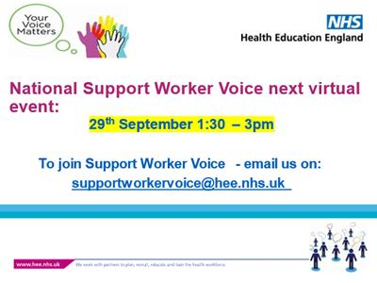

|  |
| --- |
|  |
| **Exciting Opportunities (continued)** |
|  |

**Courses for nurses - new to practice.**

The Greenwich Introduction to practice nursing course is now running again.

It is set over six months and covers: immunisations, cytology, travel health and much more please see programme below.

Please apply to Shaun Heath  at Greenwich [S.D.Heath@greenwich.ac.uk](mailto:S.D.Heath@greenwich.ac.uk) to book a place and to WKEN for funding (subject to acceptance criteria). This course is suitable for nurses who are either new to role and or newly qualified.

|  |  |  |  |  |  |
| --- | --- | --- | --- | --- | --- |
| **Week** | **Date** | **AM Session** | **PM session** | **Teaching Method** | **Teacher** |
| 3 | 27.9.21 | Introduction |  | F2F | Shaun Heath |
| 3 | 27.9.21 |  | Overview of Primary care | F2F | Shaun Heath |
| 5 | 11.10.21 | Cytology |  | F2F -Skills | Ros Deleany |
| 5 | 11.10.21 |  | Cytology | F2F -Skills | Ros Deleany |
| 7 | 25.10.21 | Cytology |  | F2F-Skills | Ros Deleany |
| 7 | 25.10.21 |  | Cytoly | F2F - Skills | Ros Deleany |
| 9 | 8.11.21 | *elearning for health* |  | *Online* | Shaun Heath |
| 9 | 8.11.21 |  | *elearning for health* | *Online* | Shaun Heath |
| 10 | *15.11.21* | *Travel* |  | *Lecture: MS teams* | *Shaun Heath* |
| 10 | *15.11.21* |  | *Travel* | *Flipped seminar: MS teams* | *Shaun Heath* |
| 11 | 22.11.21 | *Immunisations - Day 2* |  | F2F | Shaun Heath |
| 11 | 22.11.21 |  | *Immunisations - Day 2* | F2F | Shaun Heath |
| 13 | 6.12.21 | Mental health |  | MS teams | Shaun Heath |
| 13 | 6.12.1 |  | Dementia & Frailty | MS teams | Shaun Heath |
| *14* | *13.12.21* | *Resp - asthma and copd* |  | *F2F* | *Shaun Heath* |
| *14* | *13.12.21* |  | *Ear Care* | *F2f* | *Shaun Heath* |
| 19 | 17.1.22 | Asthma & Copd |  | MS teams | Shaun Heath |
| 19 | 17.1.22 |  | CVD/CHD | MS teams | Shaun Heath |
| 20 | 24.1.22 | Wound Care |  | F2F | Shaun Heath |
| 20 | 24.1.22 |  | Motivational interviewing | F2f | Shaun Heath |
| 22 | 7.2.22 | Diabetes |  | MS teams | Shaun Heath |
| 22 | 7.2.22 |  | Contraception & SAI | MS teams |  |
| 24 | 21.2.22 | Case Studies |  | F2F | Shaun Heath |
| 24 | 21.2.22 |  | Self directed study |  | Shaun Heath |

For nurses entering General Practice who require additional management and leadership skills and who wish to study at Masters level for two years, we have the New To Practice Fellowship Programme.

This course is run part time (one day a month). Education is split between Canterbury Christchurch University and Invicta Learning.

|  |
| --- |
|  |
| **Exciting Opportunities (continued)** |
|  |

Students are expected to complete the course which includes submitting level 7 academic writing to Canterbury Christchurch University, completing modules with Invicta, developing a quality improvement project for their practice and evidencing their competencies through a portfolio collected over the two years.

Nurses who have previously completed the Greenwich introduction to practice nursing course can APEL credits across to this course.

Funding for the course can be applied for through WKEN but students will be expected to sign a learning contract with the training hubs.

Both courses start in September 2021

Please contact Philly Adams if you require additional information. [Philly.adams@nhs.net](mailto:Philly.adams@nhs.net)

**Online GP Masterclass – Prescribing in Pregnancy and Breastfeeding**

**Improve your prescribing practice with the Drug Safety Research Unit (DSRU)**

The DSRUs Masterclasses are carefully designed in consultation with GPs, to provide you with interactive training which can be applied directly to your everyday general practice.

Our upcoming **online GP Masterclass – Prescribing in Pregnancy and Breastfeeding** is taking place in just 9 weeks’ time and is a day packed with practical advice from GPs and specialist colleagues.

Join us on **Wednesday 29th September** and you will:

* Improve your knowledge of prescribing for pre-existing medical problems during pregnancy
* Clarify issues to consider when prescribing during breastfeeding
* Understand pitfalls that GPs should avoid when prescribing during pregnancy
* Establish the key considerations for perinatal mental health
* Understand what GPs need to know when prescribing valproate to women of childbearing potential

Why choose DSRU for your prescribing training?

* Small delegate numbers mean you have the opportunity to ask questions and network with expert speakers
* Use this course as part of your Continuing Professional Development (CPD)
* Taught by GP and specialist colleagues, making the presentations relevant to every day practice
* No sponsorship from the pharmaceutical industry
* £150 (incl VAT) for a full day training, or £102 (incl VAT) for GP registrars.

To book your place please visit the [website](https://gbr01.safelinks.protection.outlook.com/?url=https%3A%2F%2Fwww.dsru.org%2Fservice%2Fgp-masterclass-prescribing-in-pregnancy-and-breastfeeding&data=04%7C01%7Cdenise.good%40dsru.org%7C60c93e0b3e664bdead9e08d95037f9b9%7C9dd02833a1564ca99cb178fe57aeb358%7C0%7C0%7C637629023604467115%7CUnknown%7CTWFpbGZsb3d8eyJWIjoiMC4wLjAwMDAiLCJQIjoiV2luMzIiLCJBTiI6Ik1haWwiLCJXVCI6Mn0%3D%7C1000&sdata=tjlKQ9gr9T48RGvIGWJDz0tZdB7HlNZh8HItVeTvMi4%3D&reserved=0).

The full agenda is below. Please contact the DSRU Education & Training team with any questions on [EandT@dsru.org](mailto:EandT@dsru.org)



|  |
| --- |
|  |
| **Items of Interest** |
|  |

**Pharmacists in Prevention of Cardiovascular Disease - Part of the Healthy Life Webinar Series – Monday, 16th August – 4.00pm to 5.30pm via Zoom**

We shall be show-casing the various pharmacy professional roles and opportunities to tackle the CVD prevention agenda from an international perspective; drawing synergies and learnings from Canada, Germany and the UK. Our expert speakers include:

* **Prof Ross Tsuyuki**, Professor and Chair, Department of Pharmacology, Faculty of Medicine and Dentistry, University of Alberta; Professor of Medicine (Cardiology) and Director, EPICORE Centre
* **Prof Martin Schulz**, Adjunct Professor, Institute of Pharmacy, Free University, Berlin
* **Helen Williams,** Consultant Pharmacist for Cardiovascular Disease, South East London Clinical Commissioning Group; National Specialty Adviser for Cardiovascular Disease Prevention, NHS England and NHS Improvement; Clinical Adviser for Cardiovascular Disease, UCL Partners

[Click here to register free for the webinar on EventBrite.](https://www.eventbrite.co.uk/e/pharmacists-in-prevention-of-cardiovascular-disease-tickets-157544685395)

These webinars are free and are hosted on Zoom. They are open to a wide range of professionals interested in health, including clinical trainees, senior clinicians, policy makers, academics and other health professionals. The session is also open to interested members of the public. If you wish to make a donation to the Cardiovascular Research Trust you may do so on our EventBrite page.

[Find out more about this webinar and the speaker panel on our website](https://healthyheartcharity.com/2021/05/31/the-role-of-pharmacists-in-prevention-of-cardiovascular-disease/)

**Agenda**

16:00 – 16:05  Webinar opening

Prof Donald Singer, Chair, Cardiovascular Research Trust

Anisha Soni, Trustee, Cardiovascular Research Trust

16:05 – 16:20  The role of pharmacists in CVD Prevention: A Canadian Perspective

Prof Ross Tsuyuki, Professor and Chair, Department of Pharmacology, Faculty of Medicine and Dentistry, University of Alberta; Professor of Medicine (Cardiology) and Director, EPICORE Centre

16:20 – 16:35 The role of pharmacists in CVD Prevention: A German Perspective

Prof Martin Schulz, Adjunct Professor, Institute of Pharmacy, Free University, Berlin

16:35 – 16:50  The role of pharmacists in CVD Prevention: A UK Perspective

Helen Williams, National Specialty Adviser for Cardiovascular Disease Prevention, NHS England and NHS Improvement

16:50 – 17:05  Q & A –from the audience

Anisha Soni, Trustee, Cardiovascular Research Trust

17:05 – 17:15 Final remarks from the speakers

17:15               Close of webinar

|  |
| --- |
|  |
| **Partners Page** |
|  |

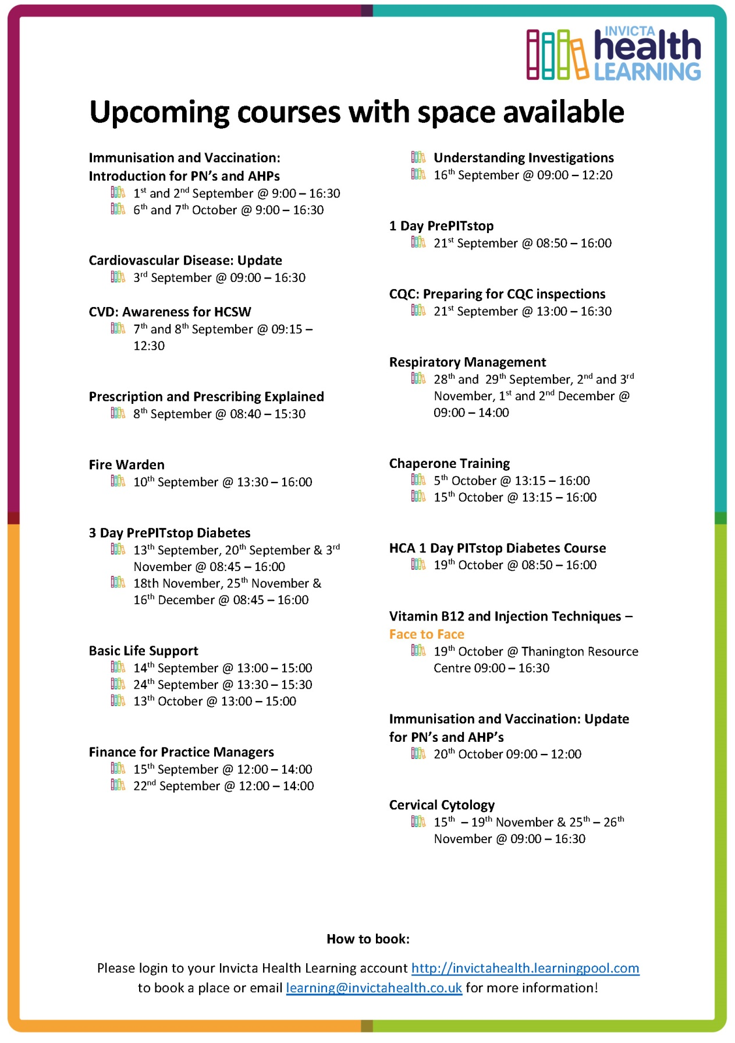

|  |
| --- |
|  |
| **Job Vacancies** |
|  |

**JOB TITLE: 6 SESSION SALARIED GP**

Dynamic, well-established GMS practice in the town of Tonbridge, Kent. We are a forward-thinking, friendly and supportive surgery, with a list-size of 16,000 patients, working in brand new state of the arc building.

We have a team of 8 Partners, 7 Salaried Doctors, 4 Practice Nurses, 3 HCAs, and supportive admin team. We are a training practice and part of the Tonbridge PCN. We are looking for a Salaried GP to work 6 sessions a week.

Tonbridge has excellent road and rail links to Ashford, Canterbury, Folkestone and London. The practice is in a beautiful location by the river Medway, a short walk from the high street and shops.

**JOB TITLE: PRACTICE NURSE**

We are also looking for an experienced Practice Nurse to work approximately 26 hours a week which will include one late night on a Tuesday until 8pm.

The ideal candidate will be an experienced Practice Nurse who specialises in Diabetes and skills/experience includes childhood immunisations, travel vaccinations cytology, chronic disease management, along with the usual treatment room procedure.

Please contact Tonja Delafons – [tonja.delafons@nhs.net](mailto:tonja.delafons@nhs.net)   Tel: 01732 371599 for more information on the above.

**JOB TITLE: SCANNING / ADMINISTRATION CLERK - Fantastic opportunity to be the next member of our growing admin team at Edenbridge Medical Practice**

*We currently have a vacancy for a* ***Scanning/ Administration clerk*** *and looking for an enthusiastic person to join us for between 20-30 hours per week. Experience with "Emis Web" and Docman 10 scanning system preferred although not essential and training will be given. Computer skills essential and a DBS check will be required.*

The Practice is a town located in Sevenoaks district with two stations with excellent rail links to London and the continent, good schools and amenities.

We are passionate about delivering high quality healthcare to our 12,500 patients by combining traditional list-holding family medicine with more innovative primary care roles including Nurse Practitioners, First Contact Physiotherapists, Social Prescribers and GP Assistants.

Plans are currently well underway for a purpose-built, combined GP and community health facility in the near future, from which we will deliver more joined-up community care.

We are a Dispensing Practice, offering a very competitive income, using Emis Web and were recently rated as ‘good’ in all areas by the CQC. We are well represented within local networks, with GPs in the Practice having leadership roles at PCN and CCG level.

For more information or to apply for this role, please contact the Practice Manager, Karen Copping on 01732 861482 or email [karen.copping3@nhs.net](mailto:karen.copping3@nhs.net)

Reference ID: SC 01 / Part-time hours: 25-30 per week / Job Type: Part-time, Permanent / Salary: £8.50 per hour

|  |
| --- |
|  |
| **Job Vacancies** |
|  |

**Fantastic opportunity to be the next member of our growing clinical team at Edenbridge Medical Practice**

*We are looking for an enthusiastic GP to join us for 4-6 sessions a week with the possibility of future partnership for the right candidate.*

This position is for a list holder with an extremely competitive salary of £11000 per session. The Practice is a town located in Sevenoaks district with two stations with excellent rail links to London, good schools and amenities.

We are passionate about delivering high quality healthcare to our 12,500 patients by combining traditional list- holding family medicine with more innovative primary care roles including Nurse Practitioners, First Contact Physiotherapists, Social Prescribers and GP Assistants.

Plans are currently well underway for a purpose-built, combined GP and community health facility in the near future, from which we will deliver more joined-up community care.

We are a Dispensing Practice, offering a very competitive income, using Emis Web and were recently rated as ‘good’ in all areas by the CQC. We are well represented within local networks, with GPs in the Practice having leadership roles at PCN and CCG level.

For more information or to apply for this role contact the Practice Manager, Karen Copping via email [karen.copping3@nhs.net](mailto:karen.copping3@nhs.net)

***Brewer Street Surgery, Maidstone. GP Partnership vacancy February 2022***

*Congratulations on choosing probably the best career available! We hope you enjoy general practice as much as we do.*

Brewer Street Surgery was established over 70 years ago and has been proudly serving patients in the heart of Maidstone and surrounding area since then. We are an exceptionally stable surgery, well-respected and currently with around 9,200 patients. Many of our elderly patients have been with us since birth, and we have a handful of families in which we are proud to look after all four generations. We achieve above the local and national average in the National Patient Survey.

We have a high reputation locally and engage with all local organisations and CCG-run schemes. We are an active member of our PCN. We achieve high QOF scores and earn well above the national average. We are fortunate to own our own building, so have no leasehold issues. We use the EMIS Web computer system.

We have a partner retiring around the end of January 2022 and are looking for a replacement partner, though we can be flexible on the dates. We are very happy to consider doctors straight off the VTS scheme who are looking to bring their skills to help develop a thriving successful partnership, or more experienced GPs, or a fulltime salaried post with a view to becoming a partner. We would be supportive if you are keen to develop interests either inside or outside the practice alongside your GP career. Most of all we are looking for someone who is passionate about being a GP- you would fit right in! If GP Partnership is for you, we would love to hear from you, even just for an informal chat.

There is so much more we would like to tell you than we can include in this short summary- we hope to hear from you if you are interested.

Thank you

Eddie and Chris

[***edward.garrett@nhs.net***](mailto:edward.garrett@nhs.net)*and*[***chrismitchell@nhs.net***](mailto:chrismitchell@nhs.net)

|  |
| --- |
|  |
| **Job Vacancies** |
|  |

**JOB TITLE: EXPERIENCED PRACTICE NURSE**

Lamberhurst Surgery is a small, friendly GP Practice; we are looking for an experienced Practice Nurse who can offer a full range of nursing services to our Practice population.  Ideally, we are looking for 20 hours per week; we are flexible on days to be worked.

Please contact Mrs Caroline Conlon, Practice Manager on 01892 890800 or [caroline.conlon@nhs.net](mailto:caroline.conlon@nhs.net) for more information.

***ADVERTISED ON BEHALF OF WEST KENT PRIMARY CARE – GP FEDERATION***

**JOB TITLE: SEVENOAKS PRIMARY CARE NETWORK OPERATIONS MANAGER**

**Closing Date: 04/08** [**https://www.jobs.nhs.uk/xi/vacancy/916617543/2021**](https://www.jobs.nhs.uk/xi/vacancy/916617543/2021)

**JOB TITLE: SEVENOAKS PRIMARY CARE NETWORK CLINICAL PHARMACIST**

**Closing Date: 04/08/2021**

**Link:**[**https://www.jobs.nhs.uk/xi/vacancy/916639627**](https://www.jobs.nhs.uk/xi/vacancy/916639627)

**JOB TITLE: PRIMARY CARE AND FRAILTY PHYSICIAN ASSOCIATE**

**Closing Date: 05/08/2021**

**Link:**[**https://www.jobs.nhs.uk/xi/vacancy/916641984**](https://www.jobs.nhs.uk/xi/vacancy/916641984)

**JOB TITLE: PRIMARY CARE NETWORK CLINICAL PHARMACIST – FULL TIME POSITION**

**Closing Date: 01/08/2021**

**Link:** [**https://www.jobs.nhs.uk/xi/vacancy/916617402**](https://www.jobs.nhs.uk/xi/vacancy/916617402)

|  |
| --- |
|  |
| **PREVIEW OF THE NEW EVENT RESOURCES SECTION…** |
|  |

***Log into the new website and click on Register or Member to access the recordings:***

[**www.westkenteducationnetwork.co.uk**](http://www.westkenteducationnetwork.co.uk)

**MEMBERS AREA (or Register if not already a member)**

