|  |
| --- |
|  |
| **Newsletter – August 2021** |  |

**WKEN Training Hub**





**Dates for your Diary:**

**Deadline for Newsletter –** please send your items through by the **24th** of the month.

**PLT DATES FOR 2021**

**9th Sept IN HOUSE**

**19th Oct TRAINING HUB**

**10th Nov PCN**

**PLT DATES FOR 2022 are being reviewed and will be shared asap**

**Weekly Desk Based Movements**

**Join us every Tuesday at 1pm for a gentle 10 minute stretch and move session with Jane Taylor**

Please usethe link below:

<https://us02web.zoom.us/j/87937270272?pwd=ZlNVZmJkajV4WjR0QXh2MnliK202UT09>

West Kent Education Network

[**www.westkenteducationnetwork.co.uk**](http://www.westkenteducationnetwork.co.uk)

**Email:** [**kmccg.wkentraininghub@nhs.net**](mailto:kmccg.wkentraininghub@nhs.net)

[Image result for twitter logo](https://www.bing.com/images/search?view=detailV2&ccid=CqXWN5l4&id=8B16F98F138AFC909C08261085B90A4D34866D39&thid=OIP.CqXWN5l4IM2LxlE-H0lHOAHaHa&mediaurl=https://img.talkandroid.com/uploads/2016/01/twitter-app-logo.png&exph=512&expw=512&q=twitter+logo&simid=607994475025467935&selectedIndex=0&qpvt=twitter+logo) **@westkentWKEN**

|  |
| --- |
|  |
| Dear Reader,  Welcome to the West Kent Education Network Newsletter.  WKEN would like to thank all those who contribute to the content of this newsletter and ask that you please share this with your staff teams as there is an array of articles and opportunities open to all, so your help to share with your teams is very much appreciated.  We would love to hear from you and share your news, so if you have suggestions for future items, including job vacancies, please send through to [kmccg.wkentraininghub@nhs.net](mailto:kmccg.wkentraininghub@nhs.net) |
|  |

## West Kent Training Hub Website…

We are extremely excited to be able to advise that the Training Hub website has been revamped in order to provide a ‘go to’ location with a wealth of information and updates.

For ease of access please scan the below QR code which will take you directly to the Training Hub website.

|  |
| --- |
|  |
|  |
| **SAFEGUARDING SECTION…** |
|  |
|  |

**Fabricated or Induced Illness**

Royal College of Paediatricians and Child Health published guidance in relation to Perplexing Presentations/ Fabricated or Induced Illness and a summary of the guidance for Primary Care is below:



**Private Fostering**

A private fostering arrangement occurs when a child under 16 (or 18 if the child is disabled) is cared for and lives with an adult who is not a relative for 28 days or more.

The Children Act 1989 defines a relative as a step parent (by marriage or civil partnership), grandparent, step grandparent, brother, sister, uncle or aunt.

Private fostering is a private arrangement made by the parent(s), (or those with parental responsibility) for someone to care for their child because they are unable to do so (permanently or temporarily). This may be due to parental ill health, a parent going abroad or in to prison, a child being bought to the UK to study English, the relationship between the child and parent has broken down etc.

Parents and Private Foster Carers have a duty to inform the Local Authority regarding private fostering arrangements, but **professionals need to recognise these arrangements and have a duty to inform the Local Authority.**

This can be done via the Front Door Service: 03000 411111 Or Send a Request for Support:

<https://webapps.kent.gov.uk/KCC.ChildrensPortal.Web.Sites.Public/Default.aspx>

**What happens following a referral?**

A social worker will visit the child in the private fostering arrangement within 7 days and complete an assessment of the Private Foster Carer within 45 days. Various checks will be undertaken to ensure this is a safe place for the child to stay. The child will be visited every 6 weeks, more often if they are subject to a Child in Need or Child Protection Plan.

**Gangs; Sexual Violence& Abuse Support**

Anyone can be at risk from gang activities. Some young people are at greater risk. Gangs can have a devastating effect on families and people may feel unable to protect themselves or their home may even be used by gangs. If healthcare professionals identify anyone at risk consider signposting to **Family Matters** - a free & confidential charity. All support provided is on a one-to-one basis and they do not need to have reported to police to access support. They also provide Rape and Sexual Abuse support. <https://www.familymattersuk.org/>

Telephone: 01474 536661

Email: gangsisva@familymattersuk.org

**Level 3 safeguarding training**

**If you have been unable to attend the training at PLTs and require safeguarding training hours**

Primary Care Safeguarding Forum has announced its annual conference will have a stream of Level 3 safeguarding training for Practice Safeguarding Leads, Practice Managers and Practice Safeguarding Administrators as well. The conference will be held virtually on Friday 24th September. **Please note fees apply**. For details on the program and booking process see <https://www.pcsf.org.uk/conference/>

**Dr Reshma Rajagopal**

**Named GP for safeguarding NHS CCG Kent and Medway Named GP for Safeguarding Children and Adults (West Kent)**

|  |
| --- |
|  |
| **Wellbeing** |
|  |

**DESK BASED MOVEMENTS - weekly 10 minute sessions**

We have received some great feedback from the weekly movement sessions so keep sending in your comments. Jane Taylor has kindly set up a specific ‘member area’ on her website so all the recordings are available and can be easily accessed.

* <https://vimeopro.com/taylormadefitness/wken-weekly-work-based-movement-sessions>

It is password protected and I have used the password:WKEN-move-more

**Join us every Tuesday at 1pm** - **we look forward to seeing you then:**

<https://us02web.zoom.us/j/87937270272?pwd=ZlNVZmJkajV4WjR0QXh2MnliK202UT09>

|  |
| --- |
|  |
|  |
| **Communities of Practice** |
|  |

**MAIDSTONE**

Facilitated by Dr Tony Jones, the following clinical communities of practice groups are available.

Email addresses are provided as the main contact for each group, but should you require further information or would like to discuss further, please contact [tony.jones@nhs.net](mailto:tony.jones@nhs.net)

Paramedics working in general practice - [ian.phillpott@nhs.net](mailto:ian.phillpott@nhs.net)

Clinical pharmacists in general practice - [elizabethwallis@nhs.net](mailto:elizabethwallis@nhs.net)

Advanced nurse practitioners in general practice - [vickiemehaffey@nhs.net](mailto:vickiemehaffey@nhs.net)

**TUNBRIDGE WELLS – and virtually to incorporate a wider area**

Facilitated by Dr Jane Roome,  both the New to West Kent (for GPs who are newly qualified, new to the area or new to role) and the West Kent Sessional GP group (for any GPs who are not a partner) have WhatsApp groups and are starting virtual meetings via Zoom. Traditionally these have been Tunbridge Wells based but given we're meeting virtually now please feel free to join and gain support and knowledge from other GPs in the area wherever your base may be. ​

Please contact [jane.roome@nhs.net](mailto:jane.roome@nhs.net) for more information and to join the groups.

|  |
| --- |
|  |
| **Dates for your diary…** |
|  |

***Educational Opportunities open for all Primary Care and interested staff***

​​​**Evening meetings, on Zoom, open to all in Primary Care. Please sign up using the links below.**

Feedback has been that the overwhelming majority of people would like the evening meetings to remain virtual so we will keep them so for the foreseeable future. We will continue reviewing the feedback and situation regarding COVID and face to face meetings as appreciate some people would like to see a return to in person meetings.

The links will be sent out the evening before the meeting so please sign up before 6pm on the day before to ensure you receive the information.

If you have any ideas or suggestions on future topics then please email [jane.roome@nhs.net](mailto:jane.roome@nhs.net)

|  |
| --- |
|  |
| **Dates for your diary…** |
|  |

**Thursday 16th September 7.30 - 9pm. Gender Identity - exact topic TBC. Dr Simon Tickle GP Specialist (Gender Identity/Social Exclusion)**

We are delighted that Dr Simon Tickle has agreed to talk to us. The exact agenda will be decided by you, the audience. Please register asap as an email will be sent asking for ideas shortly before the event.

[**https://www.eventbrite.co.uk/e/167743899519**](https://www.eventbrite.co.uk/e/167743899519)

|  |  |
| --- | --- |
| [https://cdn.evbstatic.com/s3-build/148050-rc2021-08-19_16.04-824fea2/django/images/logos/eb_orange_on_white_1200x630.png](https://www.eventbrite.co.uk/e/167743899519) | [Gender Identity- exact title TBC](https://www.eventbrite.co.uk/e/167743899519)  We are delighted that Dr Simon Tickle, GP Specialist (Gender Identity/Social Exclusion) has agreed to talk to us.  [www.eventbrite.co.uk](http://www.eventbrite.co.uk) |

**Wednesday 6th October 7.30 - 9pm. Dr Reshma Rajagopal, Named GP for Safeguarding, Adults**

**and Children (West Kent)**

Learning from Safeguarding reviews: there will be opportunity to discuss anonymised cases in virtual break out rooms and plenty of time for questions.

Certificates of attendance will be issued to those attending and will count as 1 hour Adult and 1 hour Child Safeguarding level 3 participatory hours

[**https://www.eventbrite.co.uk/e/167551690617**](https://www.eventbrite.co.uk/e/167551690617)

|  |  |
| --- | --- |
| [https://cdn.evbstatic.com/s3-build/148050-rc2021-08-19_16.04-824fea2/django/images/logos/eb_orange_on_white_1200x630.png](https://www.eventbrite.co.uk/e/167551690617) | [Learning from Safeguarding reviews](https://www.eventbrite.co.uk/e/167551690617)  Learning from Safeguarding reviews  [www.eventbrite.co.uk](http://www.eventbrite.co.uk) |

**Thursday 11th November 7.30 - 9pm. Management of hyperlidaemia. Dr Supriya Joshi, Consultant Biochemist MTW NHS Hospital trust**

Dr Joshi has kindly agreed to talk about management of people with hyperlipidaemia.

[**https://www.eventbrite.co.uk/e/167744840333**](https://www.eventbrite.co.uk/e/167744840333)

|  |  |
| --- | --- |
| [https://cdn.evbstatic.com/s3-build/148050-rc2021-08-19_16.04-824fea2/django/images/logos/eb_orange_on_white_1200x630.png](https://www.eventbrite.co.uk/e/167744840333) | [Management of hyperlipidaemia](https://www.eventbrite.co.uk/e/167744840333)  Management of hyperlipidaemia  [www.eventbrite.co.uk](http://www.eventbrite.co.uk) |

|  |
| --- |
|  |
| **Dates for your diary…** |
|  |

**Wednesday 24th November 7.30-9pm. Obesity: the science, the myths and how we can make a difference in Primary Care. Dr Stephanie de Giorgio GP with expertise in Obesity management.**

 Dr de Giorgio is a Kent GP with expertise in obesity management and has written the recent emodules on management of patients with obesity for the RCGP. She will talk to us about how we can get better at managing patients who are overweight and obese, focusing on the areas below with plenty of time for your questions.

1. Dispelling the myths

2. The science of obesity and overweight

3. Weight stigma in medical care and what we need to learn.

4. What interventions actually make a difference

5. What you can practically do in primary care and where to send patients to.

[**https://www.eventbrite.co.uk/e/167466953165**](https://www.eventbrite.co.uk/e/167466953165)

|  |  |
| --- | --- |
| [https://cdn.evbstatic.com/s3-build/148050-rc2021-08-19_16.04-824fea2/django/images/logos/eb_orange_on_white_1200x630.png](https://www.eventbrite.co.uk/e/167466953165) | [Obesity: the science, the myths and how we can make a difference](https://www.eventbrite.co.uk/e/167466953165)  Obesity: the science, the myths and how we can make a difference in Primary Care  [www.eventbrite.co.uk](http://www.eventbrite.co.uk) |

|  |
| --- |
|  |
| **Exciting Opportunities…** |
|  |
|  |

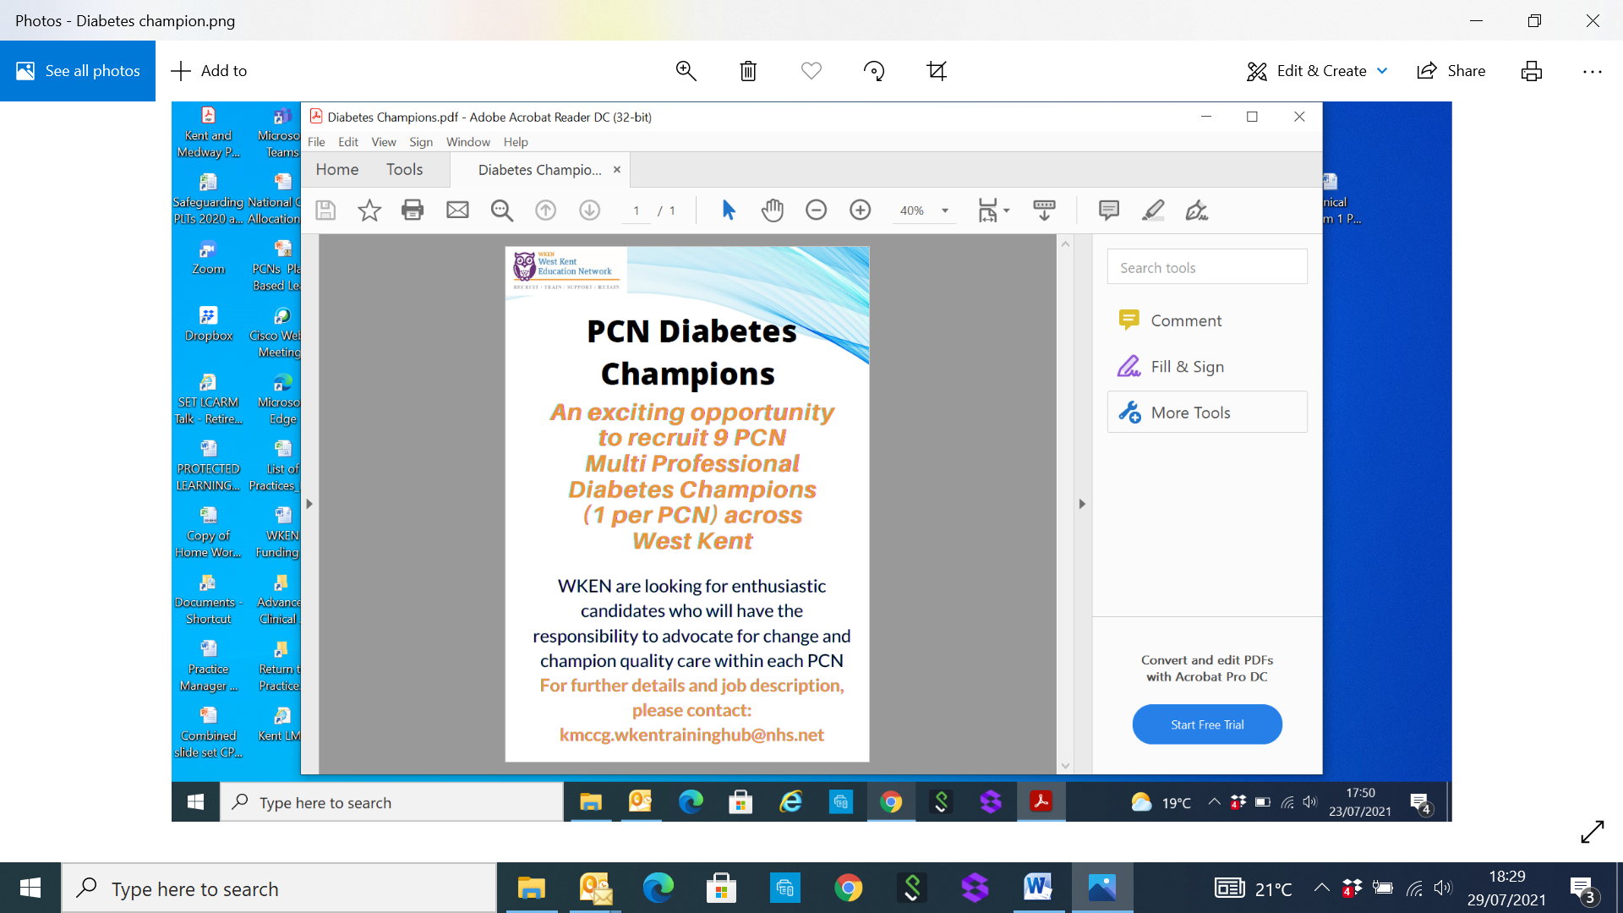

[**kmccg.wkentraininghub@nhs.net**](mailto:kmccg.wkentraininghub@nhs.net)

**CLOSING DATE**

**31st AUGUST 2021**

|  |
| --- |
|  |
| **Items of Interest** |
|  |

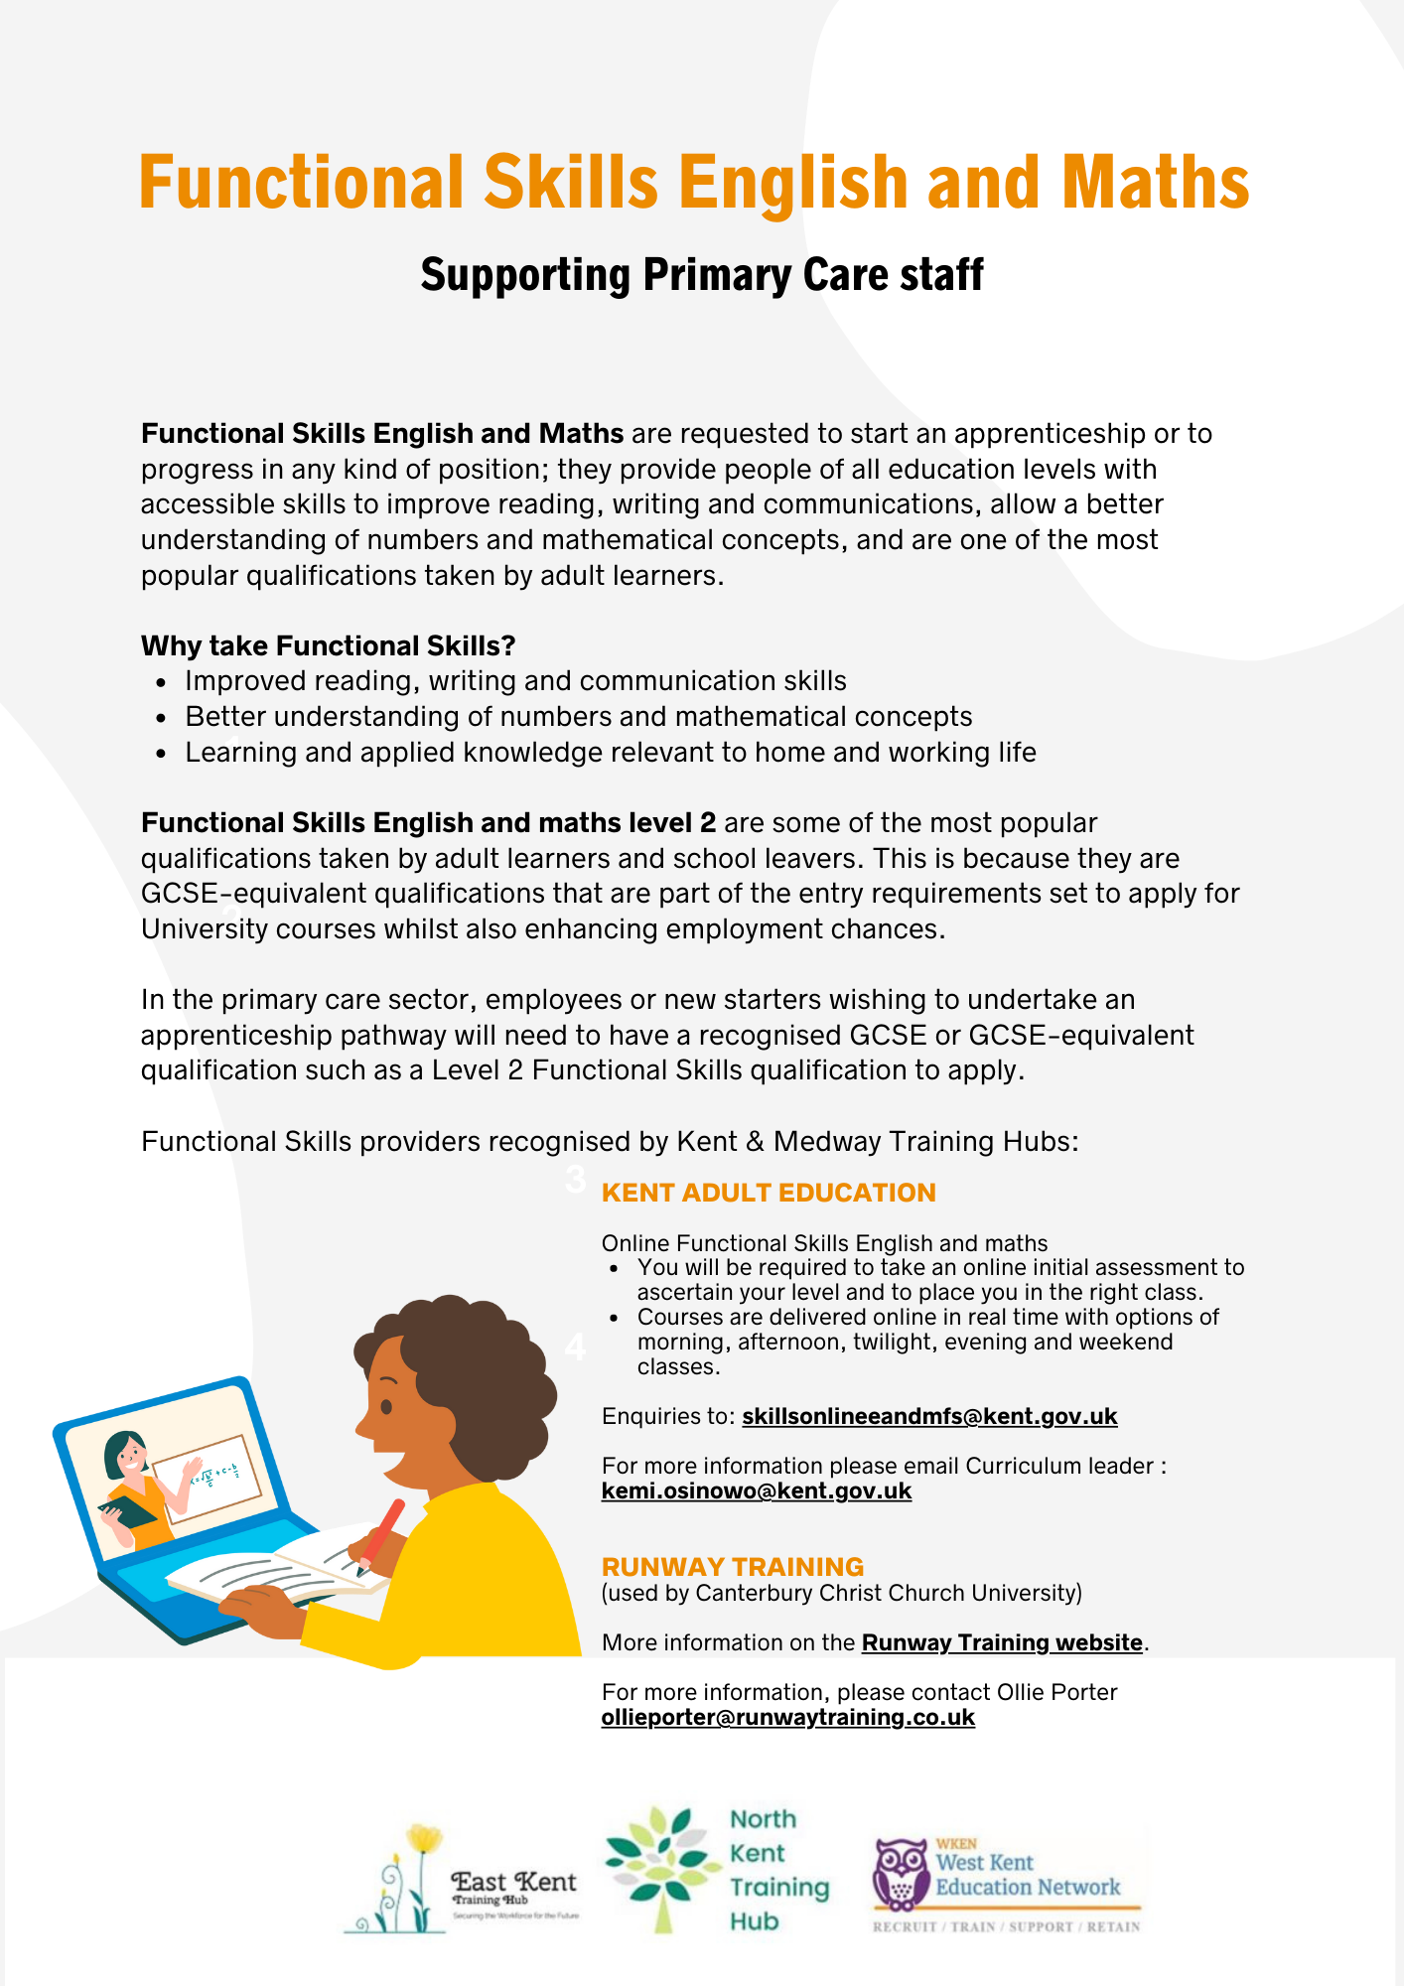

|  |
| --- |
|  |
| **Partners Page** |
|  |

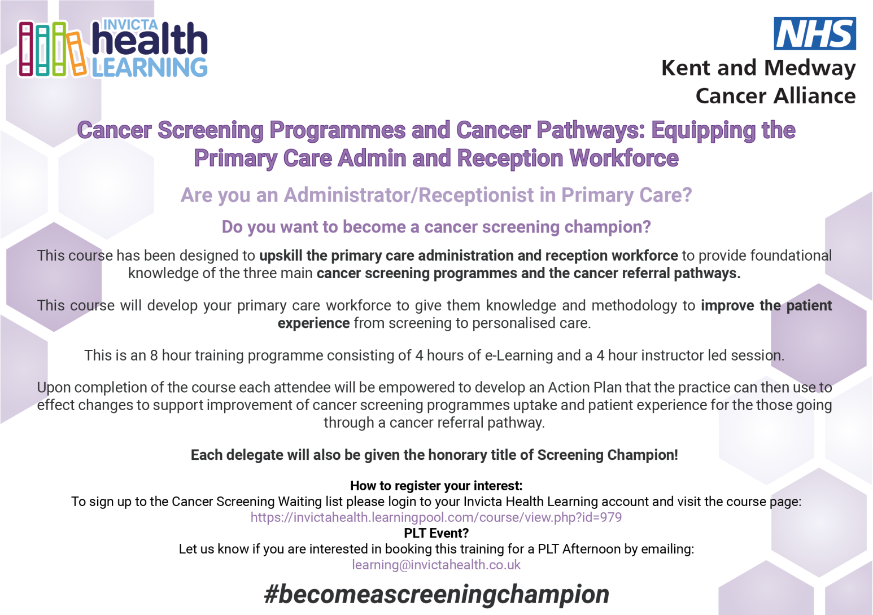

|  |
| --- |
|  |
| **Job Vacancies** |
|  |

**JOB TITLE: EXPERIENCED ASSISTANT DISPENSER**

**Wateringbury Surgery** is a dispensing GP surgery in the semi-rural village of Wateringbury, Maidstone, Kent. A three GP partner practice with three salaried GPs, nursing team, dispensary and admin team. Our team has grown over the last two years with the introduction of Social Prescriber, Clinical Pharmacist, First Contact Physiotherapist, Learning Disability Care Coordinator and Child and Health Wellbeing Coordinator.

We are a friendly, hardworking, supportive and caring team with a recognised high standard of care and service to our patients.

We are looking for an experienced Assistant Dispenser with NVQ level 2 or equivalent Dispensing Assistant qualification to join our team for 20 hours per week.

**The vacancy is for 10 months maternity cover starting 20th September 2021 however this may extend to a permanent part time contract.**

**Closing date Wednesday 25th August 2021 / Interview date Tuesday 31st August 2021**

Please apply through NHS jobs - job reference number A1653-21-5293

|  |
| --- |
|  |
| **Job Vacancies continued…** |
|  |

**Fantastic opportunity to be the next member of our growing clinical team at Edenbridge Medical Practice**

*We are looking for an enthusiastic GP to join us for 4-6 sessions a week with the possibility of future partnership for the right candidate.*

This position is for a list holder with an extremely competitive salary of £11000 per session. The Practice is located in Sevenoaks district with two stations with excellent rail links to London, good schools and amenities.

We are passionate about delivering high quality healthcare to our 12,500 patients by combining traditional list- holding family medicine with more innovative primary care roles including Nurse Practitioners, First Contact Physiotherapists, Social Prescribers and GP Assistants.

Plans are currently well underway for a purpose-built, combined GP and community health facility in the near future, from which we will deliver more joined-up community care.

We are a Dispensing Practice, offering a very competitive income, using Emis Web and were recently rated as ‘good’ in all areas by the CQC. We are well represented within local networks, with GPs in the Practice having leadership roles at PCN and CCG level.

For more information or to apply for this role contact the Practice Manager, Karen Copping [karen.copping3@nhs.net](mailto:karen.copping3@nhs.net)

***Brewer Street Surgery, Maidstone. GP Partnership vacancy February 2022***

*Congratulations on choosing probably the best career available! We hope you enjoy general practice as much as we do.*

Brewer Street Surgery was established over 70 years ago and has been proudly serving patients in the heart of Maidstone and surrounding area since then. We are an exceptionally stable surgery, well-respected and currently with around 9,200 patients. Many of our elderly patients have been with us since birth, and we have a handful of families in which we are proud to look after all four generations. We achieve above the local and national average in the National Patient Survey.

We have a high reputation locally and engage with all local organisations and CCG-run schemes. We are an active member of our PCN. We achieve high QOF scores and earn well above the national average. We are fortunate to own our own building, so have no leasehold issues. We use the EMIS Web computer system.

We have a partner retiring around the end of January 2022 and are looking for a replacement partner, though we can be flexible on the dates. We are very happy to consider doctors straight off the VTS scheme who are looking to bring their skills to help develop a thriving successful partnership, or more experienced GPs, or a fulltime salaried post with a view to becoming a partner. We would be supportive if you are keen to develop interests either inside or outside the practice alongside your GP career. Most of all we are looking for someone who is passionate about being a GP- you would fit right in! If GP Partnership is for you, we would love to hear from you, even just for an informal chat.

There is so much more we would like to tell you than we can include in this short summary- we hope to hear from you if you are interested.

[***edward.garrett@nhs.net***](mailto:edward.garrett@nhs.net)*and*[***chrismitchell@nhs.net***](mailto:chrismitchell@nhs.net)

**JOB TITLE: EXPERIENCED PRACTICE NURSE**

Lamberhurst Surgery is a small, friendly GP Practice; we are looking for an experienced Practice Nurse who can offer a full range of nursing services to our Practice population.  Ideally, we are looking for 20 hours per week; we are flexible on days to be worked.

Please contact Mrs Caroline Conlon, Practice Manager on 01892 890800 or [caroline.conlon@nhs.net](mailto:caroline.conlon@nhs.net) for more information.

|  |
| --- |
|  |
| **Job Vacancies continued…** |
|  |

**JOB TITLE: MEDICAL SECRETARY / ADMINISTRATIVE ASSISTANT (Maternity Cover)**

**Orchard End Surgery, Cranbrook** is looking to recruit an experienced medical secretary/ admin assistant. 12-14 hours per week (days/times extremely flexible). Salary is negotiable dependent on qualifications and experience.

The ideal candidate will have the following:

• Experience of working within the NHS

• Knowledge of medical terminology

• Knowledge of EMIS

• Excellent organisation skills

• Excellent verbal and written communication skills

• Experience of dealing with confidential information appropriately

• Team player and ability to work independently

• Excellent attention to detail

• Accurate keyboard skills

This may suit someone already working in a similar role, who is looking for more hours.

To apply, please send your CV by email to [g.g82733@nhs.net](mailto:g.g82733@nhs.net) for the attention of Dolina Reed, Practice Manager.

Closing date - 3rd September (but post may close earlier if suitable candidate found). Please note if you do not hear back from us your application has been unsuccessful.

**JOB TITLE: EXPERIENCED PRACTICE NURSE - Waterfield  House Surgery** is looking for an experienced Practice Nurse on a part time basis. Please apply via <https://beta.jobs.nhs.uk/candidate/jobadvert/A4449-21-8434> by 12th September or email [pm.whs@nhs.net](mailto:pm.whs@nhs.net) for queries.

**JOB TITLE: TEACHING FELLOW IN ANATOMY AT KENT & MEDWAY MEDICAL SCHOOL.**

A new 12 month fixed term position has gone live today for a Teaching Fellow in Anatomy at Kent & Medway Medical School. The closing date to apply is ***1st September*** and interviews are due to be held on ***Monday 20th September.***

This role will suit someone who is passionate about pursuing a career in medical education and specialising in anatomy.

I would be grateful if you would cascade this opportunity to colleagues who may be interested in this role.

Further details and the application form can be found here: <https://jobs.kent.ac.uk/vacancy.aspx?ref=KMMS-085-21-R>

|  |  |  |
| --- | --- | --- |
| [**www.kmms.ac.uk**](https://eur01.safelinks.protection.outlook.com/?url=http%3A%2F%2Fwww.kmms.ac.uk%2F&data=04%7C01%7Cliz.peddie%40kmms.ac.uk%7C55eac5146e3649f46e1108d946ce50d8%7C0320b2da22dd4dab8c216e644ba14f13%7C0%7C0%7C637618674201740189%7CUnknown%7CTWFpbGZsb3d8eyJWIjoiMC4wLjAwMDAiLCJQIjoiV2luMzIiLCJBTiI6Ik1haWwiLCJXVCI6Mn0%3D%7C1000&sdata=l5RNH609vFUV5vAzB0AURwraPHjzUy%2BhRys3%2FYk1eFo%3D&reserved=0)  [/Users/lesleyfarr/Library/Containers/com.microsoft.Outlook/Data/Library/Caches/Signatures/signature_778530396](https://eur01.safelinks.protection.outlook.com/?url=https://twitter.com/kmmsmedschool&data=04|01|liz.peddie@kmms.ac.uk|55eac5146e3649f46e1108d946ce50d8|0320b2da22dd4dab8c216e644ba14f13|0|0|637618674201750184|Unknown|TWFpbGZsb3d8eyJWIjoiMC4wLjAwMDAiLCJQIjoiV2luMzIiLCJBTiI6Ik1haWwiLCJXVCI6Mn0%3D|1000&sdata=wHHOABJPqI7aeXTpXXV26GtX1jwJvU52gFaNw7Pzx6A%3D&reserved=0) [/Users/lesleyfarr/Library/Containers/com.microsoft.Outlook/Data/Library/Caches/Signatures/signature_20259372](https://eur01.safelinks.protection.outlook.com/?url=https://www.facebook.com/KMMSMedSchool/&data=04|01|liz.peddie@kmms.ac.uk|55eac5146e3649f46e1108d946ce50d8|0320b2da22dd4dab8c216e644ba14f13|0|0|637618674201750184|Unknown|TWFpbGZsb3d8eyJWIjoiMC4wLjAwMDAiLCJQIjoiV2luMzIiLCJBTiI6Ik1haWwiLCJXVCI6Mn0%3D|1000&sdata=7UUW3Ue7LM%2BUA62/%2BQX6hSbhBaiFlTCY/h6BPd8bMlE%3D&reserved=0) [/Users/lesleyfarr/Library/Containers/com.microsoft.Outlook/Data/Library/Caches/Signatures/signature_1988417605](https://eur01.safelinks.protection.outlook.com/?url=https://www.instagram.com/kmmsmedschool/&data=04|01|liz.peddie@kmms.ac.uk|55eac5146e3649f46e1108d946ce50d8|0320b2da22dd4dab8c216e644ba14f13|0|0|637618674201760179|Unknown|TWFpbGZsb3d8eyJWIjoiMC4wLjAwMDAiLCJQIjoiV2luMzIiLCJBTiI6Ik1haWwiLCJXVCI6Mn0%3D|1000&sdata=b46YhqKx04eal6AeB2oxxWUW97xmgCBoO4RT5SqR7bw%3D&reserved=0) [/Users/lesleyfarr/Library/Containers/com.microsoft.Outlook/Data/Library/Caches/Signatures/signature_1309493630](https://eur01.safelinks.protection.outlook.com/?url=https://www.youtube.com/channel/UCA_7kkiYJs8XS_fU5jTyczw&data=04|01|liz.peddie@kmms.ac.uk|55eac5146e3649f46e1108d946ce50d8|0320b2da22dd4dab8c216e644ba14f13|0|0|637618674201770174|Unknown|TWFpbGZsb3d8eyJWIjoiMC4wLjAwMDAiLCJQIjoiV2luMzIiLCJBTiI6Ik1haWwiLCJXVCI6Mn0%3D|1000&sdata=cdgewJFsFm3xpZzaHL1TJxkD56fl/gqhtIUs6Rudv90%3D&reserved=0) | signature_2123974505 | signature_1678073608 |
| Canterbury Christ Church University  and University of Kent in collaboration |
| Canterbury Christ Church University, Augustine House Rm 1.26, Rhodaus Town, Canterbury, Kent CT1 2YA  University of Kent, Pears Building, Park Wood Road, Canterbury, Kent CT2 7NT | | |

|  |
| --- |
|  |
| **Job Vacancies continued…** |
|  |

**JOB TITLE: PRESCRIPTION CLERK, 30 HOURS A WEEK (MINIMUM)**

We are looking for an enthusiastic, friendly professional to join our non- clinical support team in processing repeat prescription requests. Computer experience is required. We use EMIS clinical system. Previous experience of working in general practice would be an advantage but not essential. Full training will be given.

Please apply with your CV to:

Carol Wayman [carol.wayman@nhs.net](mailto:carol.wayman@nhs.net)

West Malling Group Practice, 37 Queen Street, Kings Hill, ME19 4JF

**Closing date for applications: 10th September 2021**

**JOB TITLE: HEALTHCARE ASSISTANT**

We are looking for an enthusiastic, highly motivated Health Care Assistant to join our friendly practice team serving 21000 patients in the heart of Kent.

You will be part of our clinical team comprising of 7 GP Partners, 5 Salaried GPs, 2 Nurse Practitioners a Pharmacist and a team of Practice Nurses and HCA’s with strong support from an experienced administrative and management team. We are GP and Nurse training practice.

Your role will be varied to include phlebotomy, blood pressure checks, ECG, warfarin checks, smoking cessation, NHS health checks and ear syringing.

We are ideally looking for this to be a full time position and can be flexible. Pay will be subject to experience.

25 days holiday plus pro rata bank holidays

If you would like to be considered, please apply with full CV and a covering letter to

Tracy Skates, West Malling Group Practice – 37 Queen Street, Kings Hill ME19 4JF Or email [tracy.skates@nhs.neT](mailto:tracy.skates@nhs.neT)

We welcome informal inquiries or visits

**Application closes 10th September 2021**

**JOB TITLE: ADVANCED NURSE PRACTITIONER**

We are looking for an enthusiastic, highly motivated Advanced Nurse Practitioner to join our friendly practice team serving 21000 patients in the heart of Kent. We are a very supported team committed to providing high quality care patient care.

You will be part of a team of 7 GP Partners, 5 Salaried GPs, 2 Nurse Practitioners a Pharmacist and a team of Practice Nurses and HCA’s with strong support from an experienced administrative and management team. We are GP and Nurse training practice.

You will need to be a degree qualified Advanced Nurse Practitioner with relevant clinical skills and expertise to work autonomously. You must have relevant experience to be an independent nurse prescriber enabling you to independently assess, diagnose, treat and refer patients as appropriate. IT will be expected that you will manage your own patient lists. We would also expect you to take on specific responsibilities in other areas of practice. A speciality are of interest would be an advantage. We are supportive of training and development.

We are ideally looking for this to be a full time position and can be flexible around the hours worked.

If you would like to be considered, please apply with full CV and a covering letter to the Practice Manager, Debbie Dean via [debbiedean@nhs.net](mailto:debbiedean@nhs.net) We welcome informal inquiries or visits

**Application closes 10th September.2021**